MasTec Inc. (MTZ)
November 29,2017
Xinyue Yin, Junji Jin
Material & Industry
Introduction:
MasTec, Inc. is an American multinational infrastructure engineering and construction company based in Coral Gables, Florida. Limited to the engineering, building, installation, maintenance and upgrade of energy, utility and communications infrastructure, including electrical utility transmission and distribution, power generation, natural gas and petroleum pipelines, wireless, wireline and satellite communications, wind farms, solar farms and other renewable energy, industrial infrastructure and water and sewer systems. Its customers are primarily in the utility, communications and government industries.
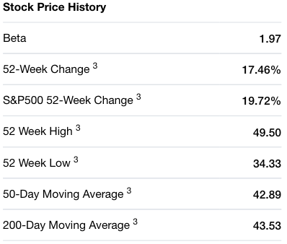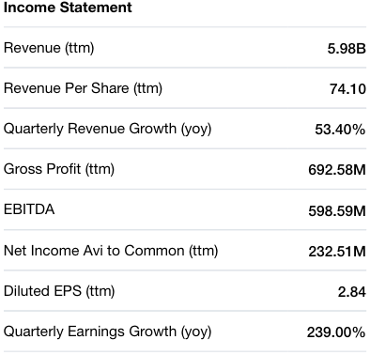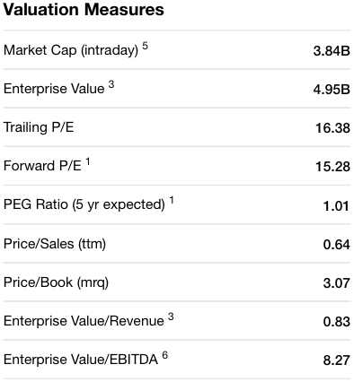
Recommendation:
We strongly recommend the BUY position of the MTZ. The revenue of the third- quarter performed better than the expectation. MTZ posted third-quarter 2017 adjusted earnings per share of 82 cents, up 1.2% year over year. The annual adjusted EBITDA are expected grow 32% year over year to be around $630 million. Adjusted earnings per share are projected at $2.8, UP 47% compared with $1.9 in fiscal 2016. There also have a positive earnings surprise history. MTZ has an impressive earnings surprise history outpacing the Zacks Consensus Estimate in all the trailing four quarters, delivering a positive average earnings surprise of 28.05%
Investment thesis:
- Strong price performance
As we seen from the graph, MTZ’s shares were outperformed the industry in the past year. The stock has gained 11.6%, as against the industry’s decline of 4.4% in the same period. the 12-month price earning ratio of MTZ is 13.26, while the industry’s average 12-month price earning ratio is 26.81. we think MTZ is undervalued, it is a prefect time to invest in.
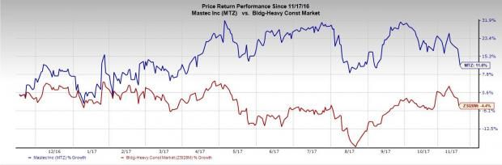
- Oil & Gas Segment
By the end of September 30, 2017, Mas Tec has completed the acquisition which is an oil and gas pipeline equipment company, that is included in the Company’s Oil and Gas segment. New source of oil & gas reserves and commodity price pressure are driving demand for lower cost and the safer transportation alternatives provided by pipelines.
- Wireless & Wireline Businesses
MTZ starts wireless business invest in the wireless from 2015, the wireless business has significant potential. One of the large customer of MTZ is AT&T, which AT&T announced plans and initiatives for 5G. AT&T was awarded FirstNet — a nationwide public safety wireless network. Currently, 28 states are availing the network’s services. Both 5G and FirstNet will help bolster 2018 revenues and provide a significant boost in 2019 as well.
Valuation:
In order to estimate future value of our stock, we used DCF model from Bloomberg. We used 12.1% WACC based on our further research instead of pre-determined 11.3% in Bloomberg. It results in more accurate estimated value per share for both Perpetuity Growth Method and EBITDA Multiple Method under DCF model, which are $60.90 (36% upside) and $58.51 (30% upside) respectively comparing with the price of $44.85 on Dec. 2.
Risks：
- Demand for pipeline construction services depends on oil and natural gas industry activity.
Demand for pipeline construction services is sensitive to the level of exploration, development, production, transportation, processing and refining activity of, and the corresponding capital spending by, oil and natural gas companies and demand by industrial and utility customers.
- Customers could be negatively affected by market conditions and economic downturns
Economic downturns or bankruptcies within these industries which we serve may impair the financial condition and make them hard to pay MTZ on a timely basis or even defaults in making payments.
- Failure to properly manage projects, or project delays
Engagements of MTZ involve large-scale, complex projects that may occur over extended time periods. The quality of MTZ’s performance depends in its ability to manage client relationship and project itself and to timely use appropriate resources.
Management：
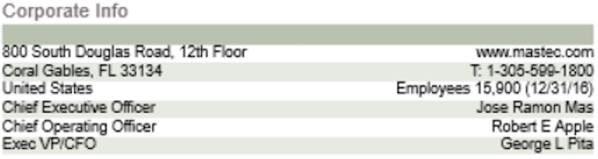
Source: Bloomberg
Mr. Mas was appointed CEO of MTZ in 2007, after he enter into MTZ, the revenue grown six times. He makes the decision to extend company form electric transmission to fields of oil and gas pipeline construction and wireless infrastructure construction. Mr. Apple was join in the company in 2005, He has more than 30 years of operational and senior management experience in commercial, technical and service-based corporations. We believed MTZ can continue its growth with efficient management team.

Stock Chart of Past Year Performance: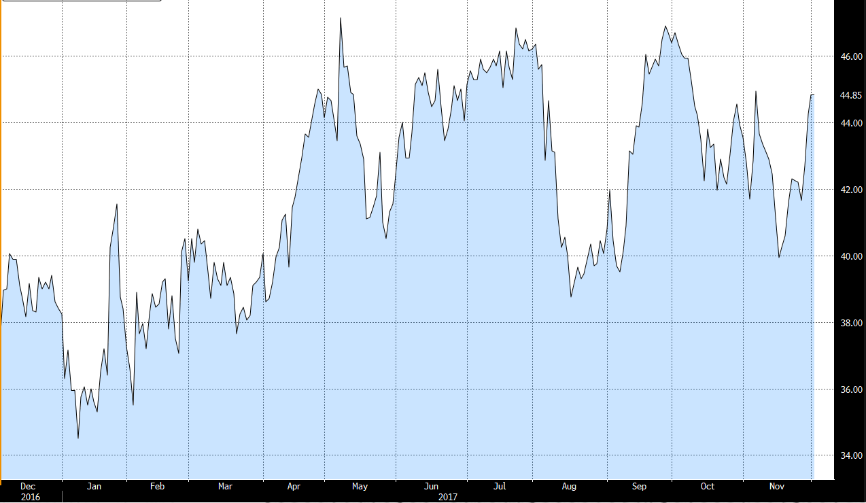
Source: Bloomberg
Peer Analysis
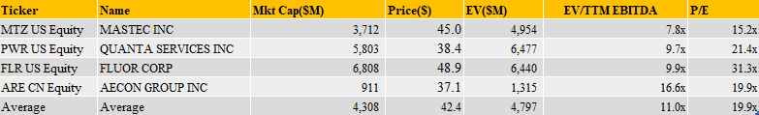

Ownership of Shares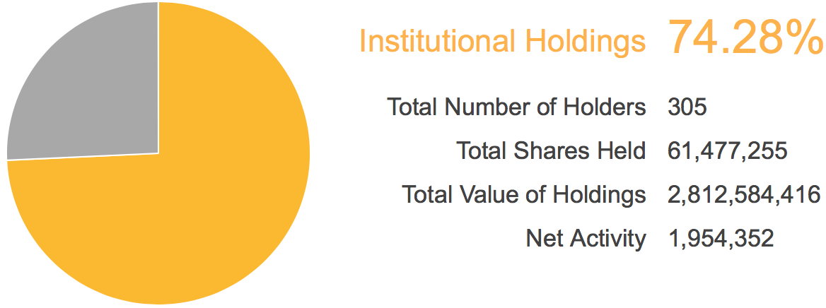
SOURCE: Nasdaq
Top 5 Shareholders
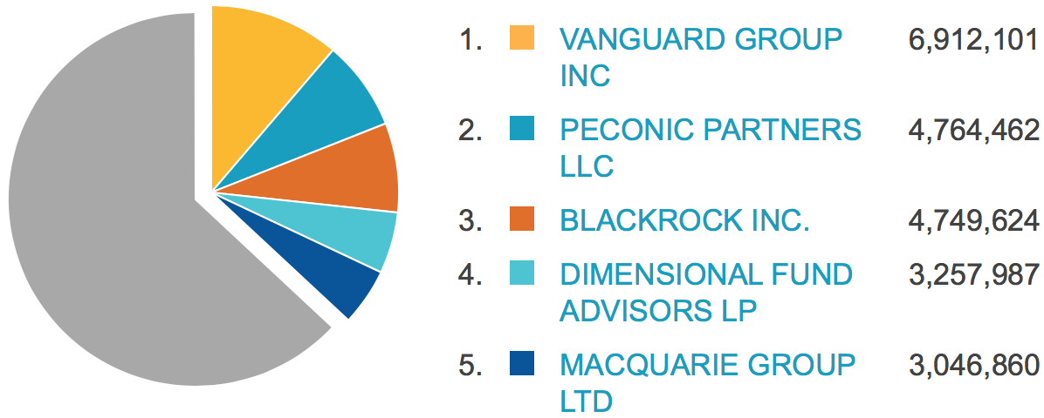
Source: Nasdaq

