ss Corning
Stock Price - $87.75
Consumer Discretionary A
Tony Cavil & Nichole Ullom
November 29, 2017
Introduction
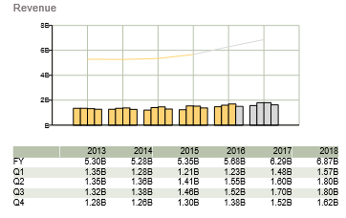
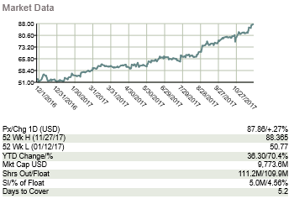
Owens Corning (NYSE: OC) develops, manufactures, and markets insulation, roofing, and fiberglass composites. Global in scope and human in scale, the company’s market-leading businesses use their deep expertise in materials, manufacturing and building science to develop products and systems that save energy and improve comfort in commercial and residential buildings. Through its glass reinforcements business, the company makes thousands of products lighter, stronger, and more durable. Ultimately, Owens Corning people and products make the world a better place. Based in Toledo, Ohio, Owens Corning posted 2016 sales of $5.7 billion and employs 17,000 people in 33 countries. It has been a Fortune 500® company for 63 consecutive years.
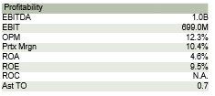
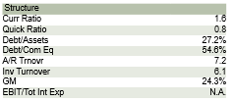
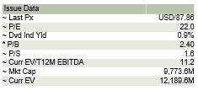
Recommendation
With respects to building products industry, Owens Corning has dominated their competition, with large increases in roofing revenue as their top line. The last 12 months they have seen over 22% growth, creating a diversified company through expansion into foreign markets as well as domestic acquisitions here in America. In 2017 the company has really focused on increasing shareholder value, in fact they focus their quarterly presentations on this topic. The current dividend yield for OC is at .89%, increasingly drawing in investors who look to supplement their income. Existing home sales, consumer income and borrowing capacity are all up in the current market, leaving a large imprint on Owens Corning, with superior cash flow yield of over 9%. These strong cash flows have made the 2 acquisitions in 2017 possible, with over half a dozen acquisitions being investigated currently by OC. Their markets overseas are increasing rapidly as countries within Europe are in their growth stages, making the recent acquisition of a European company attractive to investors. In fact their revenue has exceeded total market revenue for the industry in Europe and all of the Americas. These trends have only recently been reflected in the stock price, with the growth pace unlikely to slow into 2018.
Investment Thesis
- Home Starts. U.S. home starts continue to grow in 2017 and are expected to continue growth under current market conditions. The U.S. housing market still has room from growth after the housing crash. There is also room for growth under the recent hurricanes in the U.S. and need for remodeled roofs.
- Acquisitions. As of the January 2016, Owens Corning has acquired four companies. Currently as of October 30, 2017, Owens Corning is in the process of acquiring Paroc Group $1,047 million cash to be completed on June 30, 2018. Paroc Group will be the largest acquisition Owens Corning has made so far. Paroc Group acquisition is expected to increase synergies in Europe in 2019. With increased acquisitions, as of current and into the future, we believe that this will increase different lines of business within Owens Corning and increase their value.
- Diversification. Owens Corning has a vast amount of diversification within their three main business lines of roofing, insulation, and composite. The composite line includes building and construction; transportation; consumer goods, electrical and electronics; industrial and infrastructure; and energy generation. Customers are also diversified with operations globally. Owens corning is able to increase growth across multiple lines of business.

Valuation
To determine an intrinsic value for Owens Corning we utilized a EBITDA Multiple Method, with 5 a terminal EBITDA value of forecasted year 5. Using a WACC of 9.0%, which was also given in the Bloomberg model, we would find a price of $102.12. According to this model and many other target prices of analysts, we found that OC is roughly 12% undervalued in the current market, with a range of $70 to $110 compared to the current price of $86.70.
- Changing Markets. Owens Corning falls into the consumer discretionary sector, which historically follows the market. Any downturn in the economy will affect Owens Corning and their expected earnings for investors.
- All Time High. The current stock price of Owens Corning is at its all-time high over its 63 years as a publicly traded company.
- Divest Capital Intensity. Owens corning has decreased capital intensity, the amount of fixed assets in relation to other factors of production, in the InterWrap and organic growth projects.
Management
Michael Thaman is the current CEO of Owens Corning as of 2007. Prior to being CEO he held various positions within the company. Mike is also on the board of Sherman-Williams as of April 2017. Mike’s pay is based both on cash and non-cash equivalents that include stock options in the company.

Stock Chart of Past Year Performance
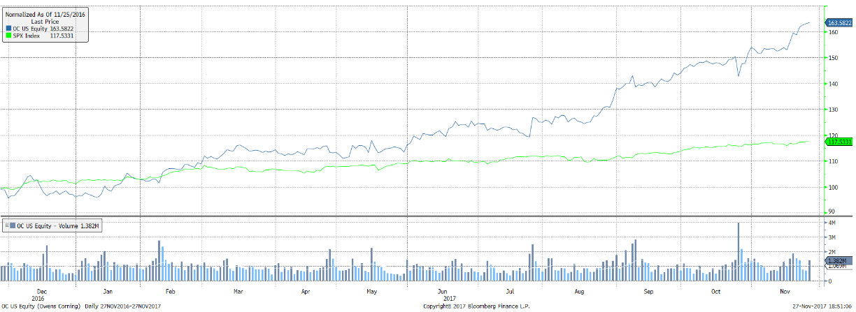
Peer Analysis
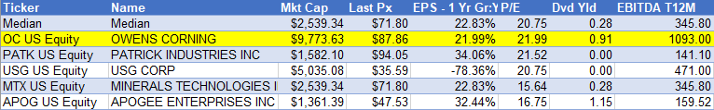
Ownership of Shares

Source: Bloomberg
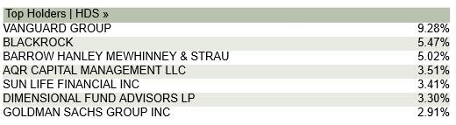
Top 5 Shareholders

Source: Bloomberg

