UnitedHealth Group Inc.
November 27, 2017
Jake Travis  Ben Waldusky | Healthcare

INTRODUCTION

UnitedHealth Group (NYSE: UNH) is a distinctively diversified health and well-being company headquartered in Minnetonka, MN. UnitedHealth Group was founded in 1977 and went public in October of 1984. UNH serves clients and consumers through two distinct platforms; UnitedHealthcare and OptumHealth. The first platform, UnitedHealthcare, provides healthcare benefits through four different membership groups: UnitedHealthcare Individual & Employer, UnitedHealthcare Retirement & Medicare, UnitedHealthcare Community & State, United Healthcare Global. These business segments compose 65% of total organization revenue with 23%, 24%, 15%, and 3% respectively. The OptumHealth (Optum) platform is a health services business that serves an array of consumers such as life science companies, care providers, and governments. Optum also operates a data analytics and technology business segment to help serve clients. Optum further diversifies its multi-faceted business with its Optum Rx business segment which operates as a pharmacy benefit management service. The Optum business platform is broken down into three segments with the following 35% revenue composition: Optum Health (7%), Optum Insight (3%), and Optum Rx (25%).

Price ($): 212.60 |  | Beta: | .982 | FY: Dec. | 12/31/2015 | 12/31/2016 | 12/31/2017 | 12/31/2018
Price Target ($): 230.65 |  | WACC: | 8.22 | Revenue (Bil) | 157,107 | 184,828 | 200,285 | 217,837
52 WK H-L ($): 213-150 |  | Growth Rate (%): | 15.10 | Gross Margin | 23.57% | 23.47% | 23.05% | 23.55%
Market Cap (bil): 205.94 |  | ROA (%): | 6.00 | EBITDA Margin | 8.09% | 8.11% | 8.60% | 9.30%
Avg. Daily Vol (mil): 2.85 |  | ROIC (%) | 10.77 | Operating Margin | 7.01% | 7.00% | 7.55% | 8.31%
Dividend ($): .75 |  | ROE (%): | 19.46 | EPS | $6.10 | $7.37 | $9.42 | $10.27
Yield (%): 1.29 |  | Debt/Equity: | 64.60 | CF/Share | 10.22 | 10.29 | 16.11 | 14.31
 |  |  |  | P/E | 19.89 | 22.42 | 21.28 | 19.61
 |  |  |  | EV/EBITDA | 10.31 | 11.48 | 12.60 | 10.69

RECOMMENDATION

We recommend a buy rating on UNH's stock at $230.65 per share. By revenue, UNH is the nation's largest publicly traded managed cared company. UNH's revenue numbers have provided steady growth over the past years. In 2015, however, the revenue growth rate tripled from 2014's 6.5% to 20.6%. The 2016 revenue growth rate was also high at 17.7%. This is primarily due to the business platform Optum's recent growth. UNH has made numerous acquisitions over the last few years, with the bulk under the Optum business platform. Notable purchases include Surgical Care Affiliates, an organization with a network of over 200 ambulatory surgery centers and Amil, a Brazilian dental and health insurance provider. Acquisitions like these has allowed Optum to seep into other market segments which in turn has provided UNH growth opportunities. Along with revenue growth, earnings growth has also been proficient. Over the last 28 quarters, UNH has beaten earnings estimates and reported positive earnings surprises 25 of the 28 quarters. Estimated YoY growth for EPS translates to 17.4%. This lends further credence to the organization's continual earnings ability despite its many acquisitions. Along with the increasing revenue streams and growth, the company has continued to maintain healthy margins. The organization's M&A activity has allowed for lower operation costs and increased price negotiation power. Further economic drivers such as growing GDP and low unemployment rate provide additional macroeconomic factors that enhance growth potential. Reputable sources such as Zacks, Argus Group, and MarketGrader have rated this stock as a buy with similar price recommendation.

INVESTMENT THESIS

- Beefing up Optum. The fast-growing business division known as Optum is expected to be this organization's primary growth driver. In 2016 Optum harbored nearly 36% of UNH's revenue. Since 2012 the business segment has generated at least 20% percent of the entire organization's revenue. OptumCare, a subsector of Optum Health is expected to be one growth leader of Optum in the next few years. The subsector is a leading health service delivery organization that strives to provide affordable services and quality care. The company plans to extend into 75 local markets, covering around 200 million people. Optum360, a revenue cycle management system, acts as another potential huge growth driver for the organization. The number of businesses that use the Optum360 computerized documentation technology has doubled to 125 in 2016 from 2015.
- Strong Numbers and Size in Industry. As discussed earlier in recommendation, UNH has had strong growth in both revenues and earnings. Compared to its peers, this is also evident. UNH's market cap exceeds its closest market competitor by nearly four times. On top of this, its revenue and earnings numbers far exceed its peers (see Peer Analysis below). UNH's revenue and EPS growth rates of 17.65% and 20.68% are much stronger than the industry averages of 6.09 and 10.47% respectively. Although UNH's EV/EBITDA amongst other peer valuation multiples are slightly over the industry medians, we do not believe the stock is overvalued due to its copious growth prospects.
- Mergers and Acquisitions. UNH composes nearly 80% percent of all mergers and acquisitions since 2015. The company does conduct mergers and acquisitions through UnitedHeathcare, however, UNH tends to perform most M&A activity through Optum because of its presence in many different markets. Currently Optum exists in 28 markets; however, in 2017 Optum purchased Surgical Care Affiliates thusly picking up another 17 markets. UNH recently purchased AMIL, a Brazilian health and dental insurance provider improving its international breadth. Another recent purchase was of Catamaran, which provided OptumRX further growth potential. Acquisition of other companies allows Optum to expand its reach and acquire other revenue streams.

VALUATION

Using the discounted cash flow model (DCF) over five years, we reached a target price of $230.65 with the terminal EBITDA multiple. This multiple was increased by 1.5x over each year. WACC was set at 8.22%, arriving the stock at a valuation of $264.32, a 24% upside from its current $212.60 value.

RISKS

- Aging Population. Although aging population also acts as an opportunity it also provides a risk for UnitedHealth Group. Health expense prices are driven up as more surgeries and treatments are needed by the elderly. It is also expected that age expectancy will increase, thus leading to more payouts by UnitedHealth Group's health insurance branch.
- Negative Healthcare Reform. The Affordable Care Act had negative effects on UnitedHealth Group causing it to lose $475 million in 2015 and up to $650 million in 2016. Further reforms in the future to health insurance could cause UnitedHealth Group to suffer other losses.
- Competition. Competitive risks come from both governmental and commercial bodies. As UnitedHealth Group continues to expand its business, rival insurers will look to increase their market share by modeling what UnitedHealth Group is doing.
- Free Cash Flow/Potential Debt Increase. Due to UNH's high amount of acquisitions it has been noted that their free cash flow has been quite volatile over the past few years. It seems this has not had an effect on the company as of today, but if leverage ratios begin to resurge due to increased acquisitions and free cash flow decreases the stock may need more attention directed to earnings growth.

MANAGEMENT

Stephen Hemsley became executive chairman, UnitedHealth Group, on September 1, 2017. In this position, Hemsley remains actively involved in supporting the senior management team, oversight of planning and performance and helping guide the enterprise. Hemsley joined the company in June 1997 and was the former CEO of UnitedHealth Group from 2006 to 2017. He also has been a member of the company's board of directors since 2006.

David Wichmann became CEO after Hemsley on September 1, 2017. He is responsible for the strategic direction and overall performance of the enterprise and its long-term growth agenda. He also acts as a member on the board of directors. Previously, Wichmann served as president of UnitedHealth Group. Prior to this he served as CFO of UnitedHealth Group and CEO of OptumHealth. Before joining UnitedHealth Group in 1998, Wichmann was a partner with Arthur Andersen.

Larry Renfro was named vice chairman of UnitedHealth Group in November 2014. Renfro is entrusted with oversight responsibility for all enterprise strategic relationships, key client relationships and companywide business growth efforts. He also serves as CEO of Optum; overseeing OptumInsight, OptumHealth and OptumRx. Renfro joined the company in January 2009 and has served as chief executive officer of the Public and Senior Markets Group. He held management positions in Fidelity and AARP services before joining UnitedHealth Group.

John Rex was appointed executive vice president and CFO of UnitedHealth Group. Joining the company in 2012, Rex previously served as executive vice president and CFO of Optum. Prior to Optum, Rex was a leading equity research analyst in the health care sector and managing director of J.P. Morgan. He also worked as a strategy and operations consultant, specializing in health services. A certified public accountant, Rex advised clients for Ernst & Young, where he also specialized in the health services sector.

STOCK PERFORMANCE CHART – PAST YEAR

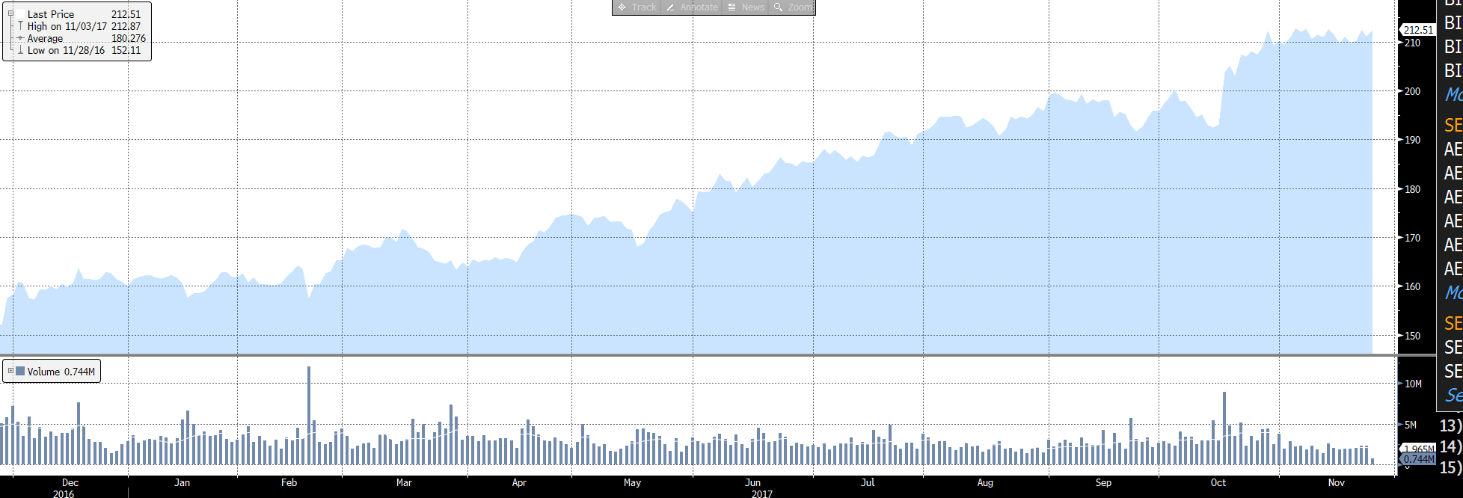

PEER ANALYSIS

Name | Ticker | Market Cap (bil) | Sales (bil) | EBITDA (bil) | Dividend Yield | EV/  EBITDA
UnitedHealth Group Inc. | UNH | 205.94 | 184.84 | 14.82 | 1.28% | 12.94
Anthem Inc. | ANTM | 56.59 | 84.97 | 6.71 | 1.20% | 12.06
Cigna Corp. | CI | 46.46 | 39.67 | 3.59 | 0.02% | 11.96
Aetna Inc. | AET | 57.54 | 63.07 | 5.97 | 0.99% | 7.04
Humana Inc. | HUM | 34.36 | 54.28 | 2.82 | 0.66% | 6.86
Peer Averages |  | 56.59 | 63.07 | 6.34 | 1.00% | 11.96
OWNERSHIP

% of Shares Held by Inside Owners: 1.59%
% of Shares Held by Institutional & Mutual Fund Owners: 98.41%
 |  |  |  |  |  | (Bloomberg)
TOP FIVE SHAREHOLDERS

Holder |  |  |  |  | Shares | %
Blackrock Inc. |  |  |  |  | 70,072,288 | 7.23
Capital Group Companies Inc. |  |  |  |  | 67,302,534 | 6.95
Vanguard Group |  |  |  |  | 65,802,639 | 6.79
FMR LLC |  |  |  |  | 57,222,780 | 5.90
State Street Corp |  |  |  |  | 44,925,411 | 4.64

