The TJX Companies (TJX)
November 18, 2017
Chad Glover and Ryan Battist Consumer Discretionary

Introduction
The TJX Companies (TJX) is the leader in off-price apparel and home fashion retail in the United States and worldwide. TJX revenue streams consist of clothing (54%), home fashion (31%), and jewelry and accessories (15%). TJX can be broken down into four different business segments: MarMaxx (U.S), HomeGoods (U.S.), TJX Canada, and TJX International. The company operates more than 3,860 stores like T.J. Maxx, Marshalls, HomeGoods, Winners, HomeSense, T.K. Maxx, and Trade Secret. TJX mainly operates in the United States, which is responsible for 77% of revenue compared to Europe at 13% and Canada at 10%.

Price ($): | 75.53 | Beta: | .88 |  | 2016A | 2017A | 2018E | 2019E
Price Target ($): | 86.86 | WACC: | 8.2 | Revenue (mil) | 30,945 | 33,184 | 35,669 | 37,565
52 WK H-L ($): | 80.92-66.44 | M-Term Rev. Gr Rate Est: | 3.93 | % Growth | 6.4 | 7.2 | 7.5 | 5.3
Market Cap (mil): | 47,644 | M-Term EPS Gr Rate Est: | 12.65 | EBITDA | 4,325 | 4,514 | 4,819 | 4,995
Float (mil): | 585.9 | CFO/Int Exp: | 82.80 | EBITDA Margin | 14.0 | 13.6 | 13.5 | 13.3
Short Interest (%): | 3.09 | Debt/EBITDA (ttm): | .53 | EPS | 3.33 | 3.55 | 3.93 | 4.22
Avg. Daily Vol (mil): | 4.1 | ROA (%) | 18.86 | P/Cash Flow | 16.33 | 13.52 | 14.85 | 13.77
Dividend ($): | 1.25 | ROE (%) | 52.13 | P/E | 21.37 | 20.94 | 19.18 | 17.85
Yield (%): | 1.59% | ROIC (%) | 35.15 | EV/EBITDA | 10.77 | 10.41 | 9.75 | 9.41

Recommendation
After posting revenue growth for the past 3 years, TJX recently missed its 3rd quarter projected revenue by 1.1%. This miss in revenue was attributed to unexpectedly warmer temperatures, unexpectedly lower clothing supplies, as well as Hurricane Maria damaging store locations in Puerto Rico. These events hindered sales in the Marmaxx segment during the 3rd quarter however all other business segments posted strong sales. Looking forward the 4th quarter includes high sales due to black Friday and the holidays, 4th quarter and 2018 revenues are expected to grow by 13.5% and 7.5% respectively. Therefore, we believe the share price to be undervalued due to the aforementioned events. Despite the rise in online sales in recent years, TJX has been able to withstand the online sales trend better than other retailers. This is because TJX is able to sell name brand merchandise at costs that are equal to or lower than online retailers. In response to online sales, TJX does offer online shopping and it owns Sierra Trading Post, which is an off-price outdoors-themed Internet retailer. E-commerce only reflects 1% of TJX’s sales, this shows that TJX has a strong brick-and-mortar presence and many people believe that TJX could expand online sales growth if need be. In addition, TJX’s constantly changing inventory creates a favorable “treasure hunting” experience for its customers, which keeps customers returning to TJX Stores. Since the great recession, there have been two customer trends in the retail environment. First, some customers are conservative with their money and want the most value for their dollar. Second, a growing economy has given consumers confidence and the ability to spend money. We believe that TJX captures both of these consumer audiences by offering premium products at low prices. In the retail industry the two main drivers are sales growth and new store openings. In 2017, TJX saw a 5% increase in same store sales and in 2018 TJX plans to open over 200 new store locations both domestically and internationally. In addition, TJX has lower operating and marketing costs, which passes value on to the customers. These factors translate into a successfully proven business model and increasing future revenues; therefore we recommend TJX as a strong buy.

Investment Thesis
Store Openings: TJX has been expanding their operations by continuing to open new stores. During 2018, TJX plans on opening up 65 Marmaxx stores, 81 HomeGood stores, 35 TJX Canada stores, and 49 TJX International stores. The continued expansion is a key indicator that TJX is a strong buy.
Opportunistic Buying Strategy: TJX has a unique buying strategy where they buy as they go which results in a rapidly changing mix of brands and products. It is a very fluid process that results in lower inventory levels that give TJX the flexibility to keep up with consumer trends and preferences.
Pricing: TJX offers name brands with prices 20%-60% lower than competitors. The company does not offer coupons but maintains fluid prices to maintain their price gap. The discount pricing of TJX will help keep sales revenue constant during a recession, while their competitors will struggle.
Low Operating Cost: TJX maintains lower operating cost compared to their competitors. The company does this through lower advertisement costs. The company markets the store names instead of individual projects like their competitors; this results in the lower marketing cost. TJX also spends less on store fixtures relative to competitors

Valuation
To reach an intrinsic value for TJX, two separate valuations were used. The first model used was a five-year DCF model. Using a terminal growth of 5.0% and a WACC of 8.2%, an intrinsic value of $87.08. A +/- .25% sensitivity analysis on the terminal growth rate and +/- .5% WACC and the intrinsic value ranged from $76.88-$100.62. Additionally an EV/EBITDA multiple valuation was conducted using 2017 EBITDA of $4,513.5 mil and peer comparable multiple of 9.6x, resulting in a valuation of 86.64. Weighting the two valuation models 50/50, a price target of $86.86 was reached, resulting in a 15.3% upside.

Risks
Consumer Trends and Preferences: TJX success is directly related to their ability to keep up to consumer trends and preferences. Their ability to obtain popular name brands is essential to continued success. These trends and preferences can be difficult to keep up.
Competition and Marketing: TJX operates in a highly competitive industry. Competitors tend to spend more money on marketing and therefore are more recognizable. Due to the TJX spending less on marketing, it may lead to fewer costumers.
Opportunistic Buying Strategy: Not buying inventory in advance can lead to a shortage of inventory and therefore losing sales and customers. If TJX does not continue to successfully execute their opportunistic buying strategy, revenues will decrease.

Management
Ernie Herrman (56) has been the president and CEO of TJX since 2016 and has been an executive at TJX since 2008. Carol Meyrowitz (63) is the current chairman of TJX, a position she has had since 2016. Before becoming chairman, Meyrowitz served as the president and CEO, during her longstanding career with TJX.

Stock Price Graph
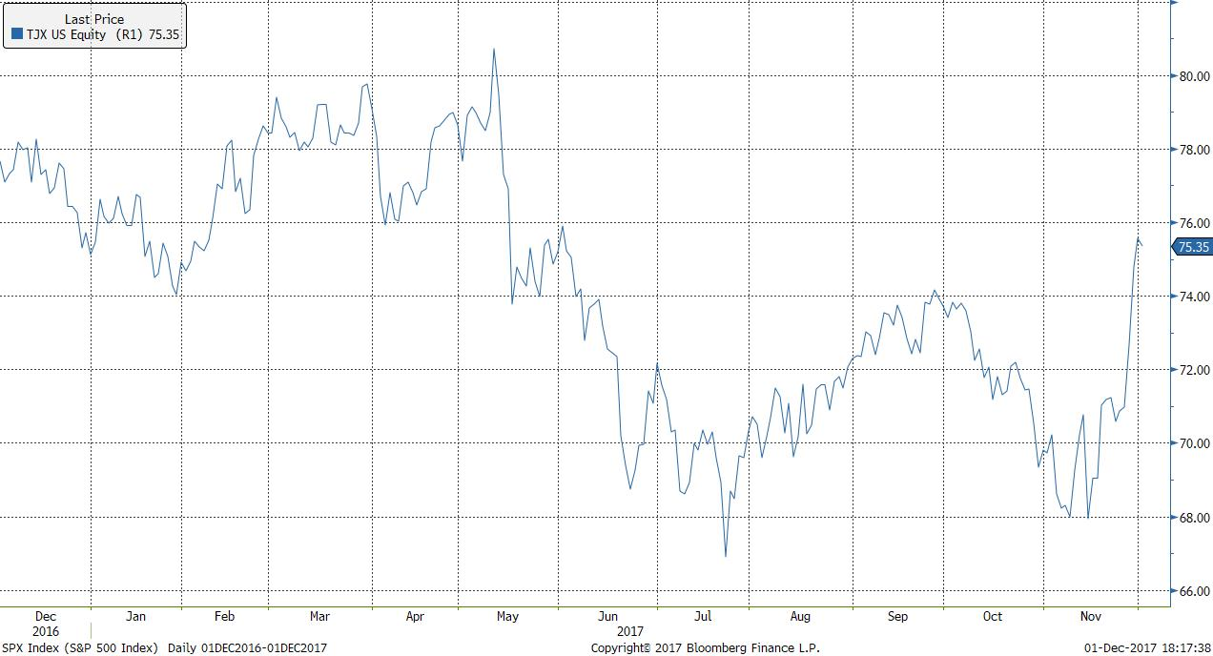

Peer Analysis
Name | Ticker | Market Cap (bil) | Revenue (mil) | EBITDA | EV/EBITDA | Dividend Yield (%)
TJX Companies | TJX | 47.64 | 33,183.70 | 4,513.50 | 10.41 | 1.59
Ross Stores | ROST | 29.20 | 12,866.80 | 2,105.20 | 11.82 | .85
Burlington Stores | BURL | 7.42 | 5,591.00 | 584.00 | 13.39 | N/A
Stein Mart | SMRT | .585 | 1,360.50 | 41.20 | 9.48 | 12.30
Citi Trends | CTRN | .349 | 695.20 | 36.60 | 4.33 | 1.18
Peer Average |  | 16.94 | 10,739.44 | 1,456.10 | 9.89 | 3.98

Ownership
% of Shares held by All Insider Owners: | 0.23%
% of Shares held by Retail & Other | -4.96%
% of Shares held by Institutional & Mutual Fund Owners: | 104.73%

Top 5 Shareholders
Holder |  |  |  |  | Shares | % Out
Vanguard Group |  |  |  |  | 48,233,033 | 7.63
Blackrock |  |  |  |  | 44,928,226 | 7.11
State Street Corp |  |  |  |  | 27,813,151 | 4.40
FMR LLC |  |  |  |  | 26,290,054 | 4.16
Wellington Management Group LLP |  |  |  |  | 19,104138 | 3.02

