NVIDIA Corporation (NVDA)
November 19, 2017
Jieni Zhang Information Technology – Semiconductor Hanzhi Liu

NVIDIA Corporation is a company that designs, develops and makes three-dimensional (3D) graphics processors and related software. The company’s products provide interactive 3D graphics to the mainstream personal computer market. The company involved in many different fields, including computer games, logging miles in driverless cars, and going deep into data centers with artificial intelligence. The graphics processing units (GPUs) that company develops are used to generate computer game images in most PCs and game consoles in the growing gaming market that help the players feel satisfied with the graphics of the game. The GPUs also work well in applications for autonomous vehicles and deep learning. The Tegra line for the company is a family of system-on-a-chip devices for mobile gaming and entertainment, as well as autonomous robots, drones, and cars. The revenue in NVDA that reported in 2017 is $6.9 billion, which is 38% improvement over $5 billion in 2016. NVDA rose to No. 379 on the 2017 Fortune 500 list from ranking of 508 in 2016. There is also a big jump in net income in 2017, which push cash flow from operations to $1.7 billion in 2017 from $1.2 billion in 2016.
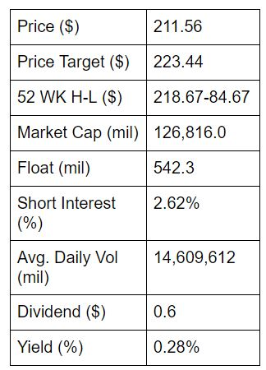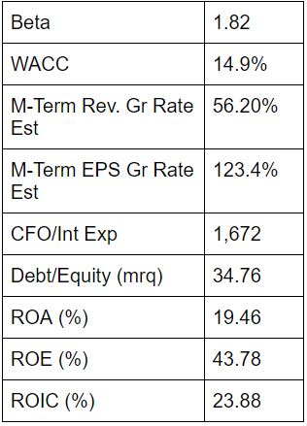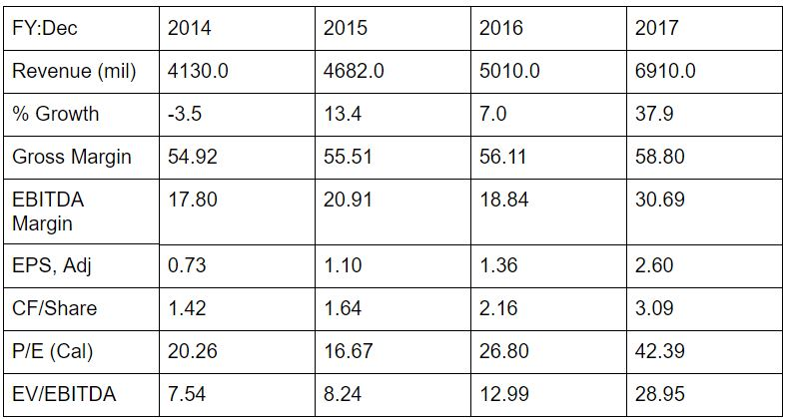

Recommendation
As a company that is the pioneer of GPU-accelerated computing, NVDA operates in two segment, GPU and Tegra Processor. The strategy of the company is to leverage the deep expertise and significant scale to serve markets where their specialty is greatly valued. The strategy helps the company have the great GeForce GPUs in games, Quadro for designers and digital artists, and Tesla and DGX for scientists and researchers. The products in NVDA are in high quality and the top products they have now have no competitors. Also, the company release the new products yearly and usually improves a lot to benefit customers. The success of the strategy shows in the financial results of the company, revenue was up 7% to reach record $5.01 billion and gross margins expanded by 60 basis points to a record 56.1%. The GPU business accounted for most of the growth, adding about $1.6 billion in the company’s revenue over the year and the data center growth of 145% to $830 million. The recommendations from financial analysts are strong buy. The company have an above average risk tolerance about 0.1672. Furthermore, the 1-year price change of the company is outstanding, the price changed from $67.57 to $211.56 and the company believes that there will still more place for company to grow. Also, the dividend of the company is quite benefit for investors. The dividend of NVDA is the second highest company in semiconductor sector. The 12 month yield of the dividend is 0.26% and the growth of 1-year dividend growth is 21.74%. The continued trend of the dividend yield could help investors earn more from the stock. Moreover, the EPS of the company in 2017 is $4.04 and the EPS growth is $107.71 which is higher than the semiconductor sector. The analyst in Bloomberg estimate that the EPS will continue growing in the future.

Investment Thesis
- International Market Penetration. The NVDA is a global company that sells its products all over the world. The company have a great potential growth in China and target to beat it in the future which is mentioned in its annual report. Also, the company outsources manufacturing to Taiwan Semiconductor Manufacturing Company Limited and Samsung Electronics Co. Ltd. The assembly, testing, and packing work is done by independent subcontractors that include Advanced Semiconductor Engineering Inc., BYD Auto Co. and so on.
- Compensation Plans. NVDA compensation components were adjusted in fiscal 2016 in order to improve NVDA’s long-term target and address their stockholder feedbacks. First, SY PSUs has a relative goal compared to SY PSUs in fiscal 2015; Second, NVDA separates their performance metrics; Last, NVDA increased average “at-risk”, performance-based compensation as a percentage of total target pay from 70% in fiscal 2015 to 75% in fiscal 2016 for their NEOs (other than their CEO). Under these compensation plans, both the Non-GAAP Operating Income Achievement and the CC Certified Revenue achievement in fiscal 2016 increased greatly. For achievement of Non-GAAP Operating Income between $724 million and $872 million, the number of SY PSUs eligible to vest would be equal to an amount linearly interpolated between the Threshold and Target Compensation Plan amounts. For achievement of Non-GAAP Operating Income between $872 million and $1,100 million, the number of SY PSUs eligible to vest would be equal to an amount linearly interpolated between the Target Compensation Plan and Stretch Operating Plan amounts. The relationship between achievement of revenue and compensation plans is also similar to the above.
- Room for Improvement. NVDA has room for improvement in the areas of revenue and EPS growth. Looking back into the past five years’ financial history of NVDA, the actual EPS grew from $1.17 to $3.06, which is about 162% increase. More importantly, the estimated EPS is always lower than the actual EPS. NVIDIA’s EPS has potential to grow in the future based on research. The actual revenue of NVDA grew from $4,280 million to $6,910 million from fiscal 2013 to fiscal 2017, which is above 61% increase in the past 5 years. The revenue has opportunity to grow as estimated.

Valuation
A five year DCF model was created to reach the intrinsic value for NVDA. Terminal growth rate is 5.0%, and the WACC is 7.7%; the intrinsic value of NVDA is $60,184.61 million. The EV/EBITDA multiple valuation was conducted using current 2017 EBITDA of $2,805 million and EV of $122,506million, and the result EV/EBITDA is 43.67.

Risks
- Interest Rates Risk. As of January 31, 2016, NVDA performed a sensitivity analysis on their floating and fixed rate financial investments. Based on their research, parallel shifts in the yield curve of both plus or minus 0.5% would result in changes in fair values for these investments of $28 million. Investments in both fixed and floating rate interest earning instruments carry a degree of interest rate risk. Fixed rate debt securities may have their market value adversely impacted due to a rise in interest rates, but floating rate securities may decrease in income than expected if interest rates fall. These factors lead to NVDA future investment income falling short of expectations. However, the debt securities held by NVDA are classified as “available-for-sale”, so no gains or losses are realized in their Consolidated Statements of Income when interest rates change unless such securities are sold prior to maturity or unless declines in market values are determined to be other-than-temporary.
- Exchange Rate Risk. The direct exposure to foreign exchange rate fluctuation is not material. Gains or Losses from foreign currency remeasurement are included in “Other income, net” in NVDA Consolidated Income Statement and have not been significant till now. The impact of foreign currency transaction gain (loss) included in determining net income was not significant for both fiscal year 2016 and 2015, and was a gain of $5 million for fiscal year 2014. Though NVDA had no forward exchange contracts outstanding as of January 31, 2016, they suggested in their fiscal 2016 annual report that they may enter certain transactions to reduce the future potential impact resulting from changes in foreign exchange market.

Management
Jensen Hsun Huang is the CEO and the president of the NVDA. Prior to establishing the company in 1993. There are 11 independent directors, as defined by the rules and regulations of NASDAQ, and one NVDA officer. He had the experience as a director of sales responsible for Sun Microsystems at LSI Logic and a microprocessor designer at Advanced Micro Devices. Colette Kress is the CFO of the NVDA, who recently joined the company in 2013 and has a 24-year veteran of the tech industry, as executive vice president and chief financial officer at Cisco’s Business Technology and Operations Finance organization and have a 13-year experience at Microsoft.

