Logan Clemment & Garret Clemment Real Estate, Telecommunications, Utilities

Introduction
T-Mobile US is one of the largest providers of wireless voice and data communications services in the United States. They are one of four national wireless carriers in the U.S.; the others being AT&T, Verizon and Sprint. The company’s 61 million T-Mobile and MetroPCS contract and prepaid consumer customers use its networks domestically and are able to connect to the compatible network of Deutsche Telekom when in Europe. It also offers low-cost, no-contract mobile services through the GoSMart brand. In addition, T-Mobile sells phones, tablets, PDAs, and accessories from such vendors as Apple, Nokia, and Samsung. It currently has about 8,000 T-Mobile and MetroPCS branded retail sites. T-Mobile has crafted an “Un-carrier” strategy to compete with the larger players, AT&T and Verizon. This strategy offers a line of simple choice plans that eliminate annual contracts, as well as caps and overage charges. They have also heavily invested to improve their network modernization to support its nationwide 4G LTE technology. T-Mobile is headquartered in Bellevue, Washington where they are lead by their CEO John Legere.

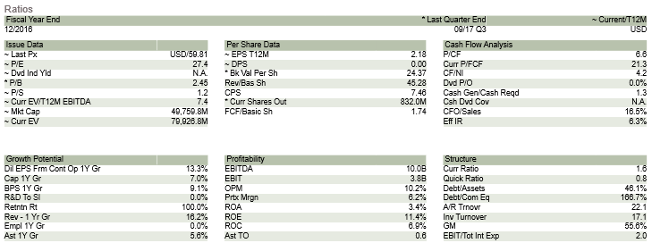
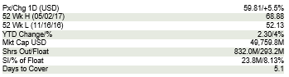
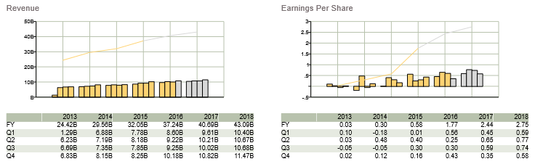
Recommendation
T-Mobile’s stock has seen a pretty good spread in the last year hitting a high of just over $68 per share and a low of around $53 per share. Throughout the summer there was preliminary talk of a merger between T-Mobile and Sprint which drove the stock price up during the middle of the year. However, towards the end of October the merger fell through which caused a pretty steep fall in the stock price. However, T-Mobile has already began to make a recovery here in the beginning of November and this is contributed to the implementation of the stock buyback program. This program doesn’t seem to be factored into their current stock price and allows for a considerable amount of potential growth. Over the next 5 years T-Mobile has the ability to buy-back up to 77% of its current shares of stock. This will cause a continued climb of the T-Mobile stock price in the future. Another important thing to consider is regarding the ownership of shares. Although insiders only own about .42% of the share available, Deutsche Telekom is actually the primary owner of T-Mobile and is heavily invested owning 64.34% of shares. This leads one to believe that ownership does have investors in mind when making management decisions. Analysts are also predicting that the economy is soon to hit the late stages of the economic cycle which only helps the telecommunications sector because historically telecommunications outperforms other sectors during the late stages of the business cycle.

Investment Thesis
- Macro Economic Indicators - The telecommunications sector has previously performed really well in recessionary times. The reason for this is because many people are unlikely going to cancel their cell phone and other wireless service plans in a time where the economy is doing poorly. In today’s day and age, many people heavily rely on their cell phone and wireless networks for much of their daily functions. With this being said, this industry has turned into more of a necessity, where as in the past a cell phone was seen as a luxury good. Many analysts are predicting that we are entering into the late stage of the economic cycle. This means that the economy has reached its peak and should start to taper off from a growth standpoint. This information is really good for the telecommunications sector because this is when many companies in this sector start to outperform other sectors.

- Buyback Program - T-Mobile is in the process of starting a share buyback program where they could end up buying back 77% of their shares over the next five years (2018-2022). T-Mobile is currently trading at 7.2x EV/EBITDA which is at the higher end in comparison to some of its peers (Sprint 7.2x, Verizon 6.7x, and AT&T 6.2x). However when it is compared to other companies in the US telecom, cable, and satellite sector that are also pursuing share buyback programs, it represents a material discount. Charter, Cogent, and Sirus XM could buy-back 32%-58% of their current market caps over the next five years, but they trade at a premium (8.9x to 14.0x EV/EBITDA) in comparison to T-Mobile.
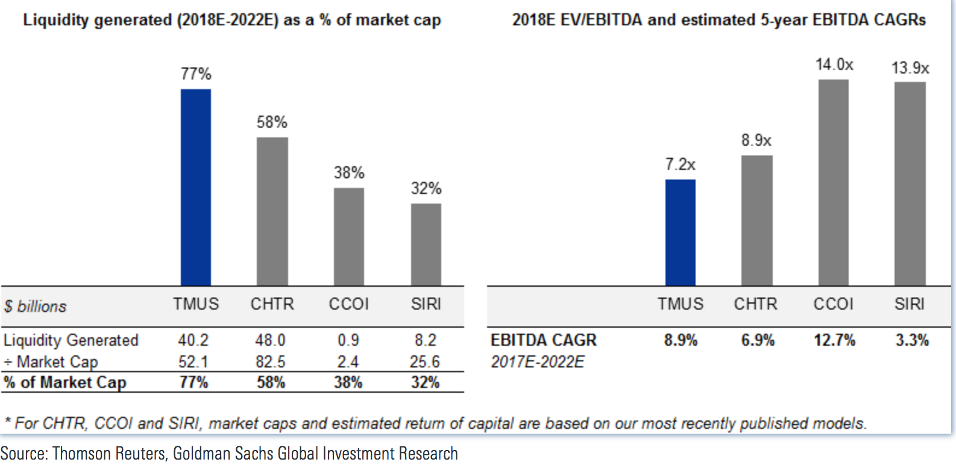

- “Un-Carrier” strategy - T-Mobile started the “Un-Carrier” strategy in 2013 and this program has helped T-Mobile grow to be the third largest wireless plan provider in the United States (behind Verizon and AT&T). With this strategy they have gotten eliminated annual contracts, reintroduced unlimited data plans, and started to include all taxes and fees in the advertised price. This strategy has worked for the last 5 years and many analysts are predicting that it will continue on this trend. This last quarter T-Mobile had 1.3 million net additions which makes this the 18th straight quarter of adding more than 1 million customers. In total they have 70.7 million customers and they continue to take customers away from Verizon and AT&T! Another part of this strategy is to have the fastest and most reliable network. They have continued to expand and upgrade their network that now covers 316 million people with 4G LTE and they want to cover at least 321 million people by year end 2017. Not only do they have the largest network they also have the fastest download speeds in the industry beating Verizon, AT&T, and Sprint. Most recently, on September 12, T-Mobile launched it’s latest “Un-Carrier” initiative, Netflix on Us, which provides all qualifying T-Mobile ONE family plans a free standard subscription of Netflix. They also have

Valuation
We have created a 5 year DCF model for T-Mobile. The present value of the cash flows for the next 5 years were as follows; $2470, $2958, $3375, $3398, and $3424 based on analysts projections. Next a terminal value was created using a terminal growth rate of 2.3% and a WACC of 7.3%. The present value of the terminal value then becomes $57,108. After adding this terminal value to the 5 projected cash flows we end with a total of $72,736. If you divide this number by the 831 million shares that T-Mobile has outstanding you get a value per share of $87.50 per share. The current price per share is $56.80 so you can see that the stock is currently 30.7% undervalued.
Risks
- Competition: The race for 5G capability is ever present and larger companies have an R&D advantage. Ex. Verizon and AT&T
- Unfavorable Merger Outcome: Sprint merger is not looking favorable at this point and this could already be factored into the undervaluation of the stock.
- High Debt Load: With future plans of repurchasing up to 77% of its own shares of stock, T-Mobile is going to need to carry a pretty high debt load in order to purchase.
Management
John Legere has served as the President and Chief Executive Officer for T-Mobile since April 30, 2013. Mr. Legere has over 34 years of experience in the United States as well as global telecommunications and technology industries. Prior to joining T-Mobile he served as the Chief Executive Officer of Global Crossing Unlimited, a telecommunications company, for 10 years. He has also held numerous positions within Dell Computer Corporation and AT&T. J. Braxton Carter is the current Chief Financial Officer within T-Mobile. He served as the CFO of Metro PCS starting in March 2005 and has since transitioned to T-Mobile’s CFO after they were combined.
Stock Chart of Past Year Performance

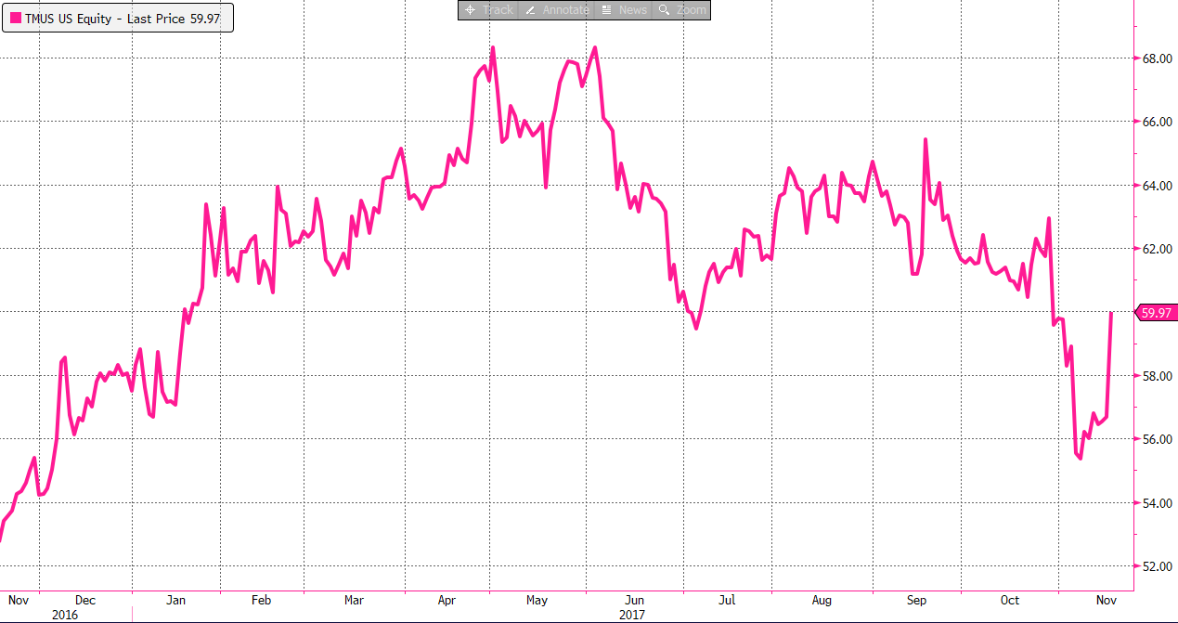
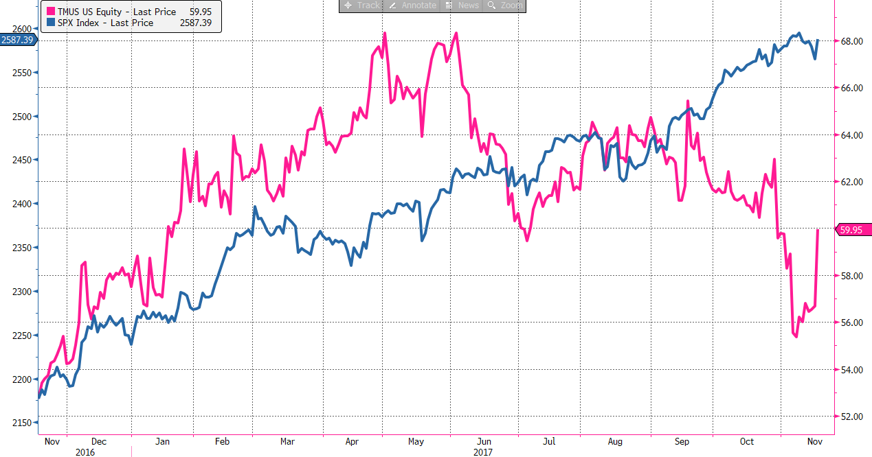

Peer Analysis
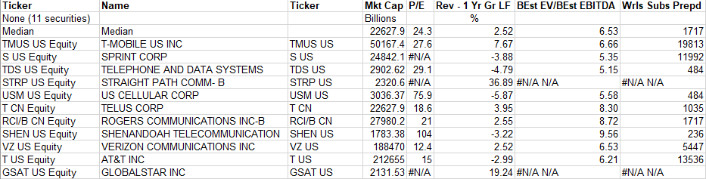

Ownership of Shares
Insider vs Institutional/Mutual Funds

Top Shareholders
