CISCO Systems Inc. (CSCO)
December 10, 2017

Jieni Zhang Information Technology - Communication Equipment
Hanzhi Liu

Introduction
Cisco Systems Inc. has been a hardware company, and it designs, manufactures, and sells Internet Protocol (IP) - based networking and other products related to the communications and information technology (IT) industry and provide services associated with these products and their use. CSCO makes the network gear - routers, switches, servers, and software. The company has been dominated in the market for internet protocol-based networking equipment, and it makes security devices, internet conferencing systems, set-top boxes, and other networking equipment for business and government agencies. Also, the company has an increasing focus on software that controls networks. For all the products, the meat-and-potatoes of CSCO has been its switching equipment, which generates 30% of its revenue. In 2016, about a quarter of CSCO’s revenue comes from its services business. While CSCO’s largest market is America, which accounts for about 60% of its sales, half of its employees resides outside of the U.S. Europe market generates 25% of revenue and Asia/Pacific market generates about 15%.
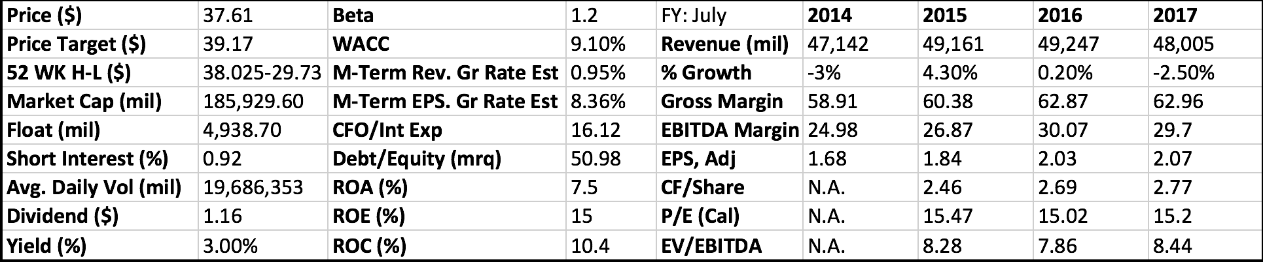

Recommendation
In 2016, CSCO’s revenue barely budged at about $50 billion from 2015. A 5% decrease in next generation networking products was blamed on the spending by service providers. However, net income of the company rose 19% to about $11 billion in 2016 from $9 billion in 2015 because of lower costs in 2016. CSCO now is defined as a hardware company but it is trying to build up its software offerings for cloud computing and software-defined networks (SDN). CSCO is shifting its business to a more subscripted and software-base model. CSCO also cooperates with Ericsson in telecom equipment. The company intends to develop products and services in the areas of 5G, cloud computing, internet protocol, and the Internet of Things. Its goal is to add $1 billion in revenue for each company by 2018. This deal helps both CSCO and Ericsson counter the merger of Alcatel-Lucent and Nokia, which created the second biggest provider of telecom equipment. Also, there are several acquisitions from buying new companies and technologies, with these benefits, the price of the stock increased a lot in 2016. Although in the first quarters of 2017, the company lose about $1.1 billion in revenue year-to-year, the acquisition of the company in the following years will be positive. The company have 5 main competitions in the networking and communications equipment markets, providing products and services, the competitors include Amazon Web Services, F5 Networks, Extreme Networks and other networking companies. CSCO is continuing expanding globally, especially in China, the expansion may help company catch more revenue. There are about 19 buy and 11 hold recommendations from the Bloomberg Analysts which may be a good choice for investors. Thus, from the low price of stock, high quality of service, acquisitions, global expansion and expansion in software service, we believe that CSCO is a strong buy stock.

Investment Thesis
- Global Presence CSCO products are sold in three different parts of world, Americas, APJC and EMEA. The company manufactures its products mainly in the United States. The America’s make up approximately 60% of the revenues, Europe the Middle East and Africa account for another 25%, and the fastest growing market, Asia Pacific, is 16% of revenues.
- Diversified Products CSCO is diversifying beyond its core switch and router business and into higher-growth new segments like wireless, collaboration, and security. CSCO’s newer products segments’ sales rose 1% in fiscal 2017 when compared to the data in fiscal 2016. CSCO has historically focused on hardware, long-term growth hinges on its ability to expand software sales, thus achieving a greater balance between hardware and software revenue.
- Acquisitions CSCO has been continuing to make acquisitions, it completed the acquisitions of Jasper, which develops a cloud-based Internet of Things (IOT) service platform. The company finally got $1.4 billion with the deal and then CSCO could provide more comprehensive range of LOT products and services. There was also an acquisition happened in 2016 that the company bought Acani Limited for $700 million on board a provider of collaboration infrastructure and conferencing software. This move helped to enhance Cisco’s collaboration strategy.
- Research and Development CSCO research and development expenditures were $6.1 billion, $6.3 billion, and $6.2 billion in fiscal 2017, 2016, and 2015, respectively. These expenditures are applied generally to all product area. The industry in where CSCO competes is subject to rapid technological developments, evolving standards, changes in customer requirements and new product introductions and enhancements. CSCO regularly introduce new products and features to address the requirements of their markets. CSCO allocates their research and development budget among their product categories.

Valuation
To determine an intrinsic value for CSCO, we use two parts of valuations. The five-year DCF model was created for CSCO. A WACC of 9.1% and a terminal growth rate of 2.3, which is found on Bloomberg Terminal, were used to arrive at a target price of $39.17. The EV/EBITDA multiple valuation was conducted using current 2017 EBITDA of $14.72 billion and EV of $149.408 billion, and the result EV/EBITDA is 10.15.
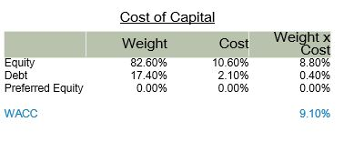

Risks
- Return on Investment CSCO expects to realign and dedicate resources into key priority and growth areas, for example, security, collaboration, and wireless. It also maintains leadership in routing, switching, and services. However, the return on investment may be lower or develop slowly in the following years.
- Economic Risk CSCO operating results may be adversely affected by unfavorable economic and market conditions and the uncertainty of geopolitical environment.

Management
CSCO is an American multinational technology conglomerate headquartered in San Jose, California, in the center of Silicon Valley. It is one of the largest networking companies in the world. The company’s stock was added to the Dow Jones Industrial Average on June 8, 2009, and it is also included in the S&P 500 Index, the Russell 1000 Index, NASDAQ-100 Index and the Russell 1000 Growth Stock Index. CSCO was founded in December 1984 by Leonard Bosack and Sandy Lerner. John T Chambers is now the chairman of CSCO. He joined the company on July 25, 2016. He is also the strategic advisor in Sprinklr company and the Co-founder of the Technet company. He had worked in other 5 information technology companies. Chuck H. Robbins is the CEO of the company and he joined the company on July 26, 2015.

1-Year Price

