Introduction:

Duke Energy (NYSE: DUK, current price: $88.05), headquartered in Charlotte, North Carolina, is an electric power holding company in the United States. It was founded in 1904 by Dr. W. Gill Wylie, James Buchanan Duke and William States Lee. Duke Energy, one of the largest energy holding companies in the United States, supplies and delivers electric services to approximately 7.5 million customers in the Southeast and Midwest. The company also distributes natural gas services to approximately 1.6 million customers in the Carolinas, Ohio, Kentucky and Tennessee. Its commercial business operates a growing renewable energy portfolio across the United States. The company once had international operations, but sold them in 2016. Now they are focusing on generating cleaner energy and building natural gas infrastructure. One way they have eliminated carbon footprints is that they have retired 40 older coal units which helped reduce carbon dioxide emissions by 29% since 2005.

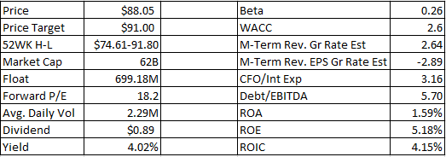

Recommendation:

We recommend a buy rating for this stock due to its innovations in microgrid technology, strong business model, and its ability to position itself to consistently pay dividends and offer a modest increase year after year as they seek to ensure future growth. Microgrids are energy storage systems that operates with solar and batteries that can independently operate without the main power grid. As climate change is becoming more severe, increasing warmer atmospheric and ocean temperature amplifies weather disasters, heightening our need for the microgrid energy storage technology that can fill in the gap and keep power running during crises and outages. In the sector analysis that we conducted in our previous presentation, we forecasted the microgrid market to be a big player in the energy sector in the near future. Microgrid is a new technology that is new and only grasped by a few big companies in the market. Nevertheless, Duke Energy’s microgrid competitors were not only losing out on stock growth, but less focused on clean energy compared to Duke Energy, thus giving Duke Energy a comparative advantage over the other microgrid competitors.

Duke Energy’s vision on microgrid technology can be the innovation that will separate itself from the other competition in the overall energy sector. Duke Energy has formed a coalition with other companies including Schneider Electric. Together, Duke Energy Renewables and REC Solar announce the completion of their first joint microgrid project. Integrating the microgrid has enabled them to reduce its energy costs, incorporate more sustainable energy and delivering demand-side efficiency, while also offering resiliency in the event of a loss of power from the grid. Duke Energy is just scratching the surface of this new technological advancement, and because of this we believe that there is more growth to be seen in the coming future for the company. Duke Energy’s business model is very sound. It provides a variety of energy-related services to segments in the energy sector. Their interest in generating cleaner energy by means of allocating an important budget ($42B) toward grid modernization and transitioning to a cleaner generation outlook tells us that they passionate and determined considering the major investments they are taking on in the upcoming years. One thing that caught our attention about Duke, is that their dividend growth has grown steadily over the past 10 years. This is an important metric because it shows management’s trust in the company’s future. A dividend payment cannot be increased if the company is unable to increase its earnings.

Investment Thesis:

In October 2016, Duke Energy completed the acquisition of Piedmont for a total cash purchase price of $5.0 billion and assumed Piedmont's existing long-term debt, which had an estimated fair value of approximately $2.0 billion at the time of the acquisition. The acquisition provides a foundation for Duke Energy to establish a broader, long-term strategic natural gas infrastructure platform to supplement and complement its existing natural gas pipeline investments and regulated natural gas business in the Midwest. The acquisition of Piedmont brought in an additional one million customers to Duke Energy.

An investment in a utility stock is usually made on the classic thought of buying a sustainable source of income. This is exactly what is happening with Duke Energy. The company shows a strong business model and a focus on stable revenue sources. Investors can expect their dividend growth to be like clockwork. Best of all, investor’s yearly paycheck increase will beat inflation year after year. While the Energy Sector as a whole has been seen to be volatile and unpredictable as of late, Duke Energy is a perfect tool to hedge that risk as it leans more on the conservative side of investments thanks to its beta of nearly 0.

Valuation:

Duke seems comfortable achieving its targeted 4%–6% earnings growth over the next several years. This is in part due to the acquisition of Piedmont Natural Gas. Its healthy product portfolio of electric, gas, renewables, and midstream puts it in what appears to be a strong position for balanced growth in the future. The recent sale of Duke’s volatile merchant power business in Latin America provides Duke with a stable long-term earnings growth. DUK is covered by 13 analysts who by majority are expecting positive earnings, estimated to rise from current EPS levels of $3.989 to $5.171 in a few years. This paints a relatively optimistic outlook in the near future, with a relatively solid earnings per share growth rate of 29.64% over the next few years. In the same period we should see the revenue increase from $23,071M to $24,769M and net income is predicted to climb from $2,778M to $3,601M in the next couple of years, growing by 29.64%. Moreover, future margins are predicted to be a respectable 14.72%.
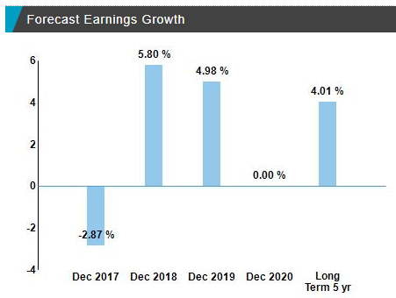
Risks:
Duke Energy doesn’t come without risk. There is stiff competition when engaging in the production and distribution of natural gas, electricity, and renewable resources. Since Duke Energy is one of the largest, better positioned companies in this industry, we believe Duke is able to differentiate themselves and beat out their competitors. One way they can differentiate themselves is through the use and utilization of their innovative microgrids. Duke also experienced a decline in their 3Q 2017 earnings through Electric Utilities and Infrastructure segment when compared to 3Q 2016. The main driver for this cause was due to unfavorable weather conditions such as hurricane Irma. These events, such as hurricane Irma, that hurt Duke Energy’s revenues and earnings can be avoided through the use of microgrids. This will allow Duke Energy to be less susceptible to risks relating to bad weather and power outages.

Management:
CEO: Lynn Good
- Lynn Good is chairman, president and chief executive officer of Duke Energy, one of America's largest energy holding companies. She became CEO in 2013 after being CFO starting in the year 2009. Under her leadership, Duke Energy has intensified its focus on serving its customers and communities well today while leading the way to a cleaner, smarter energy future.
CFO: Steven Young
- Became CFO in 2013. He has been with the company since 1980 and has climbed the ranks to where he is now today.
COO: Dhiaa Jamil
- Became COO in 2013. Jamil has 34 years of experience in the energy industry. He has been with Duke since 1981.
CHRO: Melissa Anderson
- Became CHRO (Chief Human Resource Officer) in 2015. Prior to her current role, she served as vice president of human resources of global financing at IBM Corp for 17 years.

Stock Chart of Past Year Performance:
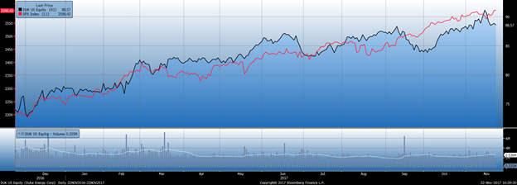
Ownership of Shares
Insider vs Institutional/Mutual Funds
- Insider 0.2%
- Institutional & Mutual Funds 75.2%
- Other 40.6%
Top 5 Shareholders:
- Vanguard Group Inc. 7.27%
- Black Rock Institutional Trust Company 4.89%
- State Street Global Advisors (US) 4.76%
- MFS Investment Management 2.01%
- Franklin Resources/Advisers, Inc 1.40%

