Taylor Larson Estee Lauder Companies (EL) Kaylin Jensen
December 10, 2017
Consumer Staples
Introduction
Estee Lauder Companies (NYSE: EL) is a United States based company in the Consumer Staples industry. The company specializes in producing makeup, skin care, hair care, and fragrance products. They operate globally selling these products through a variety of mediums ranging from brick and mortar retail stores to places like Amazon. Although some products are offered under the name Estee Lauder, the company also sells products under multiple other lines including Smashbox and Clinique. The company was originally founded by Estee and Joseph Lauder in New York in 1946. Although Estee has since passed away, the company still carries her name and the values she instilled to empower women around the world.
Price ($) | 123.75 |  | Beta | 0.753 |  | FY: Dec | 2015A | 2016A | 2017A | 2018E
Price Target ($) | 148.41 |  | WACC | 7.0% |  | Revenue (mil) | 10,780 | 11,263 | 11,826 | 13,124
52 WK H-L | 126.99-75.83 |  | Debt/Equity | 81.14 |  | Gross Margin | 80.5% | 80.6% | 79.5% | 79.0%
Market Cap (mil) | 46,078 |  | Current Ratio | 1.76 |  | EBITDA Margin | 19.0% | 18.9% | 19.8% | 20.6%
Shares Out. (mil) | 224.8 |  | ROA | 12.8% |  | EPS | 3.05 | 3.2 | 3.47 | 4.18
Dividend ($) | 1.36 |  | ROE | 33.0% |  | P/E | 30.25 | 28.81 | 25.89 | 29.94
Yield (%) | 1.21% |  | ROIC | 19.9% |  | EV/EBITDA | 16.18 | 16.96 | 17.24 | 17.85
Recommendation
With an intrinsic target price of $148.41 and an upside potential of 19%, we recommend a buy rating for Estee Lauder. Over the past several years Estee Lauder has demonstrated steady growth in revenue and net profit, and we expect this to continue in the future. This growth has been driven by the expansion of Estee Lauder on a global scale as well as the expansion of their product lines. The cosmetic industry has seen a bump in recent years as online makeup tutorials are encouraging new exploration and beauty products are being used by a wider range of people. We also believe Estee Lauder’s global operations will help them grow as a company. Given that they operate globally, they are not just dependent on one economy to see growth but have diversified throughout many regions of the world. Estee Lauder has also made acquisitions to grow the company recently. Beginning in 2014 the company started acquiring smaller cosmetic lines that were receiving a lot of attention in the market especially from makeup tutorials. We think many of these recent acquisitions have not hit their peak growth yet, and Estee Lauder will be able to benefit from the continued growth of these lines in the coming years. The acquisitions of these smaller makeup brands have allowed Estee Lauder to diversify their product line. They no longer just sell pricey makeup that appeals to an older, wealthier population. They have expanded into more hip lines such as Smash Box that will draw in a new generation of buyers who see makeup as more of an art. We think this younger population will drive revenue up for Estee Lauder as they buy more cosmetics than previously to stay up to date with the latest trends. Given Estee Lauder’s innovative approach to the makeup industry and their corporate responsibility of not testing on animals, we think their products will remain popular among both older and younger generations.

Investment Thesis
- Global Presence. Estee Lauder products are sold in more than 150 different countries and territories. The company manufactures its products mainly in the United States, Belgium, Switzerland, United Kingdom, and Canada. The America’s make up approximately 40% of the revenues, Europe the Middle East and Africa account for another 40%, and the fastest growing market, Asia Pacific, is 20% of revenues.
- Acquisitions and Licenses. Estee Lauder has acquired 26 different companies in the past 20 years. Not only has this aided in the company’s global presence, but it expanded the company’s market share and consumer base. Last year EL acquired Too Faced, a cosmetic brand to target millennials and adapt to the shift of cosmetic art. We predict Estee Lauder will continue to acquire companies that complement its current brands and products.
- Diversified Brands. Estee Lauder currently operates under 29 different brand names producing cosmetics, fragrances, skin care products, and hair care products. EL manufactures and distributes fragrances and cosmetics under large names like Tommy Hilfiger and Michael Kors through acquired licenses. These diversified brands represent Estee Lauder’s prestige image and they target loyal high-end users. Estee Lauder also markets through spokesmodels like Kendall Jenner and Gwyneth Paltrow.
- Research and Development. Estee Lauder continues to spend more each year on product innovation, product-line extensions, new packaging concepts, improving, and redesigning existing products. Consistent global standards and quality assurance lead to global success and brand recognition for high quality beauty products.
Valuation
In order to arrive at an intrinsic value for Estee Lauder’ stock price, a five-year DCF model was constructed. A WACC of 7% and a revenue growth rate of 6%, which lead to an EBITDA multiple of 18x, were used to arrive at a target price of $148.41. A ±.5% sensitivity analysis on the terminal growth rate and a ±.5% WACC resulted in a target prices falling between $141.89 and $154.65. A DCF for perpetual growth was also completed using a growth rate of 3.2% which lead to a target price of $142.38.
Risks
- Foreign Currency Movements. As Estee Lauder continues to expand globally, foreign exchange rate risk rises. Product prices, costs of operations, and asset values are all affected by the strengthening or weakening of a country’s currency. Estee Lauder diversifies away some of this risk by using 19 different suppliers across the globe to satisfy their manufacturing plants and 43 major customers in varying regions.
- Lauder Family Control. The Lauder family owns about 30% of the total common stock and about 87% of the voting power. There are five members of the Lauder family that hold both executive and board positions. However, the board member majority is held by independent members. The Lauder family is very committed to the success of the company because they are so highly invested.
- Brick and Mortar. Many department stores have been struggling to compete with online retailing and diverse companies like Wal-Mart and Target. These types of companies make up 25.21% of EL’s current revenue with Macy’s Inc. being the leading overall customer. However, EL is taking precautions against this threat by focusing on e-commerce, specialty retailers, and travel retail chains. EL, Amazon, and other online retailers currently sell the company’s products. Ulta Beauty and Sephora also specialize in cosmetic, fragrance, and beauty products by Estee Lauder Companies. Because EL is a globally recognized brand, travel retail in airports is also a growing area for new revenue streams.
Management
William Lauder has been the Executive Chairman for Estee Lauder since July 2009. In addition to being the Executive Chairman of Estee Lauder, Lauder is also a descendent of Estee Lauder’s founder. Prior to assuming his role as Executive Chairman, Lauder filled several other Executive director positions in the company beginning in 1996. Fabrizio Freda assumed his role as President and CEO of Estee Lauder in July 2009. Before joining Estee Lauder in 2007, Freda completed around two decades of service in executive positions at Procter & Gamble.
Stock Chart of Past Year Performance
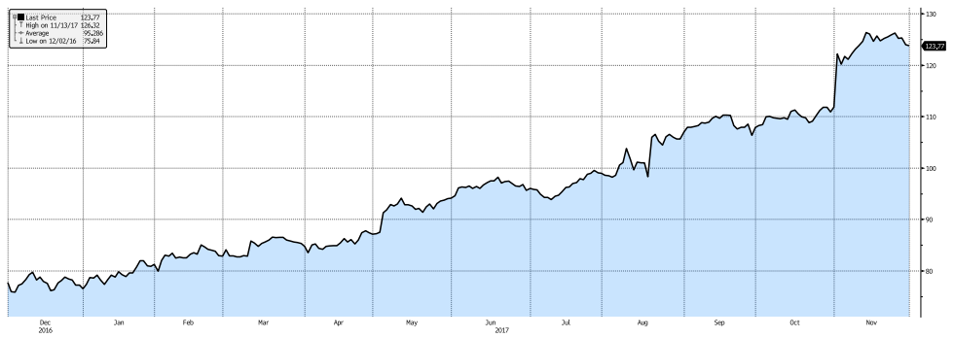
Company | Ticker | Market Cap (Bil) | Last Price | EBITDA Margin T12M | EPS | Current P/E
L’Oréal | OR.PA | 103.87 | 188.5 | 22.95 | 6.47 | 28.53
Estee Lauder | EL | 45.57 | 123.75 | 19.85 | 3.71 | 32.16
Coty | COTY | 13.2 | 17.56 | 13.76 | 0.37 | 61.76
Revlon | REV | 1.2 | 22.35 | 17.71 | 1.67 | 17.49
Avon | AVP | 0.915 | 2.08 | 10.61 | 0.07 | -
Peer Analysis
Estee Lauder has many competitors across the globe in the beauty industry. However, competitors such as Proctor & Gamble are diversified into a wide variety of product industries, so we chose some competitors that had a similar overall product base. Although the size of the competitors being compared does vary, we choose L’Oréal, Coty, Revlon, and Avon to compare to Estee Lauder. Although it is hard to compare drastically different market cap stock’s net income, we did choose to use this as a comparison because of what it shows. When looking at the net income for the four companies being compared to Estee Lauder, Coty, Avon, and Revlon all showed a net loss in at least one of the past five years.
Ownership of Shares
Institutional and mutual funds currently hold 98.52% of Estee Lauder shares while insiders, not including the members of the Lauder family, hold 1.09% of shares. The ownership matrix for this company is unique because EL is considered a controlling company according to the SEC. There are four members of the Lauder family employed at EL and on the Board of Directors.
Top 5 Shareholders
- Lal Family Corp – 24.27%
- Fidelity – 8.027%
- Vanguard Group – 6.921%
- State Street Corp – 4.029%
- BlackRock Institutional Trust – 2.926%

