Mohawk Industries, Inc. (MHK)
Stock Price - $272.20
Consumer Discretionary A
Tony Cavil & Nichole Ullom
November 20, 2017
Introduction
Mohawk Industries, Inc. (NYSE: MHK) designs, manufactures, sources, distributes, and markets flooring for residential and commercial applications. The company offers carpet, ceramic tile, laminate, wood, stone, vinyl, and rugs. Mohawk markets residential and commercial flooring in the United States, and residential flooring in Europe. Mohawk works though three main business segments: Flooring North America (nearly 45% of total sales), Global Ceramic (35%), and Flooring Rest of World (almost 20%).
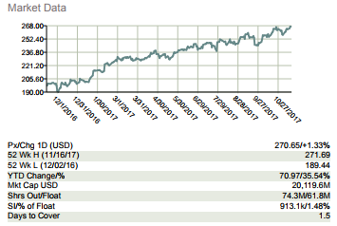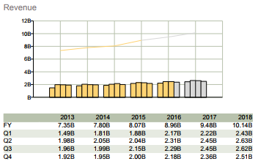
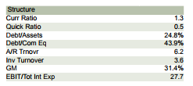
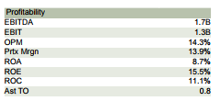

Recommendation
As the largest manufacturer and distributor of residential and commercial flooring, Mohawk Industries has dominated their respective market for the last 20 years. With a total market cap of $20.23 billion, they have been flourishing in the past 12 months, showing no signs of slowing down their growth and dominance. Mohawk has 24% of this industry, with the next closest company owning 5%, leaving more and more room to grow within. The market performance this year has grown Mohawk over 24% YTD, along with the housing market-increasing 10% and real estate growing 12%, two industries that greatly influence MHK. Net sales are already up 7% in 2017, with EBITDA up 21% since 2016 as well. Earnings per share has also seen a 7% increase while operating income has grown 16% since the beginning of the year. Two acquisitions this past year has aided growth, with management increasingly looking to expand internationally, providing a high ceiling for the next two years. These acquisitions are made possible by a strong cash flow, with a total of 32 acquisitions since the company started in 1992. MHK’s Profit Growth in 2017 (YTD) of 51.2% is ranked 12th among all S & P 500 companies, peaking a gradual growth since 2015. Revenues are forecasted to grow 10% next year alone, with earnings increasingly growing as a percentage of revenues, which has happened for two consecutive quarters. The GDP and flooring industry are growing, with low mortgages rate driving increased home sales. In international settings such as Europe and Russia, where MHK has manufacturing and business, both economies are projected increased growth in 2018. There is massive market growth potential which is still 22% below its peak in 2005, before the recession of 2008. Product innovation and new products are separating Mohawk from their already limited competition, which can be seen in ‘Peer analysis’. With a very diverse product offering, Mohawk has set themselves up to avoid huge losses in recessionary times. Top rated investment sites including Yahoo Finance, Marketwatch and Bloomberg, to name a few, rate MHK a strong Buy, with a real target price ranging from $290 to $300.
Investment Thesis
- Room for Improvement. Mohawk still has a market growth potential of approximately 22% from their previous high in 2005. An overall increase in houses being rebuilt in the United States and overall increase in housing prices will encourage more people to remodel homes to increase the values. This will have a positive effect on the remodel section and residential new section.
- Acquisitions. On April 4, 2017, the Company completed the acquisition of Emil for approximately $186.1 million from Italy which will enhance the Company’s cost position and strengthen its combined brand and distribution in Europe. These enhancements will increase product, sales, and manufacturing synergies. The Company also acquired three additional businesses during the second quarter of 2017 for approximately $63.9 million. As more acquisitions occur for Mohawk, they will continue to increase synergies throughout all three of their business lines (Flooring North America, Global Ceramic, and Flooring Rest of World).
- Diversification. Mohawk increased their diversification of products within the last decade. Mohawk’s increase diversification also increased to foreign markets. This enables the company to focus on different areas that are doing well and best serving their customers worldwide. The ceramics worldwide division is a great example.

Valuation
To determine an intrinsic value for Mohawk Industries, we used a Discounted Cash flow model, with 5 years of future cash flows which we obtained from Bloomberg. Using a WACC of 9.10%, which was also given in the Bloomberg model, we would find a price of $290.12. According to this model and many other target prices of analysts, we found that MHK is roughly 7% undervalued in the current market, with a range of $260 to $300 compared to the current price of $272.20. It should be noted again that MHK does not pay a dividend.
Risks
- Changing Markets. Mohawk falls into the consumer discretionary sector, which historically follows the market. Any downturn in the economy will affect Mohawk and their expected earnings for investors.
- Exceeding Estimates in Last Quarter. Exceeded quarter estimates for Mohawk may include an increased pressure from management as well as increased investor expectations.
- Increased Vertically Integrated. Mohawk’s vertically integrated manufacturing and distribution processes provide competitive advantages in the production of carpet, rugs, ceramic tile, laminate, wood, stone and vinyl flooring, while also provided increased risks in downturns within the economy.

Management
Jeffrey Lorberbaum serves as Chairman and CEO of Mohawk Industries. He was a board member of Mohawk from 1994-2004, when he was then appointed as Chairman and CEO. Prior to working at Mohawk, Lorberbaum work at Aladdin Mills which was his dad’s company. Aladdin was then acquired by Mohawk in 1994 and Aladdin Partners continues to hold the most stock in Mohawk.
Stock Chart of Past Year Performance
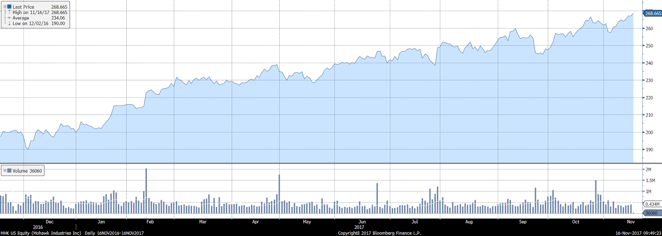

Peer Analysis
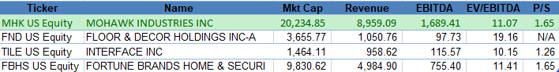
Ownership of Shares
% of Shares Held by All Insider Owners | 3.40%
% of Shares Held by Institutional & Mutual Fund Owners | 96.06%
Source: Bloomberg

Top 5 Shareholders
Holder | Shares | % Out
Aladdin Partners LP | 8,293,785 | 0 11.16
Vanguard Group | 6,256,230 | - 8.42
JPMorgan Chase & Co. | 4,655,846 | - 6.26
BlackRock | 4,569,101 | - 6.15
FMR LLC | 3,426,030 | - 4.61
Source: Bloomberg
Insider vs Institutional/Mutual Funds
The top five shareholders of Mohawk Industries include four mutual fund owners and one private company. The private company was owned Jeffrey Lorberbaum’s, the CEO of Mohawk, father before Mohawk acquired Aladdin Partners in 1995.

