The Walt Disney Company (DIS)
November 18, 2017
Chad Glover and Ryan Battist Consumer Discretionary

Introduction
The Walt Disney Company (NYSE: DIS) is a worldwide entertainment company headquartered in Burbank, CA. The company can be broken down into four business segments: Media Networks (43%), Parks and Resorts (33%), Studio Entertainment (15%), Consumer Products and Interactive (9%). Within these business segments Disney produces motion pictures, television programs, musical recordings, books, and magazines; and owns hotels, resorts, and cruise ships. Disney is the second biggest media company with a 19.2% market capitalization. These assets include but are not limited to: Disney movies, Disney Channel, ABC, ESPN, Pixar, Marvel Entertainment, Lucasfilm; as well as several worldwide Disney themed parks and resorts, most notably Walt Disney World and DisneyLand.

Price ($): | 102.64 | Beta: | 1.04 |  | 2016A | 2017A | 2018E | 2019E
Price Target ($): | 125.03 | WACC: | 8.3 | Revenue (mil) | 55,632 | 55,137 | 58,730 | 60,242
52 WK H-L ($): | 116.10-96.20 | M-Term Rev. Gr Rate Est: | 6.52 | % Growth | 6.00 | -0.90 | 6.50 | 2.60
Market Cap (mil): | 159,796.60 | M-Term EPS Gr Rate Est: | 10.1 | EBITDA | 16,682 | 16,655 | 18,080 | 18,437
Float (mil): | 1,543.50 | CFO/Int Exp: | 32.06 | EBITDA Margin | 30.0 | 30.2 | 30.8 | 30.6
Short Interest (%): | 3.99 | Debt/EBITDA (ttm): | 1.28 | EPS | 5.72 | 5.7 | 6.28 | 6.56
Avg. Daily Vol (mil): | 7.81 | ROA (%) | 9.56 | P/Cash Flow | 11.52 | 12.52 | 11.95 | 10.14
Dividend ($): | 1.56 | ROE (%) | 21.23 | P/E | 16.23 | 18.15 | 16.48 | 15.76
Yield (%): | 1.51 | ROIC (%) | 13.41 | EV/EBITDA | 10.06 | 11.22 | 10.28 | 10.08

Recommendation
After a 6% increase in revenue in 2016, Disney experienced almost a 1% decrease in revenues in 2017. This is mainly due to a poor third quarter that included struggles with ESPN, lower than expected box office performance, and Hurricane Irma. A large part of the problem comes from the shift in consumer trends of how they view content. Many Americans are leaving their cable providers for alternative options, and theatre ticket sales have decreased over the past 10 years by over 6%, even though the population continues to grow. However, Disney has been in the top two for box office market share since 2013. We believe that Disney is under valued due to these shifting trends. Disney will bounce back in 2018 due to their quality content, acquisitions, new business strategy, and international expansion. For starters, in 2018, Disney will be releasing 4 Marvel, 2 Star Wars, and 2 Pixar films. Because of the expected high box office revenue and movie success, Disney has the ability to negotiate higher box office retention rates from the theaters. The rate is typically around 52%; however Disney is negotiating higher rates. For example, Disney is asking for 65% on the new Star Wars movie. Secondly, in order to adjust to shifts in technology, Disney has been acquiring new companies and adjusting their business strategy. Due to acquisitions like BAMTech, a leader in direct-to-consumer streaming technology, marketing services, data analytics, and commerce management, Disney is clearly taking steps to become a leader in streaming services. BAMTech is known for the technology that streams the following: MLB, NHL, PGA, WWE, and HBO. BAMTech will also play an instrumental role in the release of ESPN’s new online service: ESPN+, which will help ESPN’s subscription problem. ESPN+ will be released in 2018. In addition to ESPN+, Disney is planning on releasing their own streaming service in 2019 that will have pricing significantly lower than Netflix. The new streaming services will help fight the technology struggles the industry has faced from companies like Netflix by creating new revenue streams. Lastly, there are substantial opportunities in international markets, specifically China. Working with China’s government is key for the internationally expansion because entering the market is not easy. However, Disney now has two theme parks in Asia and is known for producing movies that get into China. Note that China generally allows only around 30 movies from America to be release every year. With the high quality of content, acquisitions, international expansion opportunities, and new streaming services, we believe that Disney is a strong buy.

Investment Thesis
High Quality Content: Disney Movie Studio owns the rights to major franchises including Pixar, Marvel, Disney, and Lucasfilm. The media industry is driven by content; in 2016 Disney had 4 movies have over 1 billion dollars of box office revenue (almost five movies) and had over $7 billion dollars in total revenue (only studio to ever reach $7 billion). Disney has created 11 major franchises within consumer product, each with over 1 billion in global retail sales. The high quality of content gives Disney the ability to negotiate better deals. As stated above, Disney is asking for a retention rate of about 65% compared to the average of about 52%.
Expanding hotels and resorts: The Company opened a Disneyland in Shanghai in 2016. Disney has also added a new theme park in Walt Disney World with the recent expansion: Pandora – The World of Avatar. In 2019, Disney is opening two Star Wars theme parks in Florida and California. Disney is building two additional cruise ships, which will be ready for use in 2021 and 2023. Why is Disney expanding hotels and resorts? In the 4th quarter of 2017, hotels and resorts was Disney’s most successful business segment with a 6% and 7% year over year increase in revenue and operating income and all of this is with the negative impact of hurricanes. Disney is expecting to increase its capital expenditures by approximately $1 billion in 2018 as per CFO Christine McCarthy; capital expenditures will primarily be used in hotels and resorts.
Acquisitions: Currently, Disney is in the discussion of acquiring a large majority of 21st Century Fox. Although Disney is in the early stages of this discussion, this is something to pay attention to. Over the past 10 years Disney has been aggressively acquiring companies mainly for two reasons. The first is to increase online service abilities and the second is to obtain the rights to new content. In 2017, Disney increased its interest in BAMTech by 42% for a total of 75% (total of 2.59 bil). Reference recommendation section for importance. In 2016, Disney acquired an 11% interest in Vice ($400M) for a total of 20% interest, which is a media company that specifically targets the millennial audience. In 2014, Disney acquired Maker Studios, a leading network in online video content (approximately $500 mil). Disney also has the rights to Pixar ($7.4 bil in 2006), Marvel ($4 bil in 2009), and Lucasfilm ($4.05 bil in 2012).

Valuation
To reach an intrinsic value for DIS, two separate valuations were used. The first being a five year DCF model. Using a terminal growth of 2.3% and a WACC of 8.3%, an intrinsic value of $128.24. A +/- .25% sensitivity analysis on the terminal growth rate and +/- .5% WACC and the intrinsic value ranged from $120.09-$149.24. Additionally an EV/EBITDA multiple valuation was conducted using 2017 EBITDA of 16,655 mil and peer comparable multiple of 10.5x, resulting in a valuation of 121.81. Weighting the two valuation models 50/50, a price target of $125.03 was reached, resulting in a 21.81% upside.

Risks
Entertainment Competition: The entertainment business is highly competitive with 10 major media companies controlling over 80% of market capitalization. With the evolution of technology within media, companies have seen a sizable portion of their revenues taken by companies like Netflix. The wide variety of options that consumers have today makes it difficult to increase revenue. Also, domestic movie theatre attendance has decreased over the past 10 years from $1.4 billion in ticket sales in 2006, to $1.3 billion in ticket sales in 2016, even though the U.S. population has increased.
Consumers taste and preferences: Disney’s ability to retain the rights to their intellectual property is vital to their success. If Disney losses the rights to content, revenues will be directly impacted. Disney’s ability to produce high quality content is directly related to their success. If consumers stop consuming Disney product, the revenue and share price will be negatively impacted.
Changes in technology and consumption patterns: Disney’s ability to adjust to changing consumer trends is vital to their success. If their newly planned streaming services don’t meet expectations, the share price will be negatively impacted.

Management
Robert A. Iger (65) serves as the Chairman and Chieft Executive Officer for DIS. Mr. Iger has been on the executive board since 2000. Christine M. McCarthy (61) serves as the Senior Executive Vice President and Chief Financial Officer. Mrs. McCarthy has served on the executive board since 2005.

Stock Price Graph
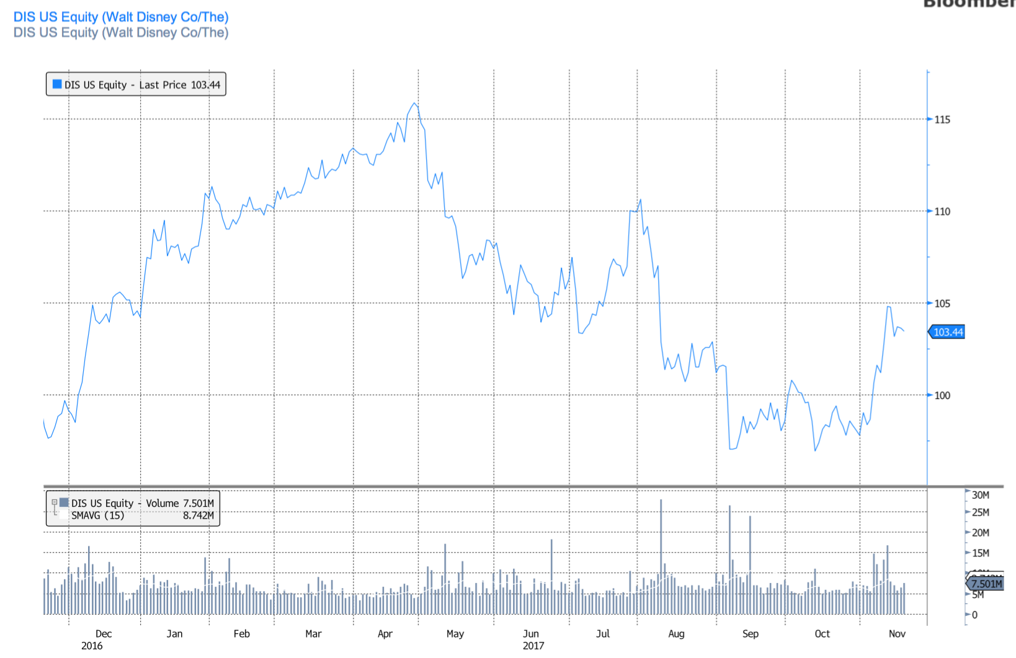

Peer Analysis
Name | Ticker | Market Cap (bil) | Revenue (mil) | EBITDA | EV/EBITDA | Dividend Yield (%)
Disney | DIS | 159.66 | 55,137 | 16,832 | 10.34 | 1.51
Time Warner Inc | TWX | 69.08 | 30,551 | 8,763 | 11.44 | 1.51
Twenty-First Century | FOX | 57.17 | 28,996 | 7,311 | 8.72 | 1.18
CBS Corp | CBS | 22.74 | 13,289 | 3,068 | 10.67 | 1.27
Viacom Inc | VIAB | 10.86 | 13,263 | 2,966 | 7.17 | 3.06
Netflix | NFLX | 83.6 | 10,885 | 814 | 100.23 | N/A
Peer Average |  | 57.17 | 25,354 | 6,626 | 10.34 | 1.71
Ownership
% of Shares Held by All Insider Owners: |  |  |  |  |  |  | 0.12%
% of Shares held by Institutional & Mutual Fund Owners: |  |  |  |  |  |  | 99.88%

Top 5 Shareholders
Holder |  |  |  |  | Shares | % Out
Vanguard Group |  |  |  |  | 102,160,555 | 6.62
Blackrock |  |  |  |  | 88,561,414 | 5.74
State Street Corp |  |  |  |  | 67,380,330 | 4.37
Laurene Powell Jobs Trust |  |  |  |  | 63,353,246 | 4.1
State Farm Mutual |  |  |  |  | 42,206,018 | 2.73

