Nasdaq: (DOX) Amdocs Limited Information Technology
Ben Zielinski, Alyssa Haglind (IT Services and Consulting)

Introduction
Amdocs Limited is a leading software and services provider to the world’s most successful communications and media companies. Amdocs specializes in software and services associated with business support systems (BSS), operational support systems (OSS) and network operations. Placing equal emphasis on four key business priorities - customer engagement, business agility, operational excellence, and cultural transformation through innovation. Amdocs continues to create next level technologies and provide the best service for digital success. Amdocs is at the heart of CSPs’ and MSOs’ digital and network transformation and is a clear market leader in enabling continuous industry adaptation and transformation. Headquartered in Chesterfield, MO; Amdocs has 25,000 employees and serves over 350 billion customers in over 90 countries. Listed on the NASDAQ Global Select Market, Amdocs has revenue of $3.9 billion.

Price | $65.59 | Beta | .71
Target Price | $75.78 | WACC | 5.40%
52 wk. High/Low | $71.72-$60.30 | Gross Margin | 16%
Market Cap | $9.4071 Billion | ROE | 12.33%
Shares Outstanding | 143.42 million | ROA | 8.17%
Dividend | $1.00 - 2017 | Price/Earnings | 21.58
Yield | 1.36% | Price/Sales | 2.50

Recommendation
Through its three business segments, and global outreach, Amdocs Limited provides information system solutions to major telecommunications companies. Its major customers include AT&T, Bell Canada, Sprint Nextel, along with many other prevalent brands within the telecom industry. Throughout the past 5 years, Amdocs has shown strong financials and growing revenue at an average of 4% per year. We would expect this trend to continue especially after partnering with Microsoft Azure to produce an innovative cloud computing platform. As companies are switching from older software and data sharing systems to more advanced cloud computing technology, we estimate that this will have a positive impact on the earnings of Amdocs Limited. Amdocs also has had a reputation over the last several years of acquiring companies in the industry through mergers and acquisitions to create synergy and better develop its products. The most recent acquisition being Vubiquity, a leading provider in content services and product solutions to further expand its operations into the entertainment and media business. Vubiquity has also just renewed a large contract with Turner Broadcasting whose clientele reaches over 60 million households in North America alone. This acquisition should bode well for Amdocs and should boost revenue moving forward to 2018 which we believe will ultimately drive up the stock price. While taking into account all the positive factors surrounding this company, we recommend a strong buy for Amdocs Limited because of their steady revenue growth, strong financials, continual expansion into new markets, and acquisitions of new companies to create synergy.

Investment Thesis
Market Expansion: Amdocs’s future development strategy is focused on expanding further into global markets. Over the last 8 years Amdocs’ has operated and produced its major revenue in North America at roughly 76% with the next largest market being Europe at 12%. In the past few years, these trends have begun to reverse, showing larger portions of revenue coming from Europe and other emerging countries while still growing revenue as a whole. As countries other countries are moving into the growth stage of the business cycle, while the U.S. is reaching a mature stage, we believe that global expansion will be a key driver of revenue and the stock price in the future as Amdocs continues to acquire new businesses and expand into new markets.
Partnerships and Contracts: Recently, Amdocs partnered with Microsoft Azure, which generates cloud computing software for businesses, to further expand from its standard business lines. Although this announcement may already be factored into the stock price, we believe that when they release the ONAP code to the open source community in May, this will have a positive impact on our investment.
Mergers and Acquisitions: As mentioned before, Amdocs recently acquired Vubiquity to further expand into entertainment and media. Their history of mergers and acquisitions and strategy of continuous expansion bodes well for future growth of this company and our investment. With increasing global expansion, it allows Amdocs to be safer and more diversified from domestic market risk.
Telecom Market: Having a large customer base in the telecom industry is a key driver for the revenue of Amdocs. With the cellphone and mobile provider industry expected to expand, this could cause an increase for the demand of Amdocs products. More consumers than ever are carrying mobile devices in their pockets, and providers and software producers are expecting this trend to continue as technology and a “connected” culture continue to be more and more prevalent every year.

Valuation
To reach an intrinsic value for DOX, we chose to use the 5 year DCF model along with an enterprise multiple model, splitting them at 50%, which brought us to a value of $75.78. This represents a 14.03% upside from its current price of $66.26. We chose the enterprise value model because we felt it was the safest and most accurate multiple when analyzing the technology sector. We used a conservative terminal growth rate of 2% and a WACC of 5.40% to bring us to our intrinsic value of Amdocs. When selecting a peer group, we started by using Bloomberg’s top 10 competitors in the industry, and further narrowed down the peers by firm size and product line to come up with relevant and accurate multiples.

Risks
Ability to evolve: Amdocs provides in a sector that is constantly growing and constantly changing. Their ability to keep up with this rapid environment is crucial for them to succeed. Amdocs has had to rapidly integrate over their lifetime and completely change how they run their business. Starting with phone books, moving to cell phones, and then later to Independent Software Vendors (ISV) and System Integrators (SI). Advancements in technology, along with the demand for a highly skilled workforce can be viewed as both a risk and a benefit to Amdocs.
Currency exchange rate risk: With the constant change in global markets, changes in monetary value can be difficult for companies such as Amdocs to manage. Economic and political uncertainty globally may further jeopardize the company’s financials going forward. It is extremely important for global companies to manage their financials while operating at this scale.
Merging Risk: After spending large amounts of cash on the acquisitions of new companies, risk could arise from a lack of revenue produced by the acquired company or lack of cooperation from the merging company as it is difficult for ideas to align. This would cause their free cash flow to be more limited and their ability to pay off debt would become weaker. Because Amdocs is constantly looking to expand and acquire, we view this as a risk to future revenue.

Management
Eli Gelman, Amdocs CEO and president, has been a director of Amdocs since 2002. In 2008 he serviced as executive vice president of Amdocs Management Limited and as chief operating officer from 2006 to 2008. In 2010 he became the president and chief executive officer. Tamar Rapaport-Dagim has been senior vice president and chief financial officer of Amdocs Management Limited since 2007. She serviced as the vice president of finance from 2004 until she was appointed to CFO in 2007. There has not been many significant management changes over the last several years, the most recent being a new investment relations manager in 2015.

Stock Chart past Year Performance
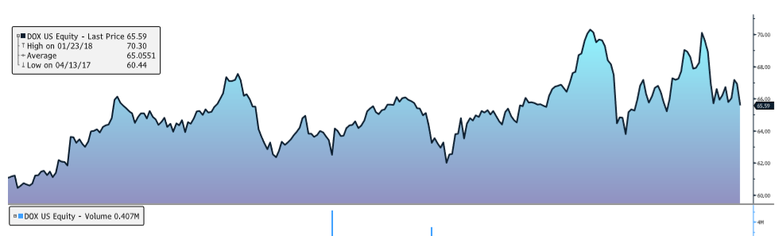
Peer Evaluation
Name | Ticker | MKT Cap | Revenue | P/S | EV/EBITDA | P/E
Amdocs LTD | DOX | 9.54 B | 3.87 B | 2.41 | 11.35 | 21.73
Convergys | CVG | 2.12 B | 2.79 B | 0.78 | 6.88 | 16.22
ExlService | EXLS | 1.90 B | 762.31 M | 2.68 | 16.56 | 29.31
Genpact | G | 6.17 B | 2.74 B | 2.25 | 16.14 | 22.26
TeleTech | TTEC | 1.43 B | 1.48 B | 1.25 | 12.86 | 22.64
WNS Holding | WNS | 2.32 B | 602.55M | 2.4 | 19.49 | 25.51
Average |  | 3.91 B | 2.04 B | 1.96 | 13.88 | 22.95

Top 5 Shareholders (Bloomberg)
Name | Shares | Percentage
FMR LLC | 16,167,615 | 11.27%
Janus Henderson | 7,545,657 | 5.26%
Boston Partners | 6,407,957 | 4.47%
Sun Life Financial | 5,623,517 | 3.92%
Blackrock | 4,908,222 | 3.42%

Ownership
98.63% of Amdocs shares are owned by institutional investors where roughly 75% of shares are owned in North America. The largest portion of shares are held by investment advisors at roughly 86% with the next closest ownership type being mutual funds at 5%.

