**Macy’s Inc. (NYSE: M)**

**Brock Schauer and Kyle Kolb Consumer Discretionary B**

**Introduction**

Macy’s Inc. is a major retailer primarily located within the United States. The company employs approximately 130,000 people and operates 700 department stores under the names Macy’s Inc. and Bloomingdales. The Company also operates over 150 specialty stores under the names Bloomingdales The Outlet, Bluemercury, and Macy’s Backstage. The company recorded 2017 sales of over $24 billion, they own approximately 50% of their stores while leasing the other 50%. Macy’s Inc. attracts customers through iconic name brands, a strong online presence, and providing a unique experience for every customer with a talented and knowledgeable salesforce. As of March, 23th 2017 Macy’s Inc. completed its previously announced CEO succession plan with Jeff Gennette becoming the acting CEO.

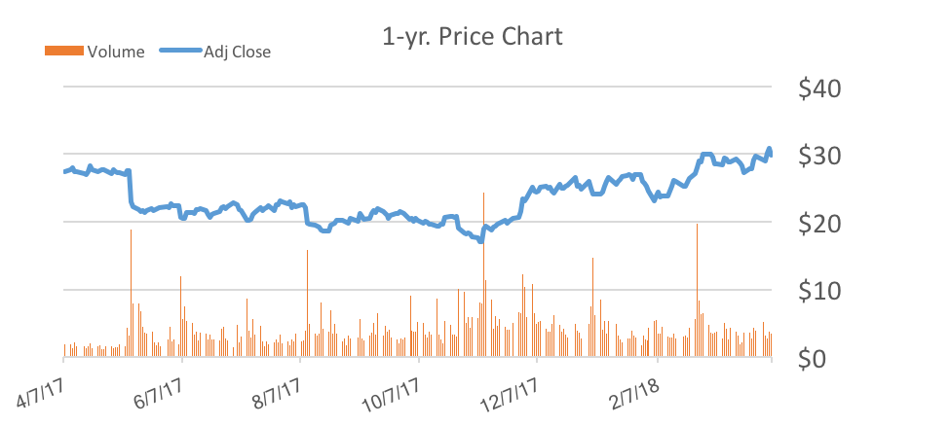

Net Income more than doubled for previous quarter

Missed earnings estimate by roughly 45%



**Recommendation**

We recommend a BUY for Macy’s Inc, with a current target price of $33.86 which represents a 13.61% upside potential. Our valuation metrics are based on an even distribution between an Enterprise Multiple Model, Price to Earnings ratio, and a two stage DCF model. The emphasis on the relative valuation is used because we believe Macy’s Inc. is a value stock derived from unjustified low future projections that are currently priced into the stock. We believe these substandard projections are unwarranted based on team analysis and therefore have concluded that Macy’s Inc. is underpriced. The two stage DCF model was selected because of the model’s ability to take our projections into future years and incorporate this into the current stock price.

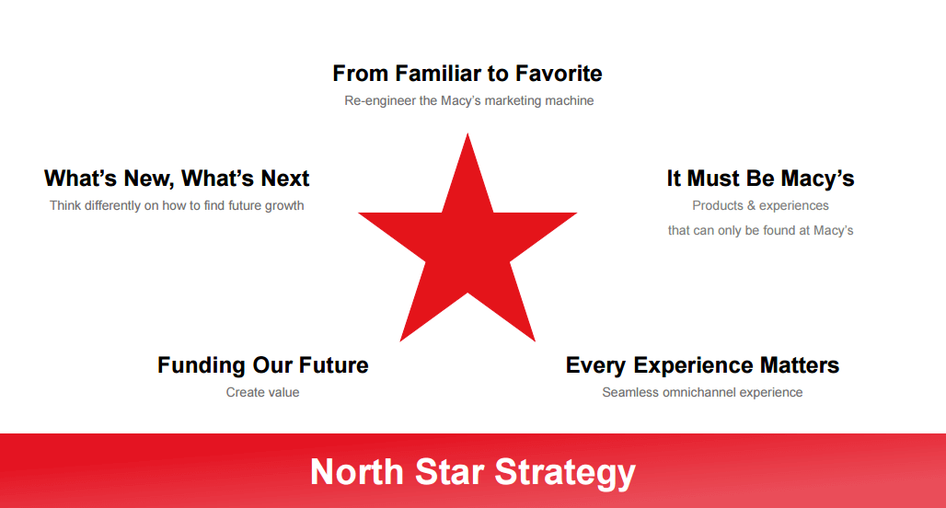 **Investment Thesis**

When analyzing Macy’s Inc, it was clear that the company’s operating strategy still followed the philosophy put in place by the founder R.H. Macy with the North Star, which remains the symbol of the company. Each of the points of the North Star represents a value of the company, and these points include; emphasis on the Macy’s brand, exceptional products and services, a positive experience for customers, ability to create resources to fuel growth, and constant innovation to meet changing consumer preferences. These points of the North Star have guided management at Macy’s Inc. for over 150 years and remain the foundation for the company’s vision in the future.

**Strategy:** Macy’s Inc. announced in January of 2017 a series of actions that would be put in place moving forward to streamline its store portfolio, improve cost efficiency and execute its real estate strategy. The highlight of these actions was the announced plan to close 100 Macy’s locations to better fit consumer preferences and manage costs. Same store sales were down YoY, driving the operating margin, ROIC, and many other metrics down. Closing these 100 stores should increase efficiency, margins, and raise same store sales in future years.

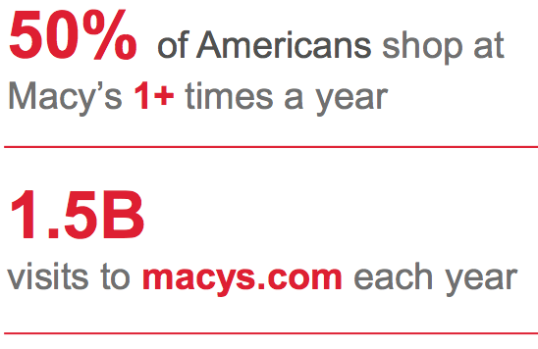**Drivers:** Through team analysis, we believe that the market currently under values Macy’s Incorporated and the current stock price is trading at an overall discount to what the true value is. There are several indicators that reflect our analysis. It is clear that the retail industry is not the same as it was in the past, and consumers are demanding faster purchases, ease of purchase, online accommodations, and life-changing experiences. Macy’s management team has realized this shift in the industry and are taking necessary actions to keep their customers and develop new ones. Some ways they are doing this is through their ‘North Star Strategy’. This strategy consists of the 5-points of their star logo and is revolved around adding value to the consumers’ life through their products. Macy’s has also taken actions on downsizing their overall stores since the retail industry is becoming more ecommerce centralized. They have started their plan to close 100 Macy’s store around the country and rather focus their efforts and capital on profitable locations. Jeffrey Gennette has recently taken over as Chief Executive Officer (CEO) for the company and he is the main reason why these new strategies are being put in place. Mr. Gennette is certain that Macy’s can remain a top brand in the public’s eyes and continue to have their loyal customers shop their products. The overall drivers of Macy’s Inc.’s revenues are located behind the efficiency of gaining customers, keeping the customers, and have them buy more Macy’s products that are offered. These drivers are dependent on the experience that Macy’s offers and how management will be able to implement effective strategies that align with continuously changing consumer preferences. Our team is confident that Macy’s Inc. will have sufficient revenue growth in the future and is currently undervalued by the overall market. Within the retail industry, moving forward the two most important drivers will be high quality products and the ability to differentiate, which Macy’s possess within their North Star strategy.

**Jeffrey Gennette**

CEO – March of 2017

* President from 2014-2017
* 35-years’ experience in retail industry
* 34 years with Macy’s Inc.

**Valuation**

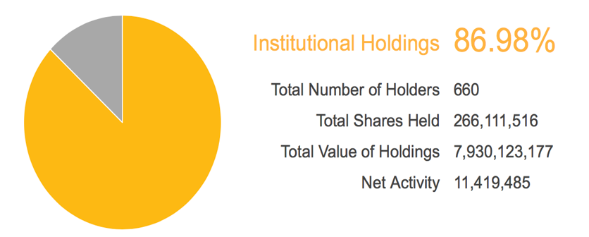Our valuation for Macy’s Inc. consists of three models – one that is reflective of their intrinsic value, a relative value to their comparable peers, and price compared to the overall industry. We first conducted a Discounted Cash Flow model that used our predicted Free Cash Flow to the Firm (FCFF) 5-years from now. After discounting the FCFF at a WACC of 8.0% and using a perpetuity growth rate of 2.0% we calculated a current valuation of $33.90. For our second valuation method, we used an EV/EBITDA Multiple Model to compare Macy’s to its peer competitors. After determining an EV/EBITDA Multiple of 7.2x for Macy’s, which is a discount of -40.88% relative to its peers, a current valuation of $32.57 per share was calculated. For our final valuation model, our team used a P/E Multiple Model because we believe that Macy’s price is low with its earnings relative to comparable competitors. Macy’s is currently trading at a P/E ratio of 9.84 which is a discount of -38.50% relative to selected comparable peers. A P/E of 11.59, which would bring the current price to $35.10 per share, would be fair value for Macy’s Inc. and we believe the market will realize the current discount and multiple expansion will result. For our overall valuation of Macy’s Inc., we used an even distribution of our three valuations to reach a current price of $33.86 per share bringing the upside potential to 13.61% above the current price.

**Insider Vs Institutional/Mutual Funds:**

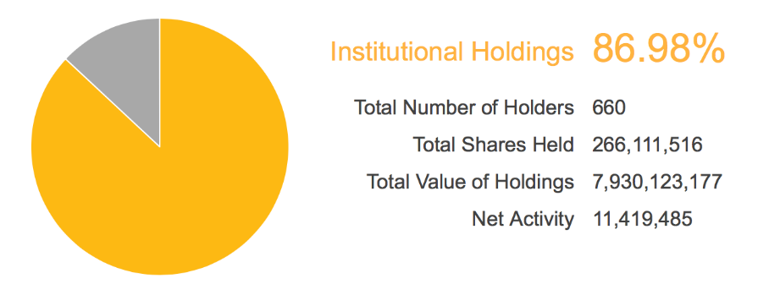**Risks**

F1: Operating lease obligations (Probability: Moderate Impact: Moderate). The company has almost $4 billion in operating leases that extend to periods of 20 years in the future.

F2: Interest rates (Probability: High Impact: Moderate). An increase in interest rates, or strain of liquidity in the market could negatively affect Macy’s ability obtain low cost financing.

OP1: Competition (Probability: High Impact: High). The retail industry is highly competitive, Macy’s needs to continue to differentiate itself in an everchanging retail environment.

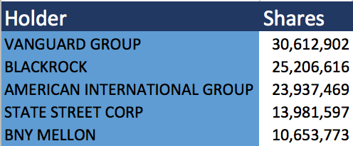OP2: Weather (Probability: Low Impact: Low). Natural disasters. Extreme weather affects the results of stores within the affected geographic region.

**Top 5 Shareholders:**

OP3: Deals with suppliers. Macy’s Inc. depends heavily on its iconic suppliers to generate sales.

M1: Consumer spending (Probability: Moderate Impact: High). Economic conditions drive consumer spending, an unfavorable economic environment could negatively impact operations.

M2: Cyclical cycle (Probability: High Impact: Moderate). Macy’s incurs lofty expenses in the time leading up to the fourth quarter holiday shopping season.

M3: Employees (Probability: Moderate Impact: Moderate). The company places emphasis on its quality employees. In healthy economic times, good employees can be hard and more expensive to find.

**Management**

As of March 23rd, 2017 Jeff Gennette assumed the role of CEO with Macy’s Inc. This transition process, which began in June of 2016, was completed smoothly with the former CEO Terry Lundgren assuming the role of executive chairman of the Board. Jeff Gennette is qualified to lead the company and has been the President of Macy’s Inc. since 2014. Management firmly believes in the continued success of Macy’s Inc. and this can be shown by the share repurchases of almost $8 million in 2016, showing that they too believe the stock is undervalued.

**Peer Analysis-**

Macy’s Inc. defines its peer group for SEC reporting purposes as the following: Bed, Bath & Beyond, Dillard's, Gap, J.C. Penney, Kohl's, L Brands, Nordstrom, Ross Stores, Sears Holdings, Target, TJX Companies, Wal-Mart. We utilized this list of peers, along with Bloomberg’s recommendations and then systematically eliminating outliers for our valuation based on metrics such as market cap, and levels of debt. The result was a comparable peer group that we feel justifies and exemplifies the undervaluation and price of Macy’s Inc.