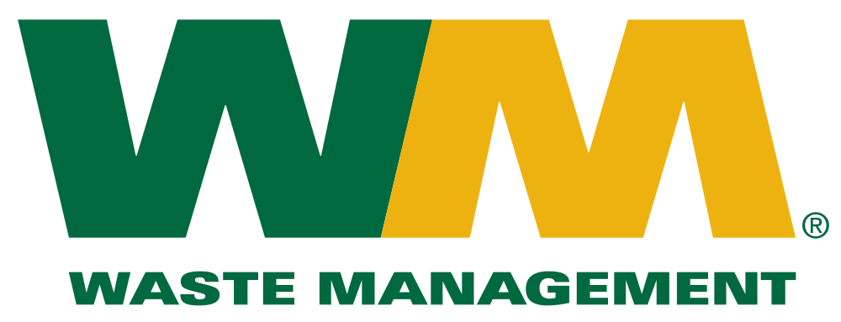
Jacqueline Robarge and
Nicholas Schone
Senior Analyst: James Kennedy

Introduction
Waste Management, Inc., is a leading provider for environmental services and engages in waste management services, including collection, transfer, recycling, resource recovery, and disposal services. In addition, Waste Management, Inc. operates waste-to-energy facilities serving municipal, commercial, industrial and residential areas in the United States, Canada and Puerto Rico. Waste Management operates with three different segments: tier 1 consists of areas in the Southern part of the United States, tier 2 consists of areas located in the Midwest and Northeast United States, and tier 3 consists of the remaining regions including Mid-Atlantic regions and Eastern Canada. Waste Management provides a full range of waste and environmental services to about 20 million residential and over two million commercial customers. Founded in 1987 and headquartered in Houston, Texas, 95% of the company’s revenue is generated in the United States.
Stock Chart
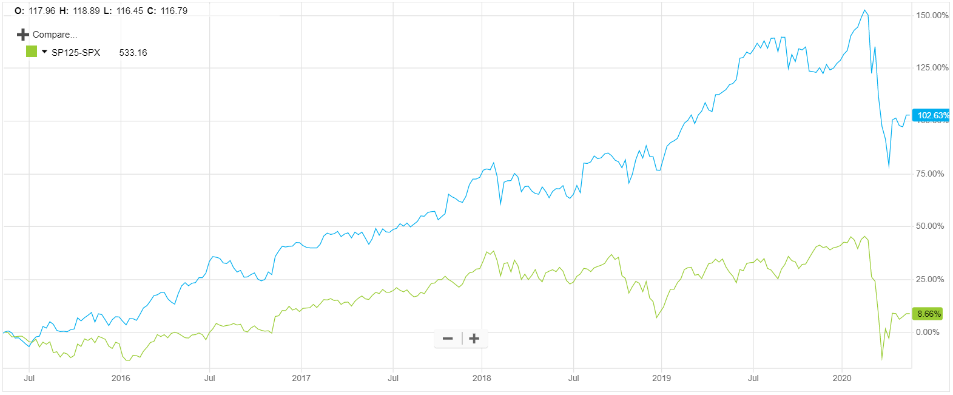

In this chart we see the percentage change since May 11th, 2015 of Waste Management, Inc. (blue) and the S&P Industrials index (green). We can see that during this time, Waste Management, Inc. has realized incredible gains compared to the index. Removing some of the variation in the stock, we can see a consistent growth in the stock until the COVID-19 pandemic announcement that caused major drops in the market in January of 2020. In the previous five years, Waste Management’s stock has increased by 102.62% to a price of $100.97.
Recommendation
We recommend a BUY of Waste Management, Inc. at $100.97 due to the current market conditions, their commitment to a sustainable future and long-term resiliency to uncertainty. With a weighted intrinsic value of $129.65 buying today would bring anticipated returns to our portfolio of $28.68/share or a 28.40% increase in the value of the stock in the next year.
Investment Thesis
Due to the following rationale, Waste Management, Inc. is positioned to continue to perform well, equating to a growth in their business and a growth in their security value:
- Strong, Consistent Business Model
  - Their fully integrated business model provides Waste Management with revenues that stem from their other revenues. For example, the company generates revenues from the sale of single-stream recyclable materials after first generating revenues from the collection of the recyclables from both commercial and individual customers.
  - Waste Management understands the interactive characteristics of their business model and how to best manage each segment for the benefit of the company as a whole.
- Investment in Future Technology
  - Waste Management has worked tirelessly to implement equipment and technology they feel is the future of the industry. By being a first mover, they have the opportunity to become leaders and experts with the new technology before their competitors have a chance to try the product. Principally, Waste Management has invested heavily into greener solutions.
- Resiliency During Economic Distress
  - As we have in the price chart comparison, Waste Management has continuously outperformed the market. Because Waste Management provides a service that is unlikely to waver, they have been able to continue growing during times of both increasing and decreasing consumer spending.
- Strong Brand Recognition
  - Waste Management is one of the most well-known brands in the country for the handling of solid waste. Present across the country, their brand has become a household name.
  - Working for their benefit, their name is synonymous with the service. When you think of waste disposal, it is difficult to not think of Waste Management.
  - Waste Management has become the nationwide leader in recycling. Their continued efforts towards a greener tomorrow are backed by their efforts today to reduce emissions, handle more waste and utilize greener energies.

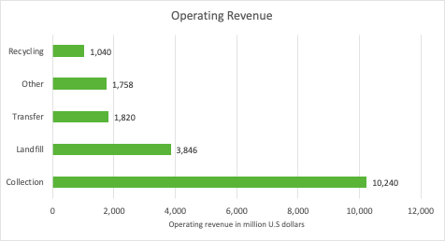
Revenue Stream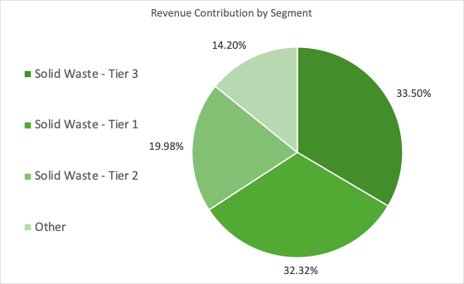
Waste Management, Inc. is thriving in the U.S and Canada market. With just over 95% of their revenue being generated in the United States, Waste Management is in a good position to continue increasing sales. Waste Management revenue contribution is broken down by tier 1, 2 and 3. The tiers are broken down by location. For example, the largest segment, Tier 1 consists of the Southern part of the United States. Waste Management Inc., largest operating segment, collection, generates just over 60% of the company’s total revenue breaking it down by commercial, residential, industrial and other allowing growth for the other segments.
As discussed in the “Investment Thesis” portion of the report, we can see that Waste Management Inc, has a strong, consistent business model that provides the company with revenues generated through other revenues. This is not likely to diminish and year after year Waste Management, Inc. will continue to have a consistent revenue stream because of their integrated business model.
Risks
Government Regulations: Government regulations are identified as a risk to Waste Management Inc. at the federal, state, provincial, and local levels because it can restrict or change operations and operating costs. Certain limitations regulate environmental protection, health, safety, land use, zoning, and transportation can put risks such as trouble expanding facilities, increasing disposal prices, bans on transportation of out-of-state waste as well as many others which could negatively affect the operations of the business.
Commodity Prices: Changes in commodity prices are considered a risk to Waste Management Inc. because it can affect the company’s ability to import and export products. One concern to the company is the commodity prices for recyclable materials specifically with China. Recently, China has reduced the import of recyclables by putting a ban on certain materials. With an increase to size in recycling operations there comes an increase to exposure of fluctuations in commodity prices for the company.

Reduction in the Need for Waste Treatment: As technology continues to improve, new solutions to the handling of waste and waste products could arise. Although these types of innovations futuristic in nature and would take even longer to be fully integrated into the average household, Waste Management works to mitigate this risk by aggressively investing in new trends and the technology of tomorrow in the industry.
Peer Analysis
Company | P/E Ratio | Market Cap (M) | ROE (%) | DIV Yield (%)
Waste Management, Inc. | 29.2 | 42,611.9 | 25.0 | 1.8
Republic Services, Inc. | 26.9 | 25,882.0 | 13.4 | 1.7
Casella Waste Systems, Inc. | 69.8 | 2,352.6 | - | 0.0
Average | 42.0 | 23,615.5 | 19.2 | 1.2

Waste Management, Inc. is clearly the best security within its direct competitors. We can see that all of the financial metrics of Waste Management, Inc. are in-line with its competitors or is considerably better. One metric of considerable significance in the company’s return on equity. Boasting a 25.0% return on equity is impressive by itself, but when compared to its competitors, we can see that Waste Management, Inc. performs significantly better. These metrics give us a favorable outlook on our investment in Waste Management, Inc.

Management
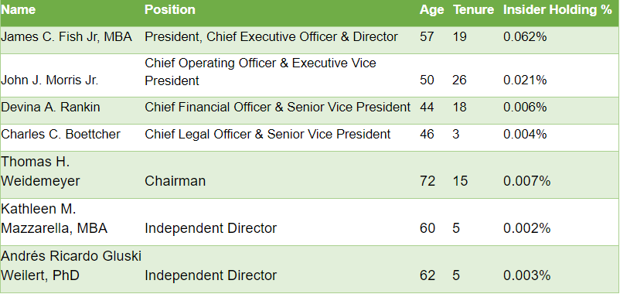
Waste Management, Inc has 13 management positions and 9 directors with an average age of 57 years and average tenure of 10 years.
The current CEO as of July 2016, is James C. Fish Jr., who has held many positions during his 19 years with Waste Management. Within the first year as CEO, Fish was named Executive of the Year by an industry leading news provider named Waste Dive, based on resonance and industry impact. Prior to his current role of CEO, he was the Chief Financial Officer, Senior Vice President for Waste Management’s Eastern Group, Area Vice President for Pennsylvania and West Virginia, and Market Area General Manager for Massachusetts and Rhode Island. James C. Fish Jr. graduated from Arizona State University with a bachelor’s degree in accounting and moved on to earn his MBA in finance at University of Chicago.
Thomas H. Weidemeyer has served as the Chairman of the Board for Waste Management since 2005. Prior to his position with Waste Management, he was the Senior Vice President and Chief Operating Officer at United Parcel Service, Inc.. Weidemeyer also serves on the board of directors for NRG Energy, Inc., The Goodyear Tire & Rubber Company, and Amsted Industries Incorporated.
Waste Management, Inc. management team continues to lead the company in a positive direction earning a great number of awards including Best Company for Women to Work in 2018 and Climate Change Leader for two consecutive years in 2016 and 2017.
Valuation
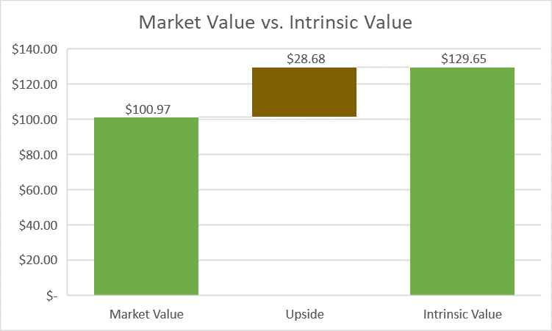
When searching for an intrinsic value of Waste Management, Inc., our team performed multiple valuations to find an intrinsic value of Waste Management, Inc.
For the DDM, we estimated dividends of $2.10, $2.15 and $2.20 per share over the next three years, respectively. In our model, we chose to use Waste Management’s current WACC of 4.60% and a terminal growth rate of 3%. Using these assumptions, we found an intrinsic value for the firm of $129.65.
Our team also performed additional valuations using models like the discounted cash flows model. During these valuations, we found intrinsic values far higher than expected. After reviewing our inputs, we reasoned that the inputs were correct, but the valuations were not reasonable. Given the consistent growth in recent years of key financials of Waste Management, Inc. we feel that the growth will be sustainable, but the target prices were unrealistic. We still took value away from this practice. By receiving extremely high outputs from multiple models, it demonstrates that the company is performing in a way that will continue to drive up the value of their security.
After performing multiple valuations, we felt that the most applicable to our valuation was the dividend discount model. This model gave us a valuation and target price of $129.65 for Waste Management, Inc.
Ownership of Shares
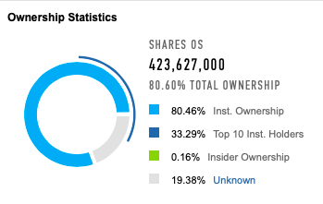
In the two charts in this section, you will find a summary of the ownership in Waste Management, Inc.
