Finance 339

Stock Pitch – Constellation Brands, Inc.

Junior Analysts: Jorge Herrero Berengue, Tucker Noe

Senior Analyst: Brock Schauer

October 22, 2018

Constellation Brands, Inc.
(NYSE): STZ
Beverages
Valuation Date:
October 19, 2018
Current Price: $222.93
Target Range:
$258.54-$279.19
Introduction
Constellation Brands, Inc. is the third largest alcohol manufacturer and distributer and is the largest beer importing company in the United States. They have a diverse portfolio of specialty and craft beers (50%), as well as diversity within their wine (48%) and spirit (2%) segments. Originally operating as a local wine distributor, acquisitions has allowed this company to grow to the largest United States beer importer. Now having one of the world’s most recognizable beer brands, Corona, Constellation Brands has emerged into the leading alcohol trends in the United States. Headquartered in New York, Constellation Brands has 40 facilities around the world and over 9,000 employees. The Company has maintained their position on the emerging craft beer segment in the United States and has enter the cannabis industry by recently taking 38% stake in the world’s largest cannabis company, Canopy Growth (NYSE: CGC). 2018 showed news highs for Constellation Brands, by increasing net income and EPS by 51% and 74% respectfully.
Source: Company Filings

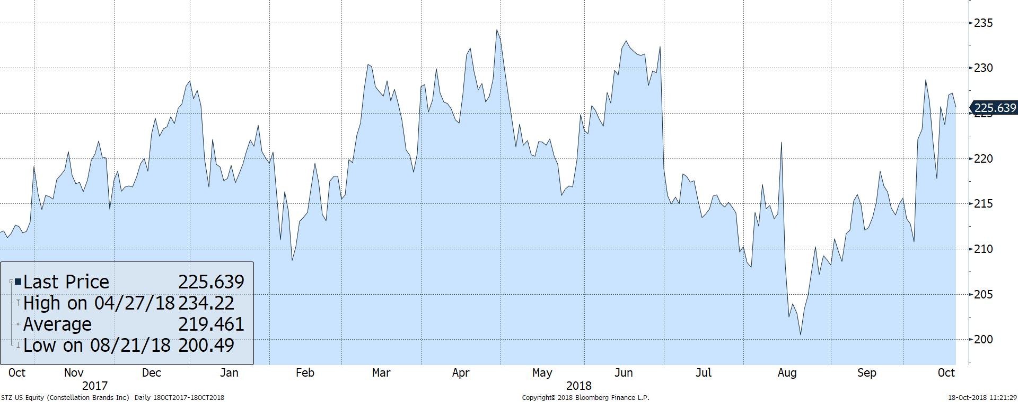
Source: Bloomberg Terminal
Recommendation
We recommend a BUY for Constellation Brands, Inc. with a current target price from $258.54 to $279.19, which would result in an upside potential of 15.97% to 25.24%. We used a combination valuation of 5-year DCF valuation and a Price-to Earnings valuation. The history of Constellation Brands has resulted in a reduction of future earnings which as decreased the value of the stock. Using a Price-to-Earnings value showed they are undervalued compared to their closest competitors, which the DCF showed how their future earnings could show their huge impacts from their recent investments.
Investment Thesis
Constellation Brands has seen an increase in all of their key metrics – revenue, EPS, profit margin - when compared to the industry and industry leaders. However, a negative reoccurring metric that impacts the company is a decrease in demand during their third and fourth quarters. However, this usually does not affect their stock price because it is known throughout the industry about cyclical American trends.
During recent years key consumers have been moving towards craft beer, this shows the increase in revenues and the phenomenal performance of some of their specialty beers like Corona Premiere which was debuted last year and acquired a return of 12%. They have seen positive outlooks from their current products in test markets and could see continuous revenues.
Investments have been proven to drive in recent years not only the growth of Constellation Brands, but also their stock price. Constellation Brands is heavily invested in Canopy Growth Corp. which has achieved a growth of over 3,100% over the last 5 years. Canopy could see an increase of 900% of revenues from 2019 to 2023 based on analyst estimates.
Source: FactSet
Constellation Brands Inc. sees fluctuations in revenue during the third and fourth quarter due to decrease of advertisement and the seasonality of their summer beers.

Valuation
Valuation Results
DCF Result: | $244.23
P/E Result: | $268.08
Current Price: | $222.93
Low End: | $258.54
High End: | $279.19
Recommendation: | BUY
Upside: | 16.0%-25.2%
To value Constellation Brands, we used a relative valuation and a valuation comparing it to its notable pears. Using a discount factor, WACC, of 8% and a perpetuity growth rate of 4%, which is relatively consistent with the growth rate of GDP, we calculated a range of $244.23 to $295.85. This is the best case and worst case for projected revenue over the next 5 years. Secondly, we compared four of Constellation Brands closest competitors and determined a relative P/E ratio of 16.05, a
-20.2% compared to their current P/E ratio of 13.35. And using the EPS of $16.70, we derived a value of $268.08. And using a weight of 60%/40%, P/E Ratio to 5year DCF, we came up with a range of $258.54 to $279.19.
Risks
Source: Team analysis

Operation Risks
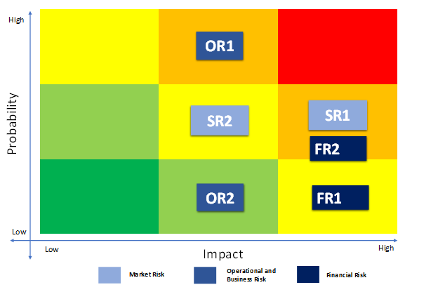
- Foreign Operations (OR1): They have production in different countries from their point of sale. This could lead to increased tariffs, differences in quality control, and geological conditions not experience in the United States.
- Wholesale Dependency (OR2): They sell their products to retailers who are supposed to market their products. A failure to position their products could see a reduction on the reputation.
Strategic Risks
- Highly Competitive Market (SR1): The alcohol market is very competitive relying on consumers preferences and consumers price sensitivity. A failure to reach the next new product could result in losses if not protected against.
Source: Team analysis

- Mergers & Acquisitions (SR2): To keep up with the recent beverage consumption trends, acquiring companies to provide these products. To many acquisitions might not produce the return compared to the investment in.
Financial Risks
- Indebtedness (FR1): They have incurred debt to finance their company acquisitions, operation expansions and constructions, and to repurchase shares of common stock.
- Reputation (FR2): Having a quality and safe product is crucial for beverages. A failure to maintain and succeed their current levels could hurt their reputation and their brands.
Source: Company Filings

Management
Ever since 1945, the start of what is now Constellation Brands, the Sands’ family has been in control and handling the business process. Currently Richard Sands, the chairman of the board, and Rob Sands, CEO, run the operations of Constellation Brands with more managers that run different product segments and different locations. But starting March 1, 2019, an outsider will take over as CEO of Constellation Brands. Bill Newlands will take over, who was previously the COO and president of Constellation Brands and President of Beam Inc. North American division.
Source: FactSet

Peer Analysis
Comp. | Sales | EPS | Div. Yield
STZ | 7,913 | 12.47 | 0.97%
BUD | 56,427 | 4.02 | 2.71%
HEINY | 26,374 | 3.64 | 1.69%
TAP | 10,880 | 6.38 | 2.00%
PDRDY | 10,716 | 6.23 | 1.69%
Constellation Brands identifies its competitors by its different beverage
sector – beer, wine or spirits – and Figure # shows who the top competitors are for The Company. When we look at how the United States alcohol segment has shifted over the past five years, Constellation Brands has shifted most of their products to appeal to the trends of alcohol consumers. This has positioned The Company in a more favorable position for continued earnings from year to year as well as finding the new product that consumers will favor. When compared to the entire industry, Constellation Brands falls within the top of major categories for the future.
Source: FactSet

Source: FactSet

Source: FactSet

95% Owned

