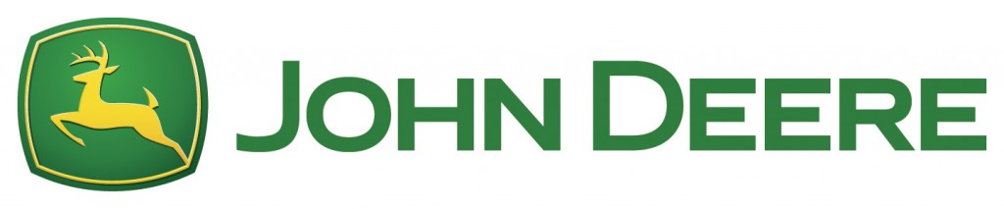
Jacqueline Robarge and
Nicholas Schone
Senior Analyst: James Kennedy

Introduction
Deere & Co., commonly known by the John Deere brand, engages in the manufacturing, distribution and repair services of equipment used in the agriculture, turf care, construction and forestry segments. Beyond these services, Deere & Co. generates revenue through their financial services. Within the agriculture and turf segment, Deere & Co. produces necessary tractors, harvesters, mowers and related equipment necessary in day to day and seasonal agricultural/turf care practices. The Construction and Forestry segment offers machines and service parts used in construction, earthmoving, road building, material handling, and timber harvesting. The Financial Services segment finances sales and leases by John Deere dealers of new and used agriculture and turf equipment and construction and forestry equipment. Founded in 1837 by John Deere, the company has grown into a household name during over 180 years of business. Headquartered in Moline, Illinois, over 50% of the company’s revenue is generated in the United States.
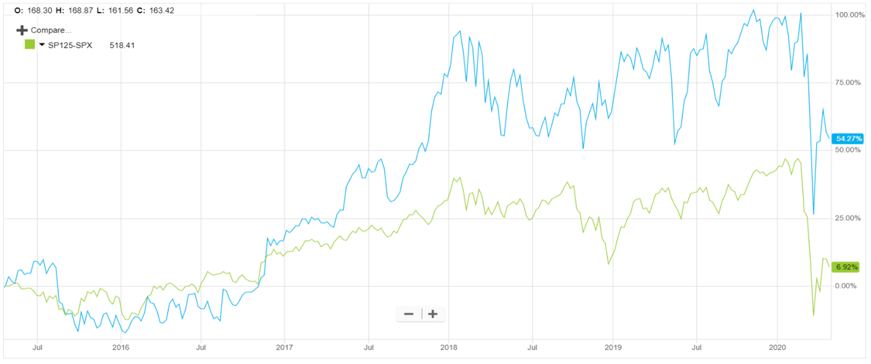
Stock Chart

In this chart we see the percentage change since April 20th, 2015 of Deere & Co. (blue) and the S&P Industrials index (green). We can see that during this time, Deere & Co. has realized incredible gains compared to the index. Removing some of the variation in the stock, we can see a consistent growth in the stock until the COVID-19 pandemic announcement that caused major drops in the market in January of 2020.
Recommendation
We recommend a BUY of John Deere & Company at $133.95 due to current market conditions, strategic acquisitions by the company and the opportunity for growth into foreign markets. With a weighted intrinsic valuation of $159.68, buying today would bring anticipated returns to our portfolio of $25.73 or 19.21% increase in the next year to year-and-a-half.
Investment Thesis
Due to the following rationale, we believe that Deere & Co. is well positioned to perform well and increase in stock price in the next year and beyond:
- Technological Investments
  - Through Deere’s acquisition of companies like Blue River Technologies, Deere & Co. has made significant investments into advancing the technological features of their products.
  - Artificial intelligence, vehicle autonomy and extremely precise GPS were once a cool thought, but Deere & Co. feels that they are very close to offering their customers such features.
- Trade Agreements
  - With the USMCA passing within recent months, Deere & Co. will likely see a growth in sales in these foreign markets, as well as a decrease in raw material prices.
  - With increased profit margins along with increased sales, the company’s bottom line will be directly impacted in a positive manner from the new trade agreements.
- Durable Consumer Culture
  - “Nothing runs like a Deere.” This is the slogan of Deere & Co., and during their 180 years of business, they have convinced a large following that this statement could not be truer.
  - Deere & Co., especially among their agriculture segment, has extremely high brand loyalty among their consumers. The risk of losing these customers is very low.
  - Deere & Co. has worked to sell a lifestyle and a culture along with their products. Doing so has given their targeted consumers something to relate with and make part of their identity.
- Strategic Structure
  - Deere’s products are traditionally thought of as agriculture and turf equipment. Within these segments there is less potential for growth. This is the segment that sustains the company and is the basis for the rest of the company’s success. It has little chance of diminishing in the future, but with new technological advancements, does have growth potential.
  - The construction and forestry segments of Deere’s revenue is a high growth area. Using what they have built in their agriculture lines, they continue to compete with other large machine manufacturers and capture market share. Like in their agriculture segment, continued improvement of products, access to new markets and advancements in technology gives this segment extreme growth potential.
Revenue Stream
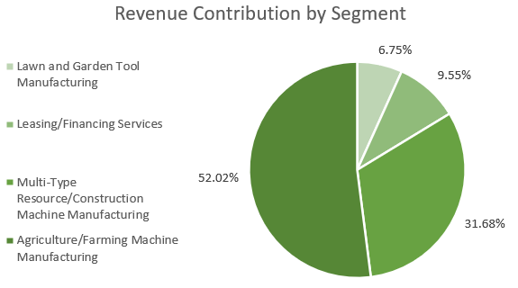
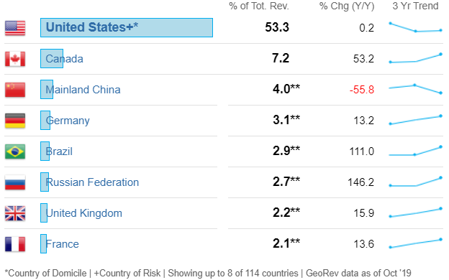

Deere & Co. is based in the Midwest and has always thrived in the domestic market. With over 50% of their revenue being generated in the domestic market, Deere is well positioned to maintain solid sales, regardless of global risks. We also can see that certain foreign markets are proving to be major growth areas for the company. Canada, for example, has always been Deere’s largest foreign market. With a growth of 53.2%, we can see that Deere still has the potential to grow in both new and established markets.
As discussed in the “Investment Thesis” portion of the report, we can see that the well-established agriculture and farming segment of the company represents over half of their annual sales. This provides the company with a consistent revenue stream year after year that is not likely to diminish. Having this sort of basis allows for expenditures focused on increasing market share in other segments.
Risks
Trade Laws and Regulations: Trade laws and regulations are considered a risk to John Deere & Company because it restricts access to raw materials and high-quality parts at a competitive price. The profitability and growth prospects of John Deere & Company are link directly with the global marketplace and poor trade agreements or imposing new tariffs against certain countries could affect the ability to capitalize on future growth in international markets
Government Farm Programs and Policies: Government farm policies are considered a risk to John Deere & Company because agricultural demand can be influenced by direct payments and other subsides directed through government policies and programs.
Agriculture and the markets surrounding it are greatly dependent on the growing seasons of crops and natural climate events. This is identified as a risk to the company due to this relationship. If the consumers of Deere’s products have difficulties in earning profits, they will be less likely to spend on equipment.

Peer Analysis
Company | Current Price (USD) | P/E Ratio | Market Cap (M) | ROE (%) | DIV Yield (%)
Deere & Co. | 138.46 | 17.5 | 43,423.8 | 25.1 | 2.3
Caterpillar | 116.30 | 13.1 | 63,974.7 | 21.1 | 3.0
Kubota | 11.69 | 16.3 | 14,263.2 | 11.3 | 2.1
AGCO | 49.49 | 27.6 | 3,714.4 | 6.9 | 0.9
CNH Industrial | 6.14 | 14.4 | 8,290.0 | 10.9 | 1.9
Average | 64.42 | 17.8 | 26,733.2 | 15.1 | 2.0

Deere & Co. is the best security within its direct competitors. We can see that all of the financial metrics of Deere & Co. are in-line with the average of its competitors or is well above the average. These metrics give us a favorable outlook on our investment in Deere & Co.
Management
The Chief Executive Office of Deere and Co. is John C. May II. Before his role as CEO, he was the President and Chief Operating Officer, President-Worldwide Agriculture and Turf Division as well as many other positions since 1997. May holds a bachelor’s degree from the University of New Hampshire and an MBA from the University of Maine. Deere and Co. has 18 management positions and 11 board positions with an average age at 58 years and average tenure of 16 years.
As of May 1, 2020, Samuel Allen will retire as a chairman of the board of directors and will be replaced by CEO, John C. May. With business running for nearly 180 years the management team and board of directors have helped to keep the reputation of their culture throughout the company as well as the public.
Name | Position | Age | Tenure | Insider Holdings (%)
John C. May, II, MBA | President, Chief Executive Officer, COO & Director | 50 | 23 | 0.014%
Ryan D. Campbell | Chief Financial Officer & Senior Vice President | 45 | 13 | 0.001%
Markwart von Pentz | President-Worldwide Agriculture & Turf Division | 56 | 13 | 0.019%
James M. Field, CPA | President-Worldwide Construction & Forestry | 57 | 26 | 0.019%

Valuation
When searching for an intrinsic value of Deere & Co., we used two different valuation methods. Our team used a Dividend Discount Model (DDM) and a Discounted Cash Flows Model (DCF).
For the DDM, we estimated dividends of $3.04, $3.04 and $3.15 per share over the next three years, respectively. Using Deere & Co.’s current WACC of 3.94% and a terminal growth rate of 2%. Using these assumptions, we found an intrinsic value for the firm of $165.57.
In our DCF, we estimated the free cash flow per share over the next 3 years of $0.75, $2.25 and $3.00, respectively. Again, using a terminal growth rate of 2% and a WACC of 3.94% we found an intrinsic value of $145.94.
Because the cash flows of Deere & Co. are more volatile than the dividend payouts, given the uncertainty surrounding the COVID-19 global pandemic. We weighted the DDM valuation at 70% and the DCF at 30%. Using this weighting, we found a weighted intrinsic value and target price of $159.68.
 |  | Terminal Growth Rate
 |  | 1.50% | 1.75% | 2.00% | 2.25% | 2.50%
 | 4.50% | $107.95 | $117.25 | $128.40 | $142.04 | $159.08
 | 4.25% | $117.81 | $129.01 | $142.71 | $159.84 | $181.85
WACC | 3.94% | $132.81 | $147.33 | $165.57 | $189.22 | $221.07
 | 3.75% | $144.07 | $161.36 | $183.60 | $213.24 | $254.73
 | 3.50% | $162.14 | $184.48 | $214.25 | $255.96 | $318.51
Because we placed such a large weight on the DDM, we felt that a sensitivity analysis was necessary to demonstrate how the valuation changed when using a different WACC and terminal growth rate.
The areas in red are those valuations that fall below the current price of the stock. In yellow we see the valuations that are greater than the current price of the stock but are below our initial valuation. In green are the valuations that are greater than our initial valuation.
Ownership of Shares
In recent position changes, the holders of Deere & Co. have demonstrated a net increase in holdings. This shows us that overall, those currently holding Deere & Co. feel that it is a good time to buy this security.
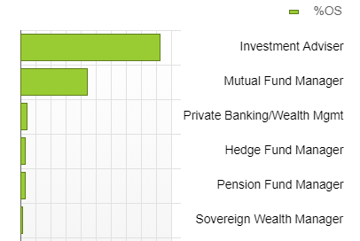
In the two charts in this section, you will find a summary of the ownership in Deere & Co.
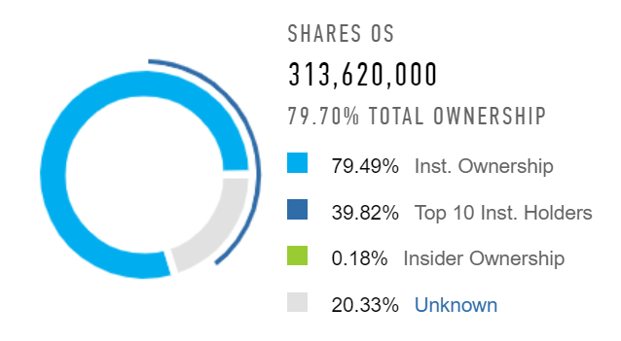

% of Holdings

