Ichor Holdings (ICHR)
April 23rd, 2018
Josh Zahn and Jeff Steers Info Tech B

Introduction
Ichor Holdings (ICHR) is a leader in the design, engineering, and manufacturing of critical fluid delivery subsystems and components for semiconductor capital equipment. Gas delivery subsystems deliver, monitor, and control specific quantities of the specialized gases used in semiconductor manufacturing processes such as etch and deposition. Chemical delivery subsystems precisely blend and dispense the reactive liquid chemistries used in semiconductor manufacturing processes such as chemical-mechanical planarization, electroplating, and cleaning. Ichor is headquartered in Freemont, CA and had its IPO on December 15th, 2016. Since the initial offering, their shares have performed very well rising over 142%. Ichor has two main customers which they have great relationships with, Lam Research and Applied Materials. Together they combine for 93% of Ichor’s revenue. Their revenue comes from The United States (59%), Singapore (34%), Europe (4%), and Other (3%).

IPO: In December 2016, Ichor issued 5,877,778 shares at a price of $9.00. Net of underwriting expenses, Ichor received $8.37 which equaled $49,197,002 of net proceeds. Ichor used most of these proceeds to finance existing debt and the remainder for general corporate purposes including funding working capital, operating expenses, and selective business development opportunities.

Price ($): | 22.48 | Beta: |  | 2.58 |  | 2016A | 2017A | 2018E | 2019E
Price Target ($): | 34.25 | WACC: |  | 18.76% | Revenue (mil) | 405.7 | 655.9 | 956.7 | 1,355
52 WK H-L ($): | 34.35-18.03 | Current Ratio |  | 1.89 | % Growth | 39.6 | 61.67 | 45.86 | 41.72
Market Cap (mil): | 590.76 | FCF/Share (%) |  | 1.18 | EBITDA | 33.4 | 70.6 | 125.3 | 205.5
Float (mil): | 26.2 | EBIT/Int Exp: |  | 19.33 | EBITDA Margin | 8.23 | 10.76 | 13.10 | 15.16
Short Interest (%): | 25.3% | Debt/EBITDA (ttm): |  | 3.18 | EPS | 18.33 | 2.19 | 3.64 | 4.46
Avg. Daily Vol: | 833,761 | ROA (%) |  | 13.40 | P/Cash Flow | .69 | 20.21 | - | 10.72
Dividend ($): | N/A | ROE (%) |  | 31.50 | P/E | .59 | 11.24 | 10.28 | 12.10
Yield (%): | N/A | ROIC (%) |  | 19.90 | EV/EBITDA | 7.35 | 12.01 | 5.65 | 9.5

Recommendation
We recommend a Buy for Ichor Holdings (ICHR) at $32.52 because of these four reasons: Projected increase in R&D spending, an increase in capital intensity for producing delivery subsystems for chip manufacturers, the expanding services being offered, and the strong growth potential of their financials, specifically revenue. Ichor is a small-cap company that makes fluid delivery subsystems for chip making equipment, specifically working with industry leading companies such as Applied Materials and Lam Research. After their IPO in December of 2016, the company grew from 530 employees to 1,420 employees, which specifically resulted in the number of engineers increasing from 30 to 65. This is significant because their Research & Development spending is limited to the number of employees that they have, and an expanded workforce will finally allow the company to devote a much larger allocation towards R&D, which will greatly benefit their bottom line with the creation of new innovations. The increased capital intensity for producing delivery subsystems for chip manufacturers has resulted in original equipment manufacturers (OEMs) outsourcing these processes in order to become more specialized suppliers and improve the value that they add to their customers. The outsourcing of these processes is a trend that has enabled OEMs to reduce their fixed costs and development time, which provides significant growth opportunities for specialized subsystems suppliers like Ichor. Additionally, as semiconductor chips become more complex, additional steps are required for manufacturing, which greatly increases the demand for both gas delivery systems and chemical delivery systems. Another reason why we feel strongly about Ichor relates to their expanding services being offered to customers, as in 2017 they produced 35 different product lines that involve 13 unique manufacturing steps, which grew from only 14 product lines in 10 unique manufacturing steps in 2016. The financials of Ichor are incredibly strong, and we feel that the company will continue to grow at a rapid pace in the coming years. Specifically, revenue increased by 62% from $405.7 million in 2016 to $655.9 million in 2017, while net income also increased significantly from of $20.8 million in 2016 to $56.9 million in 2017. In addition, the positive outlook for Ichor is expected to continue, with the company’s estimated earnings growth rate for the current and next quarters at 64.9% and 61.7% respectively. In addition to revenue and net income significantly increasing, Ichor boasts an impressive EPS growth rate for 2018 of 45%, while also having an ROE of about 32%, which is drastically larger than the industry average of only about 12%. The exponentially increasing revenue combined with strong demand from chip manufacturing companies such as Applied Materials and Lam Research is why we believe Ichor Holdings would be a Strong Buy.

Investment Thesis
Deep fluids engineering expertise: In the fluid delivery industry, employee expertise is key to the success of the company. Ichor has significantly more chemical, mechanical, and software and systems engineers than their close competitors. These individuals act as an extension to the customers product development team as they work together to design the best product. These engineers are also constantly working to create the next innovate fluid delivery product or idea that will change the industry.
Operational excellence: Ichor positions themselves so they are within close proximity to their largest customers. This allows them to provide products with extremely short lead times which gives the customer more flexibility. All locations have a high capacity without extra expenditures which helps Ichor take advantage of times with increased demand.
Early engagement with customers: Ichor has engineers and managers at the actual site of each customer working on the products. This enables Ichor to build strong relationships that will last well into the future as well as pioneer innovative and advanced solutions that the customer would not have thought of.
Growth of current services: There is significant opportunity in the gas and chemical delivery systems industry and Ichor is poised to take advantage of it. In 2016 between the two customers, Ichor operated in 14 product lines in 10 unique manufacturing steps. In 2017, they grew their operated product lines to 35 and unique manufacturing steps to 13. This growth was in one year and is a sign of the growth potential in this industry.

Valuation
Two separate models were used in the valuation for Ichor. The first was a three stage free cash flow to the firm model. The cash flows for the first five years were calculated separately, the second stage used a growth rate of 5% for five years, and a terminal growth rate of 2% was used. When calculating the WACC, we computed our own and then compared it to other companies in the industry. We then added a 1% volatility premium due to the additional risk that comes from a small cap company. This lead to a WACC of 18.76% and a one-year price estimate of $38.43. Our next valuation model was an EV/EBITDA multiples model. We came up with a peer group of eight different companies that are all in the manufacturing business with similar market caps. Next, we narrowed it down to four companies who have recently gone public. Averaging their multiples, we calculated a multiple of 14.70x and a one-year price estimate of $30.55. We then split these two valuations 75/25 favoring the multiples approach. This is because we believe the multiples approach is more accurate comparing to similar companies and avoids the risk that a cash flow valuation brings. Our final one-year price estimate is $32.52 with an upside of 49.37% from the closing price on April 23rd of $21.77.
Risks
Concentrated customer base: 93% of Ichor’s revenue’s is from two customers. If one of the companies does not perform as well or if tensions between Ichor and their customer weaken, the revenues of Ichor could be adversely affected
Semiconductor Industry: Generally speaking, the Semiconductor Industry is extremely volatile. While it has reduced 3x in the past 10 years, there is still great risk when investing in the semiconductor industry. In 2017, 97% of Ichor’s sales were to the Semiconductor industry. This could be a cause for concern as the success of Ichor is likely dependent on the success of the Industry.
New to public trading: In December of 2016, Ichor Holdings first went public at a price of $9.00 per share. As a small cap company that is new to the public stock exchange, they have a significantly greater amount of risk as can be seen by their beta of 2.46. If Ichor is unable to correctly invest their equity funds and generate a return for investors they could see their share price plummet.
Little control over margins: The margins of gas and chemical delivery systems vary greatly and can influence their overall margins. Also, providing this service to limited customers gives Ichor little control over their product price which can have an adverse effect on their margins for any given quarter. Aside from customers, these margins can also be affected by natural disasters and political turmoil.

Management and Compensation
Thomas Rohrs (65) was appointed as CEO and a member of the Board of Directors in 2014. Prior to his time at Ichor, Mr. Rohrs was the CEO at Electroglass and then at Skyline Solar. Previous to being a CEO, Mr. Rohrs was an Executive Vice President at Applied Materials. He holds a BA in engineering from Notre Dame and an M.B.A from the Harvard school of business. For these reasons we believe Mr. Rohrs is an exceptional leader for this company.
Philip Barros (36) was appointed as CTO in 2015. Prior to this position, he was the VP and then Executive VP of Engineering and even before that he worked in several different management positions at Applied Materials. He also holds several granted and pending patents related to gas and chemical delivery systems and their use in semiconductor manufacturing.

Together, we believe the blend of youthful and experienced leaders both with great knowledge and expertise will move Ichor Holdings in a positive direction and stimulate their success.

Stock Price Graph
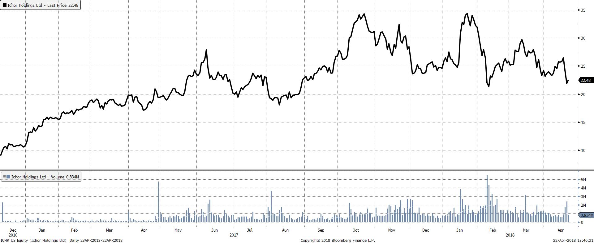

Peer Analysis
Name | Ticker | Market Cap (million) | Revenue (million) | EBITDA (million) | P/E | ROE
Ichor Holdings | ICHR | 590.76 | 655.89 | 70.57 | 10.28 | 31.50%
Ultra Clean | UCTT | 657.43 | 924.35 | 100.11 | 7.96 | 29.08%
FormFactor | FORM | 1,004 | 548.44 | 94.49 | 23.97 | 9.52%
Nanometrics | NANO | 600.09 | 258.62 | 51.61 | 20.54 | 11.93%
Axcelis Tech | ACLS | 732.66 | 410.56 | 52.84 | 16.74 | 45.75%
Industry Average |  | 546.58 | 138.69 | 26.11 | 44.82 | 11.97%
Peer Average |  | 748.55 | 535.49 | 74.76 | 17.30 | 24.07%

The Peer Group consists of four companies within the semiconductor manufacturing industry with relatively similar market caps who are direct competitors of Ichor Holdings. We believed this was the most accurate peer group given the volatility of their industry. As illustrated from the ratios above, ICHR has been a major force within the industry since its IPO in December of 2016. All the above ratios are better than the industry average, which demonstrates why we feel that ICHR is a great company with a bright future within the semiconductor manufacturing industry.

Ownership
% of Shares Held by All Insider Owners: | 0.35%
% of Shares held by Institutional & Mutual Fund Owners: | 99.65%

Top 5 Shareholders
Holder |  |  |  |  | Shares | % Out
Swedbank AB |  |  |  |  | 2,040,000 | 7.76
Paradigm Capital Management |  |  |  |  | 1,564,790 | 5.95
Vanguard Group |  |  |  |  | 1,174,856 | 4.47
Blackrock |  |  |  |  | 1,157,563 | 4.40
Point72 |  |  |  |  | 825,241 | 3.14

