Valuation Date: 11/2/2020 Recommendation: BUY
Ticker: TTWQ Price Target: $180.00
Current Price: $154.03 Sector: Communication Services
Introduction
Take-Two Interactive Software, Inc. was founded in 1993 and is based in New York City, New York. Take-Two is a video game holding company with their two major publishing labels being Rockstar Games and 2K, both of which have multiple internal game development studios. Take-Two rose into prominence in the video game industry with popular franchises such as Grand Theft Auto and their various 2K sports titles. Take-Two’s video games have multiple platforms for all types of users, and are created for consoles, personal computers, smartphones, and tablets, and have been sold through retail, digital, or streaming services. For their most recent fiscal quarter ending in June 2020, Take-Two saw an increase in revenue of 54% to $831.3 million from one year ago.
Investment Thesis
Take-Two Interactive has seen an explosive rise in its stock price in the past few years with its continued revenue gains and consistent product releases. Take-Two Interactive is a leader in its subsector and provides a positive outlook with its incredible lineup of upcoming games and a growing revenue outlook.
Research and Development Emphasis: Take-Two Interactive currently invests about 9.3% of its revenues into research and development purposes to either create new and innovative titles or to amplify current titles to further its sales. The company has been able to increase its R&D spending by 51% since 2018 and aims to establish itself as an innovator within the gaming industry.
Deep Pipeline of Future Titles: As it stands, Take-Two Interactive has 93 games planned, with 47 of those inspired by existing titles. With their continued development of new and previous titles, Take-Two aims to create meaningful long-term engagement with their consumers. Take-Two stands to gain significant profits if they can develop another successful “hit” game or franchise.
Further Inroads into Mobile Gaming: In August, Take-Two Interactive acquired mobile game developer Playdots for $192 million. Take-Two will now be able to expand and diversify its current lineup of mobile games, catering more towards the casual and free-to-play segment with this acquisition. Playdots, along with Take-Two’s current holding of Socialpoint, provide an avenue for Take-Two to grow its presence in the flourishing mobile gaming market.
Consistent Online User Base: Revenues from online sales such as virtual currency, add-on content, and in-game purchases increased 52% from 2019 to 2020, which has provided a perspective about how Take-Two’s users are continuous customers. Its three most popular franchises, Grand Theft Auto, Red Dead Redemption, and NBA 2K comprise most of their revenues and are perpetually profitable due to their online sales.

Risk Analysis
Dependance on Hit Titles: Take-Two Interactive has shown a clear dependence on their “hit” titles to provide an overwhelming majority of their revenue. Their most popular franchise, Grand Theft Auto, comprised 23% of Take-Two’s net revenue. Take-Two’s five best-selling franchises, which include Grand Theft Auto, account for 87.4% of their net revenue in its most recent fiscal year. Other competitors can take up market share with their “hit” titles which are difficult to predict and are unreliable.
Product Market Acceptance: New products present problems regarding market acceptance, sufficient sales, and proper release timing. Titles generally follow a life cycle of high initial sales and followed by a rapid and sharp decline of sales following the first few months of launch. The life cycle of a product can be extended through continued development of downloadable content (DLC) for the title, but in general are not as profitable as initial sales. Changes in the release timing of a product can drastically affect total sales due to delays causing optimal launch timings to be marred.
Dependance on Console Success: Take-Two interactive derives most of its revenue from video games developed for third party platforms, such as Sony’s PlayStation and Microsoft’s Xbox product lines. In the fall quarter, the release of the new console generation from these two companies creates new opportunities and risks. The success rate of Take-Two’s titles for the future generation of consoles is heavily dependent on the overall success of the upcoming console generation. In the coming year, as sales emerge and prices for the new consoles lower, there will exist downward pressure on software prices to diminish as well.
Shift in Economy due to COVID-19: Most of Take-Two’s products are related to the discretionary spending of consumers. If there is a negative shift in consumer discretionary spending, Take-Two’s profits would deteriorate. If COVID-19 were to continue having adverse effects on the global economy, then the overall profits of Take-Two would suffer.
Management
Strauss Zelnick has been the CEO of Take-Two Interactive since 2011. Zelnick became the majority shareholder for Take-Two in 2007 when he became chairman, and later Chief Executive Officer in 2011. Before his time with Take-Two, Zelnick formed a private equity firm named ZelnickMedia and was previously the CEO of the now-defunct music and entertainment company BMG Entertainment. Zelnick has been in the media and entertainment industry since the late 1980s.
Board of Directors and Executives: There are eight members in the board of directors, as well as six executives, comprising an average age of 58 years old. The board members come from diverse business backgrounds with an abundance of leadership experience, providing expertise in a variety of fields.
Compensation: Zelnick himself doesn’t earn a direct salary from Take-Two but instead earns money from the management fees that Take-Two pays to ZelnickMedia. Zelnick receives compensation in cash and stock awards as the owner of ZelnickMedia.

Valuation
To understand and properly valuate Take-Two Interactive and its shares, we used a combination of the discounted cash flow model and multiples method.
Discounted Cash Flow:
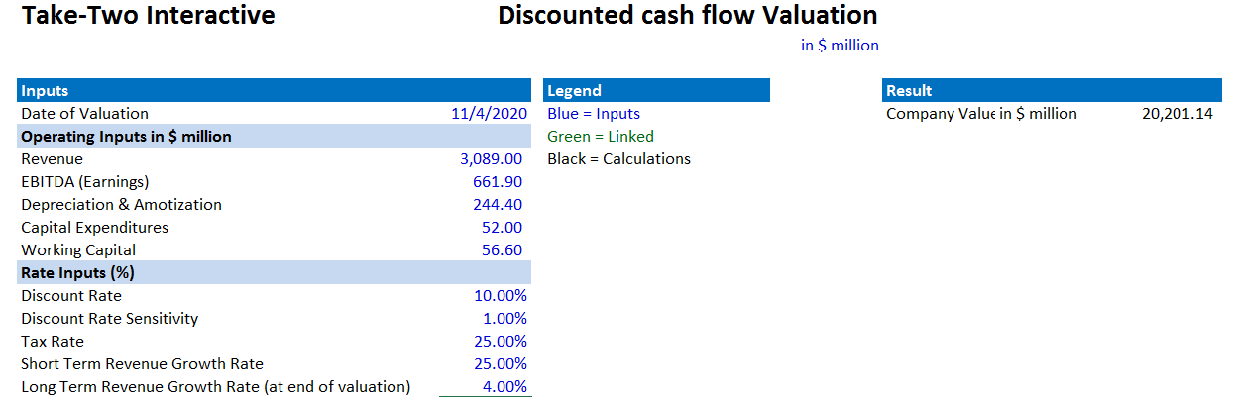
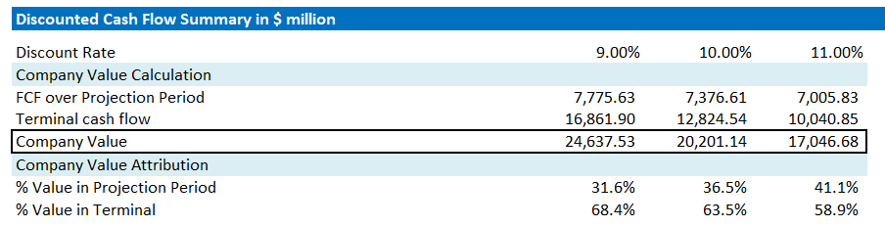
With our discounted cash flow model, we determined a total market valuation of $20,201,140,000; around $180 per share, an increase of over $20 per share. With a price target of $180 achieved from this method, Take-Two is a clear buy.
Multiples Method: Looking at the PE ratios of the four major competitors in this sector using the multiples method, we see that Take-Two (29.4) and Ubisoft (26.8) are trading at a premium. This could indicate that Take-Two may be overpriced, however other indicators discussed will outweigh this valuation.
Recommendation: With our valuation we achieved an overall price target of $180, which determines that Take-Two Interactive is a BUY

Stock Chart of the YTD Stock Performance
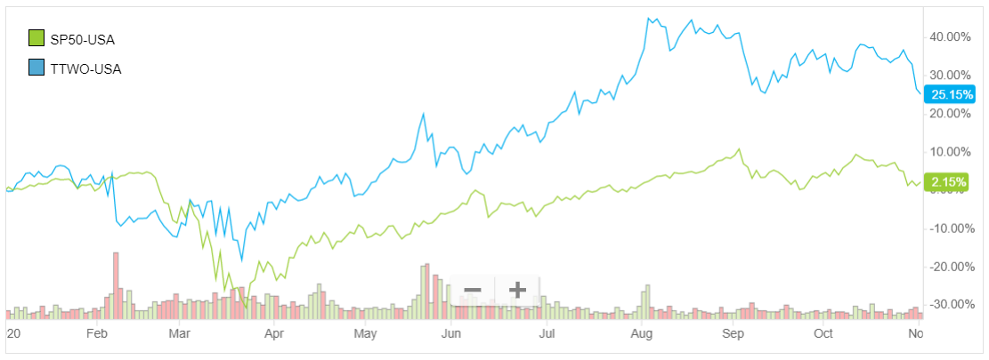
Utilizing the YTD stock performance graph, we can see that during COVID-19 and past the initial quarantine that Take-Two greatly outperforms the S&P 500. Take-Two does follow the general trends that the S&P 500 follow but present a significantly higher growth over the same period.
Peer Analysis
We found Take-Two Interactive’s three most comparable competitors and utilized various metrics to compare their current market positions.
Company | Price ($) | Market Cap (M) | Sales Recent FY (M) | PE (NTM) | PEG (NTM)
Take-Two Interactive | $ 154.03 | $ 17,713 | $ 2,990 | 29.4 | 3.8
Activision Blizzard | $ 75.73 | $ 58,528 | $ 6,450 | 21.5 | 1.6
Electronic Arts | $ 119.83 | $ 34,607 | $ 5,466 | 20.7 | 2.3
Ubisoft Entertainment | $ 88.23 | $ 10,876 | $ 1,858 | 26.8 | 3.0
Peer Averages |  | $ 30,431 | $ 4,191 | 24.6 | 2.7
Market Cap (M)
In early 2020 Take-Two’s holding 2K Sports signed a deal with the NFL for non-simulation football games. This allows Take-Two to compete with Electronic Arts and its monopoly in professional football video games, providing another avenue for them to gain market share over their consumers. Along with their avenues into mobile gaming, Take-Two presents a more dynamic outlook than their direct competitors.

Top Five Institutions | % OS
The Vanguard Group, Inc. | 10.97%
BlackRock Fund Advisors | 6.65%
SSgA Funds Management, Inc. | 4.95%
Massachusetts Financial Services Co. | 3.21%
Fidelity Management & Research Co. LLC | 2.96%
Ownership of Shares
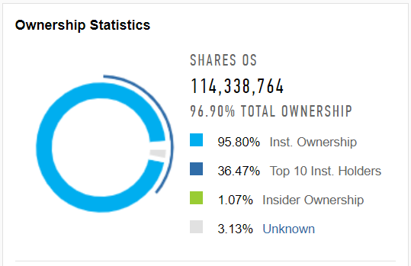

Top Five Insiders | % OS
ZelnickMedia Corp. | 0.51%
Goldstein Lainie | 0.19%
Zelnick Strauss | 0.15%
Viera Paul Earnest | 0.07%
Michael James Sheresky | 0.05%

