Valuation Date: 5/13/2020 Ticker: AVGO Recommendation: BUY Sector: Info Tech
Current Price: $ 272.23 Target Price: $311.79

Introduction
Key Statistics:
- 52 Week Range: $155.67-$331.58
- Avg Daily Vol (3 Mo): 3,611,330.3​
- Basic Shares (M): 399.8​
- Market Cap (B): 110.0​
- Dividend Yield: 4.7%​
- WACC: 8.3%

Broadcom Inc. was founded in 1961 and is a global technology leader, designing, developing and supplying a broad range of semiconductor and infrastructure software solutions. Broadcom’s category-leading product portfolio serves critical markets including data center, networking, software, broadband, wireless, storage and industrial. Their solutions entail data center networking and storage, enterprise and mainframe software focused on automation, monitoring and security, smartphone components, as well as factory automation.

Investment Thesis
- Semiconductor Solutions: Semiconductors are made by imprinting a network of electronic components onto a semiconductor wafer. These devices are designed to perform various functions such as processing, amplifying/selectively filtering electronic signals, controlling electronic system functions/processing, and transmitting/storing data. They provide semiconductor solutions for managing the movement of data in data center, telecom, enterprise, and embedded networking applications. They provide a broad variety of RF semiconductor devices, wireless connectivity solutions and custom touch controllers for mobile applications. They also offer semiconductor solutions for enabling the set-top box and broadband access markets and for enabling secure movement of digital data to and from host machines, such as servers, personal computers and storage systems, to the underlying storage devices, such as hard disk drives, solid-state drives, and a broad variety of products for the general Industrial and Automotive Markets.
- Infrastructure Software: Portfolio of mission critical software solutions enables customers to leverage the benefits of agility, automation, insights, resiliency and security in managing business processes and technology investments. These software products help customers improve economics by increasing throughput and lowering cost per transaction, increasing business agility through tooling and processes, increasing reliability and availability of operations through machine intelligence and automation solutions, and protecting enterprise data with security and compliance. Their software-based management tools designed to maximize uptime, dramatically simplify storage area networking deployment, and provide high levels of visibility and insight into the storage network.
- IP licensing: Broadcom has also entered into a variety of IP licensing and cross-licensing arrangements that have both benefited their business. A portion of revenue comes from IP licensing royalty payments and from technology claim settlements relating to such IP. The semiconductor industry is characterized by the existence of a large number of patents, copyrights, trademarks and trade secrets and by the vigorous pursuit, protection, and enforcement of IP rights; including by patent holding companies that do not make or sell products. Many of customer agreements require they to indemnify customers for third-party IP infringement claims. While, claims of this sort could harm the relationships with customers and might deter future customers from doing business with them.
- Acquisition: Broadcom’s strategy is to combine best-of-breed technology leadership in semiconductor and infrastructure software solutions, with unmatched scale, on a common sales and administrative platform to deliver a comprehensive suite of infrastructure technology products to the world’s leading business and government customers. They seek to achieve this through responsibly financed acquisitions of category-leading businesses and technologies, as well as investing extensively in research and development, to ensure products retain technology leadership. This strategy results in a robust business model designed to drive diversified and sustainable operating and financial results.

Valuation
A price target of $311.79 was arrived at through the utilization of two valuation models: a Discounted Cash Flow Model (DCF) utilizing ISS-EVA, and a Dividend Discount Model (DDM). The weighted average between these two results was then used to determine the most sufficient target price estimate.
DCF: For the discounted cash flow, forecasted sales growth rate was adjusted with our own assumptions into ISS-EVA. This led to an income statement valuation of $306. A weight of 60% was used in this model.
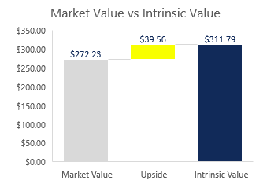
DDM: For this model, the current stock price of $272.23 was used in conjunction with a sufficient discount rate of 10%. Additionally, dividend growth was set at 22% with TTM dividends per share around $13.05. Due to Covid-19 and the economic impact, it can be assumed that the dividend growth will decline, but still have a similar potential appeal to investors. This led to the arrival of a $320.47 price target, with a 15.05% upside. A weight of 40% was used in this model.
Finally, intrinsic value was calculated to accurately arrive at the target price of $311.79, with a potential upside of 10.44% This amounts to an estimated $39.56 upside per share.

Risks
Reliance on key customers: Broadcom is dependent on a small number of end customers, OEMs, their respective contract manufacturers, and certain distributors for a majority of our business, revenue and results of operations. This customer concentration increases the risk of quarterly fluctuations in operating results and the sensitivity to any material, adverse developments experienced by significant customers. In addition, top Customers’ purchasing power has given them the ability to make greater demands on Broadcom with regard to pricing and contractual terms in general. This trend is expected to continue, which may adversely affect their gross margin on certain products and might also result in substantial liability that could harm business, financial condition and results of operations.

Dependence on component suppliers: Broadcom mainly adopts the outsourcing manufacturing business model. Their semiconductor products are usually manufactured according to a specific process that requires the most advanced manufacturing equipment and technology for semiconductor wafer manufacturers. Qualified manufacturers tend to have high costs, and their products may not be as cost-effective as current suppliers, which will reduce our profit margins. Due to the influence of the third-party manufacturer, they may not be able to meet the needs of customers and may not be able to fulfill contractual obligations. This could result in significant losses to customers and net income could decline, adversely affecting business, financial position and operating results.

Rising raw material prices: The manufacturing process relies on a variety of materials, including silicon, gallium arsenide and indium phosphide wafers, copper lead frames, precious and rare earth metals, composite molds, ceramic packaging, and a variety of chemicals and gases. Higher commodity prices, capacity constraints or other factors to extend the lead time, limit supply or raise prices, resulting in supply disruptions or increased demand. Broadcom’s business, financial position and operating results may be adversely affected if they do not obtain sufficient quantities of materials in a timely manner or at a reasonable price, if the quality of the materials deteriorates, or if they are unable to pass on higher material or energy costs to customers.

Adverse global economic conditions: A general slowdown in the global economy or in a particular region or industry, an increase in trade tensions with U.S. trading partners or a tightening of the credit markets could negatively impact Broadcom’s financial condition and liquidity. Such events may also cause customers and consumers to reduce, delay or forgo technology spending, resulting in customers sourcing products from other suppliers not subject to such restrictions or tariffs. This can lead to the insolvency or consolidation of key suppliers and customers, intensify pricing pressures.

Management
Broadcom’s Executive Team is made up of six members. Most of the company's executives have been with the company for more than a decade, meaning that they are familiar with the company's affairs and can skillfully use their working techniques to help the company run smoothly. Its board of directors consists of nine members. They come from a variety of industries and all have experience in other big companies like Google, ICS and so on. President, Chief Executive Officer: Hock E. Tan. Mr. Tan has served as President and Chief Executive Officer since March 2006. Mr. Tan previously served as the President and Chief Executive Officer of Integrated Circuit Systems, Inc. and also served as Chairman of the board of Directors of Integrated Device Technology, Inc. His extensive career in the technology industry in general, and in the semiconductor industry in particular, including service as the chairman of the board of directors of a publicly traded semiconductor company helps the company grow and expand its market share in the semiconductor industry.

Stock Chart of Past Year Performance

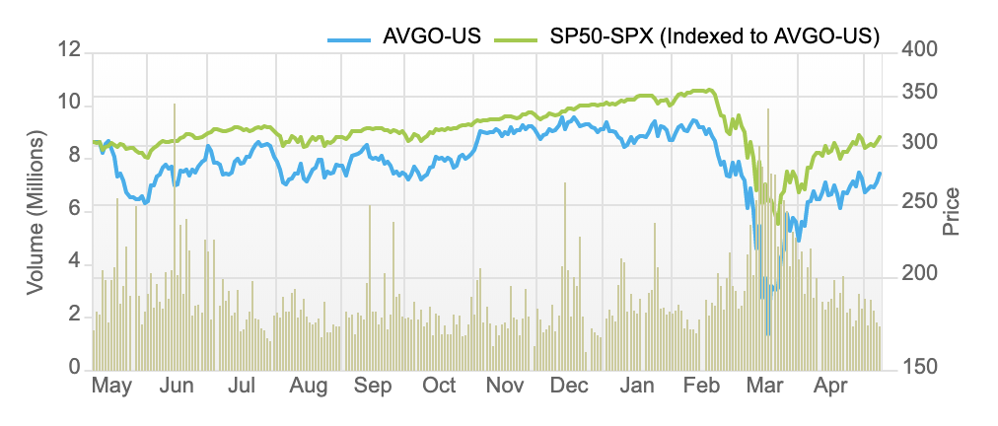
As shown in the graph above, Broadcom has been performing slightly below the market in the past year. However, years prior this reality was reversed. We see the current underperformance as only temporary, especially due to current repercussions from Covid-19. However, due to past performance and previous years, it is time to buy once again. Broadcom is a fantastic business that focuses on delivering strong free cash flow and revenue growth. Due to their focus on optimizing business acquisitions to in turn maximize sustainable free cash flow, it can be assumed that AVGO will once again return to beating market expectations in the near future.

Peer Analysis
Name ​ | Price ($)​ | Market Cap (Millions) ​ | 2019 Sales (Millions) | EBITDA (Millions) ​ | Dividend Yield (%)
Broadcom Inc. | 272.23 | 110,000 | 22,497 | 10,111 | 4.7
Infineon Tech | 19.34 | 24,783 | 8,929 | 2,195 | 1
Qualcomm​ | 80.53 | 90,624 | 24,273 | 9,482 | 3.2
NVIDIA | 322.16 | 191.4 | 11,716 | 4,112 | 0.2
Texas Instruments | 114.52 | 105,500 | 14,383 | 6,737 | 3.1
Analog Devices | 108.14 | 40,442 | 5,991 | 2,610 | 2.3
Marvell Tech Group | 26.41 | 17,804 | 2,865 | 481 | 0.9

While looking at some of Broadcom’s top competitors, there are a few key metrics to note. First off, AVGO has a very large market cap when compared to its peers. Secondly, they have the second highest sales in 2019, slightly second to Qualcomm. Lastly, they have the strongest dividend yield in the industry. This is something rare in the Information Technology Sector, which can be seen as a strong positive for many investors.

Ownership
Reflecting the data below, large Firms account for a high portion of the company’s stock ownership. In addition, three of the top five institutional shareholders chose to increase their holdings last year. On March 15th report, Broadcom’s co-founder, Samueli Henry, decided to raise his stake as well. This can be seen as a good indicator of future expectations.

Top 5 Shareholders
Owner | % of Ownership
Capital Research & Management Co. | 10.91%
The Vanguard Group, Inc. | 7.97%
Capital Research & Management Co. (International Investors) | 7.39 %
Capital Research & Management Co. (Global Investors) | 6.80%
BlackRock Fund Advisors | 4.58 %
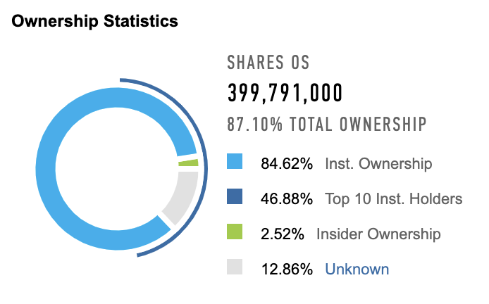

Recommendation
As of May 11, 2020, at the current price of $272.23, we recommend to BUY AVGO.

