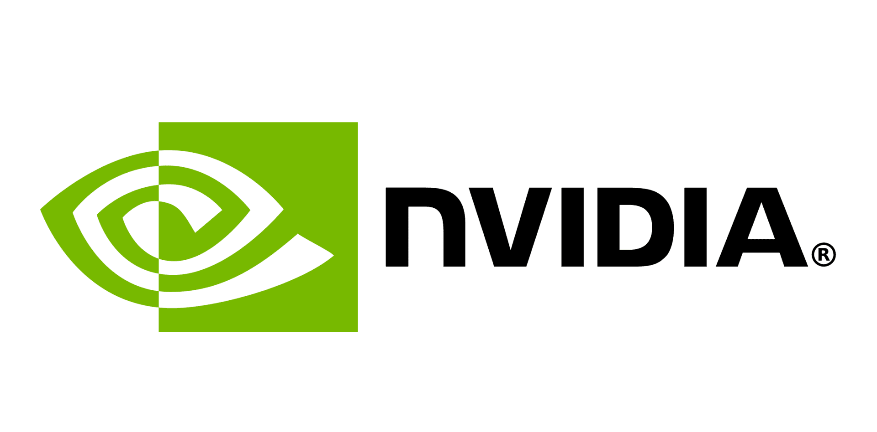
Valuation Date: 4/20/2020 Recommendation: BUY
Ticker: NVDA Target Price: $325.63
Current Price: $282.32 Sector: Information Technology
Key Statistics:
- 52 Week Range: $132.60-316.32​
- Avg Daily Vol (3 Mo): 15,008,263.0​
- Basic Shares (M): 612.5​
- Market Cap (B): 179.0​
- Dividend Yield: 0.2%​
- WACC: 8.3%

Introduction
Nvidia was founded in 1993 and is headquartered in Santa Clara, California. It designs graphics processing units (GPUs) for the gaming and professional markets, as well as system on a chip units (SoCs) for the mobile computing and automotive market. Since 2014, Nvidia has diversified its business focusing on four markets: gaming, professional visualization, data centers, and auto. Nvidia is also now focused on artificial intelligence. In addition to GPU manufacturing, Nvidia provides parallel processing capabilities to researchers and scientists that allow them to efficiently run high-performance applications. They are deployed in supercomputing sites around the world. For Fiscal 2019, Nvidia reported record revenue of $11.72 billion.

Investment Thesis
Nvidia focuses on GPU innovation and development. Based on its proprietary processors, Nvidia divides its market into four segments: Gaming, Professional Visualization, Data Centers, and Automobiles.

Gaming: Computer games are the biggest entertainment industry. Nvidia uses GPU improvements to improve the visual quality of graphics in computer games, improve the game's frame rate to enhance the game experience, and improve the sense of reality by integrating the behavior of light and physical objects. This technology can be used on its own or across platforms. In 2019, Nvidia's gaming revenue was $6.25 billion, up 13% from a year ago driven by growth in gaming GPUs.

Professional Visualization: Nvidia works closely with other software vendors optimizing GPU for them to serve the professional visualization market. Nvidia's GPU computing solutions increase productivity and introduce new capabilities to key parts of the workflow in major industries such as automotive, media and entertainment, construction engineering, oil and gas, and medical imaging. Professional visualization revenue was $1.13 billion, up 21% from a year earlier driven by strength across both desktop and mobile workstation products.

Data Centers: The NVIDIA accelerated computing platform addresses AI and HPC applications. NVIDIA's accelerated computing platform greatly improves the performance and power efficiency of high-performance computers and data centers. It accelerates the deep learning of AI and increases the workload of learning machines. Datacenter revenue was $2.93 billion, up 52% from a year ago, led by strong sales of some Volta architecture-based products.

Automobiles: NVIDIA’s Automotive market is comprised of cockpit infotainment solutions, AV platforms, and associated development agreements. Nvidia is working with hundreds of automotive ecosystem partners, including: automakers, truck makers, tier-one vendors, sensor makers, automotive research organizations, and high-definition mapping companies and startups to develop and deploy AI systems for self-driving cars. Automotive revenue of $641 million was up 15% from a year earlier, driven by infotainment modules, production DRIVE platforms, and development agreements with automotive companies.

Acquisition: Nvidia is committed to improving the company's product mix, fully optimizing its mobile platform and opening doors to new markets through its acquisition plan. Through acquisitions, Nvidia reorganizes the talent pool and becoming a better, bigger company.

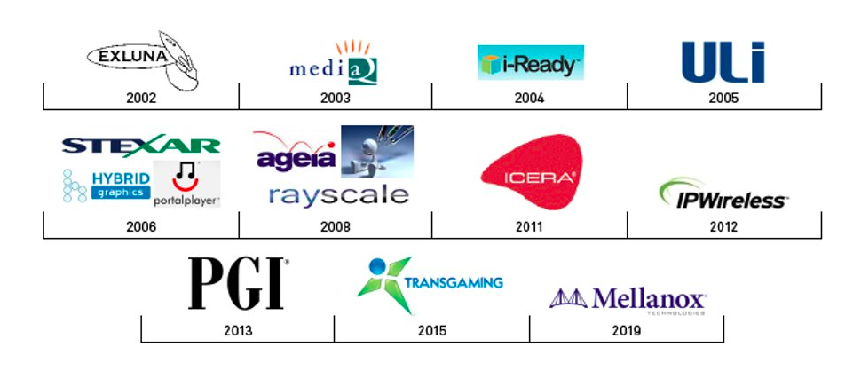

Valuation
We arrived at our target price of $325.63 through the utilization of two valuation models: a discounted cash flow model (DCF) and a P/E multiple method. We then took the weighted average between these two results to determine the most sufficient target price estimate.
DCF: For the discounted cash flow, we started by placing our assumptions into the model to get a discounted cash flow (shown below).
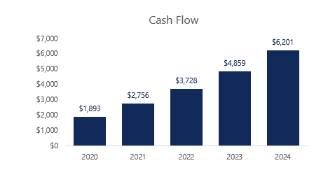
To calculate future years, we used a growth rate of 23%. Over the last five years, NVDA has averaged around a 50% EBIT growth rate; however, from 2018-2019, it dropped down to 20%. Due to our key segments listed in the investment thesis being expected to grow, we felt that 20% was on the lower side. Hence, the reason for the increased estimate to 23%.
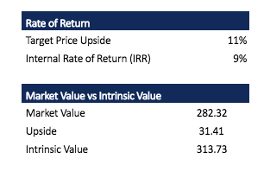
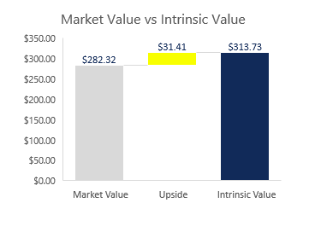
Lastly, market value and intrinsic value were calculated to determine our upside. Intrinsic value calculated out to be $313.73, giving us an upside of $31.41.
P/E Model: This model involved multiplying the 2019 annual EPS by the Median P/E to arrive at a price estimate of $337.53.
Finally, the results of these two models were combined for a weighted average. Both models were found to be of equal importance, so the weight was 50% for each of them. ($313.73*.5) + ($337.53*.5) = $325.63 This new weighted average has an upside of 15.34%.

Recommendation
As of April 20, 2020, at the current price of $282.32, we recommend to BUY NVDA.

Risks
Changing Market Needs: It is important for technology companies to keep up with the latest trends in the market. Nvidia's GPU-based visualization and accelerated computing platforms focus on four major businesses: gaming, professional visualization, data centers, and automobiles. Nvidia has invested a lot of resources in these businesses, and these investments may not generate objective income in the short term. If the investment is not successful, or the technology is not widely accepted by the market, then the revenue and financial impact will be noticed.

Intense Market Competition: As industry standards evolve and customer needs change, competition will intensify as new competitors enter Nvidia’s market. Competitors may have lower product, service, and technology costs as well as more advanced features. If Nvidia cannot successfully compete in the target market, this will lead to a revenue decline, resulting in a series of negative financial results.

System Security and Data Protection: Security holes and malicious cyber-attacks have become more common and complex this year. Preventing them successfully or implementing appropriate precautions becomes more difficult. Nvidia needs to design safer products to improve reliability and security, which can lead to increased costs. However, if the protection fails, it will not only interfere with the operation, but also have a negative impact on the reputation and the stock price.

Dependence on Third Parties: Nvidia relies on third party companies to test and package its products. This leads Nvidia to control product quality and product delivery schedule. In the production process, any change of a third party may cause the product to not meet the market demand.

Risk and Uncertainty in International Business: Nvidia has operations around the world. The semiconductor wafers in GPUs are made, assembled and packaged outside the United States. Sales from outside the United States accounted for 87% of total sales. Global political tensions, barriers and restrictions on imports and exports, different legal standards supporting property rights and employment practices, and climate change regulations all have potential to impact Nvidia’s sales and revenue.

Management
Nvidia's management team consists of two founders and four company officers with an average age of 58. Its Board of Directors has 12 highly educated members from a variety of industries. Prior to Nvidia, they all held key positions at large companies in their respective industries.

CEO: Jen-Hsun Huang co-founded Nvidia in 1993 and has served as President, Chief Executive Officer and Board Member. Previously, Mr. Huang held positions at Advanced Micro Devices, Inc., including micro design processor and LSI Logic Corp., where he was responsible for the Company's chip systems strategy. He turned Nvidia from a startup to a global leader in visual computing. Under his leadership, Nvidia has built a record of continuous innovation and sharp execution, and its products have gained strong market share.

CFO: Colette M. Kress joined Nvidia in 2013, as Executive Vice President and Chief Financial Officer. Prior to joining Nvidia, Ms. Kress held a variety of important financial positions at Cisco Systems, Inc., Microsoft Corporation, and Texas Instruments Incorporated. At Cisco Systems, Inc., she was also responsible for financial strategy, planning, reporting, and business development for the Operations and Engineering departments.

Stock Chart of Past Year Performance
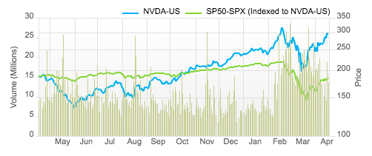
Over the past year, Nvidia's share price, which was roughly the same as that of the S&P 500 index at the beginning, fell sharply until it hit a low of $133.78 on June 3th. This is primarily due to a decline in revenues and adjusted net income margin due to a crashing Cryptocurrency Market. Share prices then took off, beating the S&P 500 around November and peaking on February 19th. On that day, the stock was worth as much as $314.70. Then, because of COVID-19, Nvidia’s share price fell along with the rest of the market. After the initial panic, share prices have risen steadily. We think it is now finally a right time to make a purchase.

Peer Analysis

Name ​ | Price ($)​ | Market Cap (Millions) ​ | 2019 Sales  (Millions) ​ | 2019 R&D  (Millions) ​ | EBITDA (Millions) ​
NVIDIA | 282.32 | 179,000 | 11,716 | 2,376 | 4,112
Intel​ | 60.63​ | 258,400​ | 33,100​ | 13,362 | 9,126​
Broadcom​ | 265.88​ | 106,300​ | 22,500​ | 4,700​ | 9,252​
Texas Instruments​ | 113.55​ | 106,500​ | 84,383​ | 1,544​ | 6,948​
Xilinx​ | 89.00​ | 22,146​ | 3,060​ | 743​ | 1,062​
Qualcomm​ | 76.17​ | 87,066​ | 24,300​ | 5,400​ | 9,271​
AMD | 56.60​ | 66,270​ | 6,730​ | 1,200​ | 919​

Ownership

Top 5 institutions/ Insider Stake holders | % OS
The Vanguard Group, Inc. | 7.55%
Fidelity Management & Research Co. LLC | 7.09%
BlackRock Fund Advisors | 4.51%
SSgA Funds Management, Inc. | 4.08%
Huang Jen Hsun | 3.53%

