Real Estate,
Telecommunications, and Utilities
Analysts: Jake Kennedy and Spencer Pederson
Senior Analyst: Kyle Kolb
Investment Strategy
October 3, 2018
Real Estate
Overview
Overall, real estate is looking very strong as it continues to be recovering from the 2008 recession. The industry as a whole has both key areas in which growth can occur as well as areas that still need to be developed. The industry is in the process of adapting to the plethora of technology changes that have taken place the century. Many real estate companies employ an older workforce which could be a reason for the industry struggling to keep up with all of the technological changes. In summary, we should be optimistic with regards to future implications as well as cautious and informed as to the subsectors that could potentially be declining.

Key Drivers
- Interest Rates- Like bond yields, demand for property typically has an inverse relationship with interest rates. As rates increase mortgage rates increase and thus dampen interest in acquiring property. Interest rates have recently only begun to rise, and the general consensus of many industry experts is that interest rates will continue to increase in the coming years. The effect of this trend will likely have an overall negative impact on the industry, however, the extent of the change in interest rates will be a telltale sign of what may be to come.

- Changing Demographics- The focus of this driver is focused mainly on the differing generational qualities as well as changes in population growth. For example, baby boomers are continuing their shift out of the workplace an into retirement. The implications of this change in demographics may be huge for senior living as well as retirement living markets (typically located in the southern U.S.). The differing qualities between generations (Baby Boomers, Gen X, Millennials, and Gen Z) range from housing preference to spending habits and will ultimately have a major impact on varying subsectors of real estate.

- Economic Conditions- Major economic players such as GDP and unemployment rates play a role in how profitable real estate companies may be. In short, when the economy is strong, the real estate industry is strong and vice versa.

- Technology- The overall impact of technology in any industry sector cannot go unnoticed. Real estate is an industry that seems to lag the ever-increasing changes in technology. The development and increase in the number of finTech real estate is causing a disruption within the industry and shifting big players focus to the improvement of technology within their companies. As this driver seems to potentially have the biggest impact in the coming future, the details will be explained further in a separate section.

Property Type Analysis
To gain a more detailed and granular understanding of an industry, it is necessary to take a closer look at the different subsectors. Each property type brings its own unique backstory to the table to be analyzed and broken-down differently.

Industrial- Over the last five years, industrial space users have consistently been noticing the benefits of facilities that best fit within their supply chain. This has caused an increase in the willingness of companies to prioritize and potentially pay more to rent out these spaces. The outlook of the industrial space seems poised for growth.
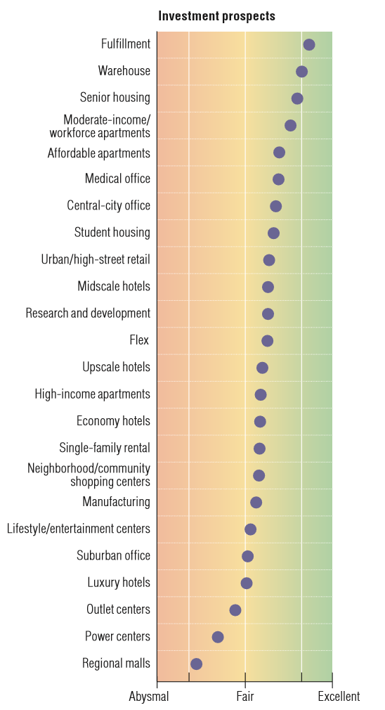
Office- A big influence as to growth within the office sector is whether the space is in a central business district (CBD) or a suburban location. CBD office builds have been performing strongly while offices in the suburbs have been growing at a significantly lower rate. Looking forwards, workplaces are offering the benefit of employees being able to work from home. The extent of this new trend is not yet having a large impact but should be considered by real estate companies in the coming future.

Apartments- As generations continue through different stages of life, the real estate industry fluctuates accordingly. As baby boomers are moving through retirement, the future of senior housing is expected to be an enticing market. Student housing for millennials (and now generation z) through apartments has been a market that has been not only steadily increasing but has consistently provided returns even through economic downturns. There are many questions, however, as to what the future may hold with regards to interest rate fluctuations as well as government policy changes.

Single-Family Homes- The single-family housing market has come a long way since the crisis of 2008. Homeownership rates declined from 2005-2016 by 6%, however, there seemed to be an inflection point in 2017 and rates have risen 1-2% since. The question is whether this trend will continue. To reiterate from the apartments section, rising interest rates raises questions as to the direction this industry is heading.

Retail- Of any area in real estate, retail seems to potentially have the bleakest future. With e-commerce and other technology, it appears the retail industry could be reaching maturation. However, it is widely believed the brick-and-mortar retail will still be the basis of the industry. The growth or decline of the industry will most likely depend on the ability and willingness of retailers to adapt to changing demographics.

There are many other subsectors that could be analyzed, however, these five areas account for the overwhelming majority of the current real estate industry. Ultimately, real estate investment trusts (REIT) and real estate development companies within every sector of the industry have areas they need to be focusing on in order to withstand coming future changes.

Future Implications
Technology is changing businesses globally. In the 1990s it cost around $3 million to create a tech start whereas today that price has dropped to around $300. FinTech startups are enabling efficient property searching, investments in real estate, and the input of smart building technologies. REITs and commercial real estate companies need to be working with and supporting these startups in order to shrink the gap between business productivity and the exponential curve of change in technology.
As the economy is nearing almost a decade of growth since the recession of 2008, the question is this: How long can the economy continue to sustain this level of growth? The Real Estate sector seems poised for growth in the near future, however, in the back of all our minds is the potential of an inflection point that could dramatically alter predictions.

Telecommunications
Overview
The telecommunications industry is currently in a period of massive transformation as new technologies begin to take hold. To implement these new technologies, capital investment will need to intensify, providing companies that focus on fiber and towers opportunity, and when these new technologies take hold, cellular providers will be able to find new ways to grow. As a result, the telecommunications industry has growth potential that can be unlocked in the coming years.
However, because of the massive amount of disruption this industry is experiencing, companies will need to be mindful of their core markets, as organizations that have core markets dealing in outdated technologies will struggle to keep up if they don’t expand their business models to include the new advancements. As a result, investors should watch to see which companies put the most effort in to stay with the trends and jump on new industry developments when they first occur, as these companies will likely be the ones who are able to thrive.

Key Drivers
- Internet of Things (IoT)- As wearable devices continue to become more popular, the ability to have connection to a cellular network will become increasingly important due to its ability to enable consumers to unlock the massive potential that wearable devices have. Along with wearables, other new technologies like connected cars and integrated home security and entertainment systems will provide new avenues of growth for cell providers like Verizon, AT&T, Sprint, and T-Mobile by giving them a new set of devices to provide service to.
- Continued Implementation of 5G Coverage- Now that 4G LTE coverage has largely dispersed through the market, cellular providers will look to 5G coverage to provide them with a new source of revenue and market share growth. Providers will need to be mindful of the fact that implementation of 5G coverage will require considerable investment, but an influx of capital will help to minimize service delivery costs and improve time-to-market for 5G technology, making the extra investment worth it.
- Capital Investment- As mentioned before, high amounts of capital investment will be required to continue to advance the industry. However, companies will also be looking to become more efficient with their resources, suggesting that capital intensity may not increase as sharply as actual capital investment.

Future Implications
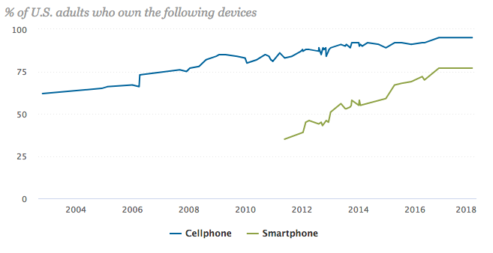
The telecom industry is one that has the potential to grow a great deal in coming years, but for this to happen, companies will have to find new opportunities for core market expansion and utilize these opportunities as much as possible. For example, smartphone ownership had steadily been increasing at a rate of roughly 10% per year since 2011, but between 2016 and 2018, it leveled off at around 77%, indicating that the market may be running out of room for growth. Because of this, companies will need to find new ways to differentiate their products to maintain a competitive advantage in the arena of smartphones. Differentiation will have to come not only from increasingly advanced products, but also from faster and more reliable cellular connections through the further development of 5G network technology.

Utilities
Overview
The utilities sector has shown consistent growth over the last decade. It is expected that the industry will continue in this direction, however, there are many shifts taking place within the industry itself. Utility customers show great enthusiasm towards the implementation of renewable energy in their communities and homes, but the current political stance on capitol hill is focused more so on the preservation of fossil fuels. Younger generations seem to be the primary voices of the desire for renewable energy, which is something to consider in the long-term. High levels of capital spending have been another trend recently. This spending is used to repair and improve infrastructure to provide a more efficient means of delivering the product.
Another area that impacts change rests in the economy. The United States economy could potentially be at a tipping point as it is believed to be in the late stages of the business cycle. The utilities sector is considered to be low risk and during recessional periods users still need heating, cooling, and power. In this scenario, the sector could perform well when compared to other industries. On the other side of the coin is continued economic expansion. The utilities sector has been underperforming when compared to the S&P 500 since 2008. Inflation rates in 2018 have been above 2% and interest rates are on the rise. High dividend yields tied to utility companies are less attractive during these times as fixed income becomes a more reasonable option. The next few years will most likely reveal the direction our economy is heading.

Key Drivers
- Digitalization- Digitalization of the utilities industry will allow companies to map out new ways to implement technologies to deal with challenges and take advantage of new opportunities. While this process does have high start-up costs, it also brings significant increases in levels of productivity and efficiency. Digitalization will help make power grids smarter, enabling more efficient operations moving forward.
- Increased Transport Electrification- On November 17th, 2017, Tesla unveiled a prototype for their new, fully electric semi-truck, with a plan for production by 2019. While an aggressive production plan like this may not be possible, the idea is there, showing that the future of over-the-road shipping is likely electric. Along with this, many cities around the United States already have electrified public transportation systems in place, and electric car sales went up by 35% in the first half of 2018 compared to the first half of 2017, showing that the trend is continuing to grow. With the increased electrification of transportation, utility companies have an opportunity to expand their services on both consumer and commercial levels to better handle electrified transportation.
- Interest Rates- Generally, the utilities sector has an inverse relationship with interest rates. A key component when investing in a utility company is analyzing their dividend yield. As the sector is considered to be relatively risk-averse, they can be safe investments with higher yields than fixed income alternatives when interest rates are low. However, when interest rates increase fixed income becomes the more desirable option.
- Oil and Natural Gas Prices- Utility companies frequently pass on increases in the price of oil or natural gas to the consumer, making a utility company’s strength depend a great deal on the prices of these commodities. With oil prices on a consistent rise dating back to late 2017, and natural gas prices showing strong, consistent growth heading into the winter, oil and natural gas appear to be growing positively for the time being. However, utility companies will need to keep a close eye on these markets and their trends to determine their best plan of action when it comes to their energy mix and to effectively deal with any price changes.
Future Implications
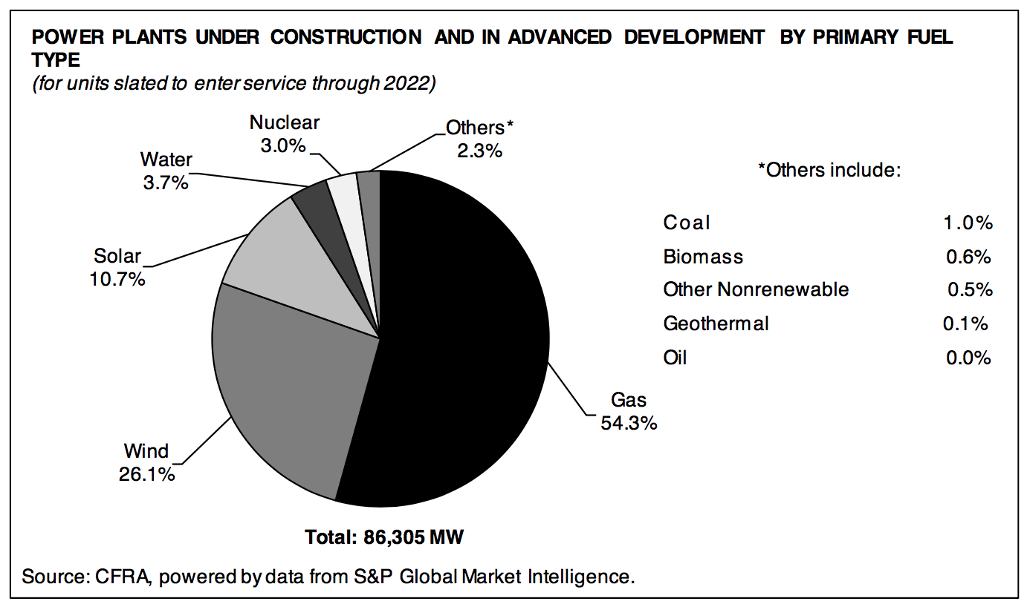
There are many things that need to be taken into consideration when looking at the future of utilities. On the positive side, industry fundamentals have been healthy and are supportive of dividend growth and earnings in the coming years. Because utilities have become a necessity during both times of economic expansion and recession, they can be a safe investment when considering the current stage in the business cycle. Negatively, interest rates are on the rise and deter the interest for a high dividend paying stock when a bond could provide larger coupon payments. As economic expansion continues, the defensive nature of the utilities sector becomes less attractive.
We believe that renewable energy could become a much larger player in the long term. The millennial generation is one that is heavily focused on the bettering and preservation of the environment. As they gain control over industries and politics there could be a strong push towards renewable energy. However, the current political climate is not in favor of renewables. This being said, utilities are by no means an industry that is expected to achieve some explosive level of change. There are some areas that may benefit in the short term and others in the long term, but as a whole, we expect steady and continued growth.

American Tower Corporation (AMT) Decision: Hold American Tower Corporation in a company that is heavily involved in both the real estate and telecommunications sectors. This real estate investment trust owns and operates numerous wireless communication and broadcast towers across the United States and the world. The main factors that are driving our decision to hold this investment include:
- Demand for not only a wider range of wireless coverage, but also faster coverage
- Increasing cell phone usage across the globe
- Strong fundamentals
There is some concern that the cell phone market in the United States could be reaching a maturation point. However, cellular towers continue to go up all over the country. With the implementation of 5G on the horizon, it is also expected that a demand for tower improvements will be on the rise as well. Outside of the United States, American Tower already has contracts to build tens of thousands of towers across the globe. Developing countries are seeing a rise in cell phone usage and this trend is expected to continue for years to come. Lastly, American Tower’s financials seem healthy and right around industry averages.
T-Mobile (TMUS) Decision: Hold
T-Mobile is a United States-based wireless network provider. Cellular services are provided under both the T-Mobile and MetroPCS brands, and services include wireless voice, messaging, and data services. The company is headquartered in Bellevue, Washington and was founded in 2004.
- Proposed T-Mobile/Sprint merger
- T-Mobile has a small market share
- Closing service quality gap
The proposed merger between T-Mobile and Sprint, which is currently under review by the FCC, will give T-Mobile added scale that will enable them to better compete with industry giants AT&T and Verizon. Along with this, whether or not the merger goes through, T-Mobile's market share will remain far smaller than Verizon’s or AT&T’s, giving them much more room for growth when compared to those two competitors. Finally, while T-Mobile's network quality has typically been rated behind Verizon’s or AT&T’s, the gap has closed a great deal in terms of both coverage quality and geographic area covered, reducing the competitive advantage of T-Mobile’s competitors moving forward. With successful implementation of their “Un-Carrier” strategy in recent years, as well as a marketing strategy that has effectively tapped into the value market, T-Mobile has established themselves as a smart industry player who is well-poised for growth.
Ormat Technologies, Inc (ORA) Decision: Sell
Ormat Technologies, Inc. owns and operates power plants that focus on geothermal and recovered energy. This company sells electricity and also offers energy storage and management-related solutions. The following are our reasons we suggest that we sell our investment in Ormat Technologies.
- Renewable Energy is not expected to achieve growth in the short term
- Low dividend yield for a utility company
- Recent officer and director issues
The current leaders of our country are not focused on the implementation of renewable energy in our country. On top of this, they are protecting other areas that produce energy such as fossil fuels. Another factor in our decision to sell this investment is the low dividend yield that comes from this company. We believe that it is important to have a utility company that has a high dividend yield to potentially be an area of growth during recessional periods. Lastly, a shareholder derivative complaint was recently filed against company officers for breaching their fiduciary duties which hurt our position in the stock.

