Junior Analysts: Vince Herber and Chao Han
Senior Analyst: Riley Tollison

Introduction
Enterprise Product Partners L.P. is a large American midstream focused energy company. They operate entirely in the United States, with their headquarters located in Houston, Texas. Enterprise provides midstream services such as pipelines, storage and natural gas processing. Founded in 1968, Enterprise has grown to one of the largest midstream companies in the United States. Since its IPO in 1998, Enterprise’s assets have risen from $715 million to $57 billion (as of December 31, 2019). Operating in the midstream sector allows Enterprise to collect revenue in a largely fee-based way, which helps withstand changes in energy prices and market volatility. Currently, Enterprise employs over 7,000 people.
COVID-19 Impact
Since the beginning of 2020, there has been a clear contrast between the performance of the S&P 500 (+14.23%) and the performance of Enterprise (-25.96%). Since the beginning of the COVID-19 pandemic, countries all around the world went into lockdowns, work and school became virtual for many, and travel between countries became strictly prohibited in most places. As a result, the worldwide demand for oil dropped significantly, which sent oil prices way down and the energy sector took a big hit. Since mid-March, the energy sector has taken the biggest hit of any sector, dropping by 26.83%.
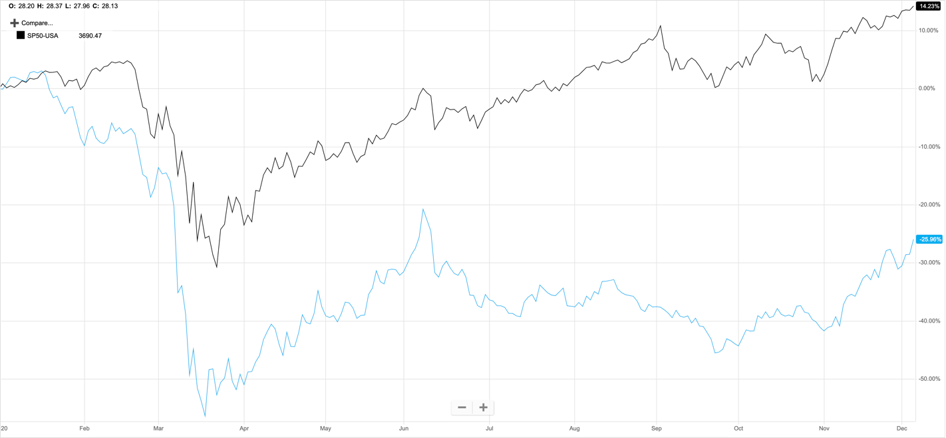
S&P 500
EPD

-25.96%
14.23%
However, with Enterprise being a midstream-focused company, it is less sensitive to changes in oil prices compared to upstream or downstream-focused companies. Upstream companies rely heavily on oil prices because they want to limit their exploration for oil if prices are low and won’t produce a profit. On the other hand, downstream companies rely on oil prices because they are the ones selling the final goods and products. If oil prices are low, they will have to sell their products for a cheaper price. We’ll show later, when talking about revenue and looking at the peer analysis, why Enterprise is undervalued and why the company didn’t take as much of a hit from COVID-19 as you would expect.
Revenue Streams
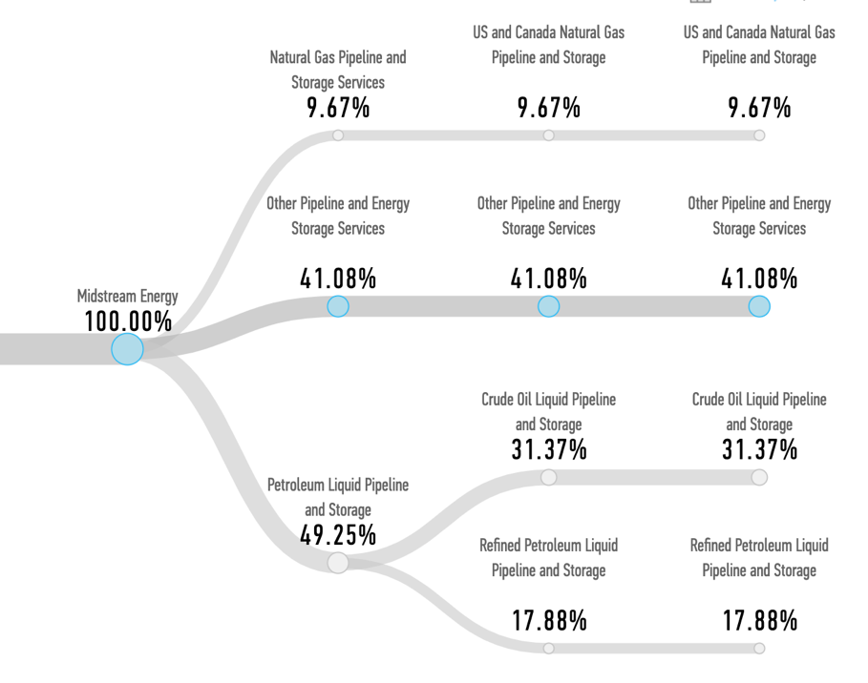
100% of Enterprise’s revenue comes from the midstream segment of the energy industry. Within the midstream segment, about half of the revenue comes from petroleum liquid pipeline and storage. This includes the transportation and storage of crude oil and refined petroleum liquid. The other half of Enterprise’s revenue comes from pipelines that transfer and store natural gas and NGL’s. Although the revenue is split between petroleum liquids/oil and natural gas/NGL’s, the NGL pipelines produce the biggest gross margins for Enterprise.
NGL’s are the key to producing lots of everyday items. From cellphone parts to everyday PPE, NGL’s are responsible for most of the plastics used to make those products. Demand for NGL’s remained steady during the onset of the pandemic as it was needed to produce things like masks, gloves, and ventilators.
Recommendation
As of 12/04/20, we recommend to BUY Enterprise Product Partners L.P. with a target price of $24.38.
Investment Thesis
- Enterprise has very diversified assets that allow for consistent cash flow from different types of operations. With over 50,000 miles of pipelines, storage capacity for crude oil and natural gas, natural gas processing plants, and terminals to import and export products, Enterprise has revenue coming from multiple different avenues within the energy industry. As the COVID-19 vaccine begins to be distributed and we begin to move past this pandemic, we believe Enterprise has more room for acquisitions and growth within the energy industry.
- A large majority (about 85%) of Enterprise’s operating income is fee-based. This allows for more stable cash flows, with outside factors having way less of an impact than it would on upstream or downstream companies. We believe this is a great income model to have to withstand volatility and the negative effects of the ongoing COVID-19 pandemic.
- Enterprise offers a very high dividend. Since 2014, Enterprise’s dividend has grown by an average of 4.17% per year. The growth rate has slowed a bit in the past couple years, but this has allowed Enterprise to reinvest more money into the company and add to its assets. They have a current dividend yield of 8.85%.
- Enterprise, and its management, has the experience and the relationships that gives them an upper hand in this industry. The management team has a diverse set of experiences within the energy industry and have been successful navigating through different economic conditions. This is very important as we are still in the middle of a pandemic.
Risks
- One risk is the political and environmental policies that may try to be implemented. The United States seems to be shifting towards a more environmentally friendly approach. However, we don’t see this as a major issue over the next 10-20 years. According to the IEA, global energy demand is expected to reach pre-pandemic levels by 2022 and will continue to increase in the following years. Although there is some political and regulatory uncertainty, we believe that oil and gas demand will continue to rise for many years to come.
- Another risk is a cut back on investment due to a longer COVID-19 recovery than expected. Along with most major energy companies, Enterprise had to cut back some capital spending projects due to COVID-19. If the pandemic goes on longer than expected, that could continue to remain the case and delay future growth. If this is the case, we still feel comfortable with Enterprise’s position. They had a 1.7x distribution coverage ratio for Q3 of 2020, which is a great position for a midstream energy company in the middle of a pandemic. This should allow for Enterprise to continue its dividend growth that it’s had over the past couple of decades.
Valuation
We used three different valuation techniques to best determine the intrinsic value of this stock.
P/E Multiples Model
Since 2000, Enterprise has traded at a consistent P/E ratio of anywhere between 20-30. Only during the great recession did the P/E ratio fall closer to 10. Because of the COVID-19 pandemic, Enterprise P/E ratio has fallen back down and currently sits at 10.10.
With a strong business model to withstand this pandemic, we believe the P/E ratio will increase closer to pre-pandemic levels. We weighted half of our model with the current P/E ratio of 10.10, and the other half of an average over the last five years of about 15.26. With EPS, we used the same technique by weight half of the current EPS and half of the EPS average over the last five years. We are confident in using these numbers based on our belief that Enterprise is built to survive the rest of this pandemic and then thrive afterwards.
After arriving at a P/E value of 12.68 and an EPS of $1.83, we arrive at a target price of $23.20.
Dividend Discount Model
Due to the very stable dividend growth that Enterprise has had since its IPO in 1998, we opted to use the dividend discount model in our valuation. The dividend discount model is very helpful when evaluating companies with consistent dividend growth. We expect next year’s dividend to be around $1.81. Although dividend growth has been high over the last 20 years, we believe this growth will slow until we are fully recovered from this pandemic. We decided to set the dividend growth rate at a conservative 1%. However, we expect this growth rate to eventually increase in 5-10 years. Lastly, we arrived at a base WACC of 7.60%. However, we changed the WACC in the model to show its effect if it were to increase or decrease.
WACC | Weight | Price
7.20% | 0.1 | $29.19
7.60% | 0.7 | $27.42
8.00% | 0.2 | $25.86

After weighting out the three prices shown in the chart above, we arrive at a target price for the dividend discount model of $27.29.
Graham Number Model
We chose this model because of its very conservative approach. Graham believed that a company's P/E ratio should not exceed 15, while the price-to-book ratio shouldn’t be above 1.5. The formula consists of taking the EPS and BVPS, along with the 15 P/E ratio and the 1.5 price-to-book ratio. By multiplying all four numbers and then taking the square root of that calculation, we arrive at our target price for this model. Below is the model:
$$\sqrt{15×1.5×2.05×11.13}$$
Using the model, we arrive at a target price of $22.66.
Valuation Summary
Valuation | Target Price | Upside
Dividend Discount Model | $27.29 | 31.45%
P/E Multiples Model | $23.20 | 11.75%
Graham Number Model | $22.66 | 9.15%

As shown in the table above, we arrived at three different target prices from our model.
In our most bullish valuation (Dividend Discount Model), we arrive at a target price of $27.29. In our most bearish valuation (Graham Number Model), we arrive at a target price of $22.66.
After equally weighting all three models, we arrive at a target price of $24.38. This is an upside of 17.15%.
Peer Analysis
Company | Market Cap (m) | Div. Yield | 5 yr. EBIT Growth
Enterprise (EPD) | $45,317 | 8.57% | 9.70%
Kinder Morgan (KMI) | $33,798 | 7.03% | -3.60%
Plains (PAGP) | $2,358 | 7.38% | 0.50%
Energy Transfer (ET) | $18,697 | 8.80% | n/a

Some of Enterprise’s biggest competitors in the midstream segment are shown in the table above. One advantage Enterprise has over its peers is the amount of capital they have. Enterprise is loaded with assets and cash that will allow them to maintain their standing as a top midstream energy company in the United States. It will give them an advantage post-pandemic as they will be able to invest in more growth opportunities.
Another advantage that Enterprise has on its peers is its longstanding relationships with upstream and downstream energy giants. Having these longstanding relationships gives Enterprise an advantage with future business opportunities.
Management
Enterprise has a very experienced management team, with lots of prior experience battling the ups and downs of the energy industry. This is a big sign of confidence as Enterprise is battling, and will continue to battle, the effect that the COVID-19 pandemic has had on the energy industry. On average, the members of the management team have over 30 years of industry experience.
Randall Fowler is the current Co-CEO and CFO of Enterprise. He joined Enterprise in 1999 as director of investor relations. He has held numerous other positions within Enterprise during his rise to CEO and CFO. Fowler earned a bachelor's and master's degree from Louisiana Tech University. Fowler currently serves on the advisory board for the college of business at Louisiana Tech. Fowler also serves on multiple other boards.
Along with Fowler, A.J. Teague also serves as a Co-CEO of Enterprise. Teague has also held a director position at Enterprise since 2010. Teague joined Enterprise in 1999 after working 22 years for Dow Chemical. Over his career at Enterprise, he has held multiple leadership positions in his climb to Co-CEO of the company. Teague also serves on many boards within the industry.
Ownership
Enterprise is different from other companies because a very large percentage of their outstanding shares are owned by insiders. However, this shows that the management team is very confident in the future of the stock. Over the last couple of months, Co-CEO A.J. Teague has purchased shares at around $19-$20. This displays his confidence in the growth of the stock and the current value of it.
Here are some more insights into the ownership of Enterprise:
Rank | Institution | % OS
1 | Harvest Fund Advisors LLC | 2.01
2 | Tortoise Capital Advisors LLC | 1.22
3 | Goldman Sachs | 1.07
4 | ALPS Advisors Inc. | 0.89
