**Kimberly-Clark Corporation**

April 18, 2018

Caiti Setterman | Griffin Egan Consumer Staples Sector

# Introduction

Kimberly-Clark Corporation (NYSE: KMB | price: $106.54) is a Fortune 500 multinational corporation specializing in the manufacturing and selling of personal care products. KMB operates in three distinct operational segments: Personal Care, Consumer Tissue, and K-C Professional. Based out of Irving, Texas, KMB has been operating for over 140 years and has expanded into 35 different countries world-wide. KMB has a vast number of products and product lines, but the most popular and top performing products include Kleenex facial tissues, Kotex cleaning and hygiene products, as well as Huggies disposable diapers. With over one-quarter of the population purchasing products daily, Kimberly Clark generated $18.26 billion in revenue during 2017, and is on track to continue their successful operations and maintain their strong market position for the coming years.

# Recommendation

We issue a buy recommendation for Kimberly-Clark Corporation based on a 1-year target price of $131.18. This intrinsic value represents a 23.14% upside potential from the April 18, 2018 closing price of $106.54. Throughout the last 5 years, KMB has experienced slightly declining revenue streams. It is important to note that industry peers have also been affected by the weak selling environment. Because of this consistent decline in revenues, KMB is taking steps towards developing a new business strategy to aid in growth and increased market share. A main portion of the company’s new strategy involves increased cost cutting efforts. KMB has identified a variety of ways to enhance the company’s productivity including expansion into emerging markets and the cutting out of underperforming brands. Specific details regarding this new strategy will be made public on April 23, 2018 during the 2018 Q1 Earnings Release.

# Investment Thesis

***Product Innovation:*** Kimberly Clark’s products target a variety of consumers from babies to seniors. A first-mover business strategy has been the company’s focus, as they pride themselves in creating essentials for a better life for people everywhere. By combining creativity with technology, KMB has been able to create innovative products for consumers around the world.

***Cost Cutting Initiative***: Trends of declining revenues have encouraged KMB to consider a serious change in their cost-cutting efforts. Currently, the company’s standard cost cutting program is to decrease annual expenses by $450 million. Over the next three years, KMB plans to double their efforts, adding an additional $500 million to their standard program. It is projected that this restructuring will not only show success in decreasing the company’s annual expenses, but also power earnings growth and adjusted EPS growth in the years to come. Additionally, KMB plans to use saved costs to increase its dividend payout 3%.

***Expansion Into Emerging Markets:*** With a majority of its current focus in developed markets, such as the United States, KMB’s revenues have been largely affected by recent price cuts. Therefore, the company has identified another opportunity: expanding into emerging markets, such as China, while simultaneously cutting out underperforming brands within their existing product lines.

# Valuation

To reach an intrinsic value for KMB, two valuation methods were used. The first method used for valuing the company was a five-year DCF model. Using a terminal growth rate of 2% and a WACC of 7.28%, a price of $120.84 was derived. A sensitivity analysis of ±.25 on the terminal growth rate and WACC resulted in an intrinsic value range from $119.63 - $122.17. The second valuation method used was a P/E multiples valuation. Peers were selected through the analysis of annual revenues, market cap, P/E ratios, and inventory turnover ratios. A chart of the peers used in this relative valuation can be found in *Table 1*. Using KMB’s 2018 diluted EPS of $6.40 and a peer average P/E ratio of 22.11x, a relative valuation of $141.53 was derived. Weights for the models were split 50/50 and resulted in a 1-year target price of $131.18, representing a 23.14% upside potential.

# Risks

Within the household products industry, we see two main components that could serve as a risk for Kimberly-Clark: high domestic competition and the need for strong and unique innovation. KMB is currently pursuing several different avenues to mitigate the effects of these potential risks.

***High Domestic Competition:*** With many well-established companies in the Household Products sector, such as Procter and Gamble, Unilever, and Colgate, competition for the U.S. domestic market is incredibly high. Because of this, companies in this industry must focus on creating brand loyalty as well as new products to create new growth opportunities in order to gain larger percentages of the domestic market and beat out their competitors. KMB is well aware of this potential risk and is pursuing growth initiatives aimed at combatting this risk.

***Strong and Unique Innovation:*** Stemming from the many key players, much of the market has already been capitalized on which creates a need for new methods of innovation for a company in this industry to grow and thrive. The main method for innovation that we identified, which will be vital going forward, is gearing operations and products toward millennials and online-channels. If current market leaders cannot get ahead on these types of innovations and evolve their business, they may fall behind in relation to their competitors and the market.

# Management

Thomas J. Falk (59) currently serves as the Chairman and CEO for KMB. Mr. Falk, with 33 years tenure, was elected Chief Executive Officer in 2002 and Chairman of the Board the following year in 2003. Prior to these elections, he served as the company’s President and Chief Operating Officer for four years. Mr. Falk also serves on the Board for a number of prestigious organizations. Additionally, KMB has formed an extremely experience team of regional Presidents and Senior Vice Presidents to lead the company.

# Stock Chart of Past Year Performance

**Figure 1: KMB Stock Prices**

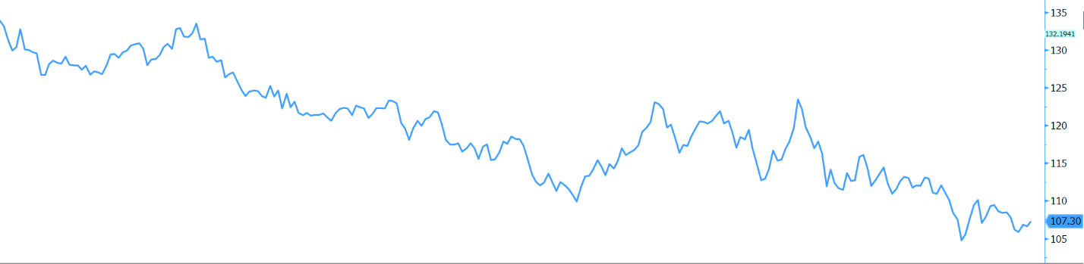

Source: Bloomberg

# Peer Analysis

**Table 1: Valuation Peer Analysis**



# Ownership

**Table 2: KMB Ownership**



# Top 5 Shareholders

**Table 3: KMB Top 5 Shareholders**

