**Boingo Wireless (NASDAQ: WIFI)**

**Spencer Pederson and Jake Kennedy October 22, 2018**

**Introduction**

Boingo Wireless Inc. offers wireless connectivity solutions for a variety of consumer devices including laptops, smartphones, and more recently, wearables. Boingo focuses on providing their services at large venues such as stadiums, airports, military bases, universities, and large apartment complexes. To support the highly concentrated demand for internet connectivity in these locations, they use distributed antenna systems (DAS) and small cell networks that strengthen signals to fulfill this demand. Boingo also offers the ability for internet service providers, such as Verizon and T-Mobile, to use their DAS networks to provide better coverage for their consumers. Although Boingo focuses primarily on the United States, their reach spans across the world with a network of around 1.5 million hotspots. Founded in 2001, they were originally known as Project Mammoth, Inc. Boingo is currently headquartered in Los Angeles, California and is striving to achieve their goal of connecting the entire world to wireless networks.

*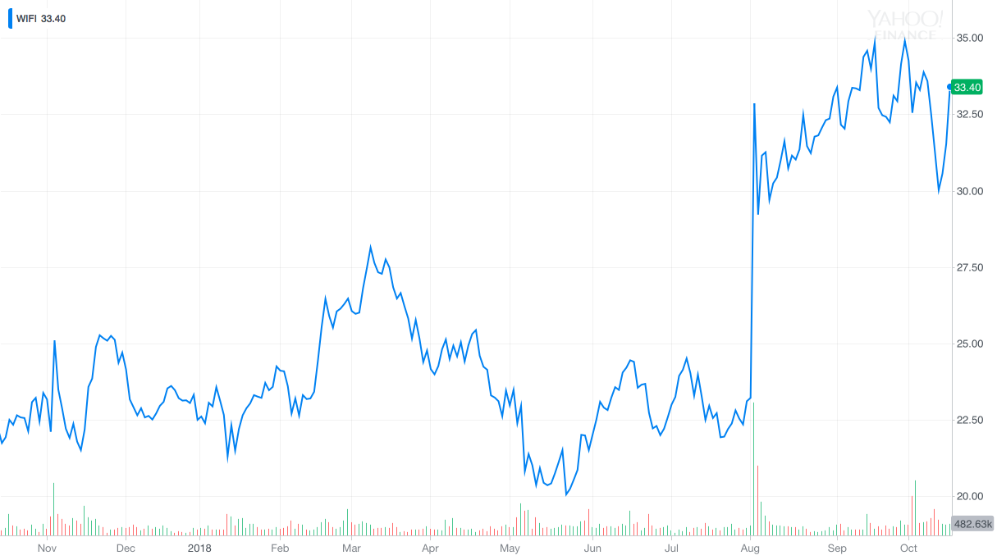One Year Stock Price History*

**Recommendation**

We recommend a BUY for Boingo Wireless Inc. Boingo has experienced double-digit revenue growth for the last 15 quarters and this trend is expected to continue. Although recursion to the mean is inevitable, we expect Boingo to have the highest increase in revenue and net income they've ever experienced over the next two years. This dramatic increase will occur due to the expected number of new DAS venues to be added to their network, the profound impact of the addition of a new revenue segment (small cells), and the rise of 5G. Ultimately, we have reached a target price of $47.69 which represents a 45.62% upside from the closing price on October 19, 2018, of $32.75.

**Investment Thesis**

Boingo has experienced a large amount of growth over the course of the past two years. This is largely due to the introduction of new segments including military and DAS. The addition of new segments has essentially "diversified Boingo's portfolio" which makes them less susceptible to market risks. Along with this, Boingo is in a league of its own. They are able to provide wireless connectivity across the entire United States, while its competitors typically only compete on a regional basis. This being said, the basis of our thesis is that revenue estimates for Boingo will be exceeded for the following three reasons:

DAS- Boingo currently has 47 DAS venues live with a backlog of 78 contracts that have been signed and are expected to be implemented within the next 18-24 months. In other words, Boingo's largest source of revenue is expected to triple in size over the next two years. We feel that current estimates are somewhat reflective of this expected increase in revenue in this segment, however, are not reflective of the following two areas.

Small Cells- This is a new business segment that Boingo is expected to introduce over the next year. The best way to think of small cells is simply DAS but on a smaller scale. Boingo already has a plethora of experience with large venues and they will now bring this experience to the higher number of smaller venues in the market.

5G- This is the pinnacle of our thesis. Leaders of the development of 5G expect the product to be rolled out by 3Q18 and we feel that it will be an incredible boost to Boingo. To understand 5G, one must understand the difference between 3G, 4G, and 5G. As you go higher in "G's", efficiency and speed increases, however, the coverage area decreases. Boingo's products, specifically DAS, can be viewed as individual cell towers. In other words, this decreased coverage area that comes with 5G can be amplified with Boingo's services, and we expect carriers and property owners to desire to remain competitive and use these services.

**Valuation**

Our process for valuing Boingo Wireless utilized two different models, as well as a Monte Carlo Simulation with sensitivity analysis to look at different simulations for market conditions and what effect these market conditions would have on the stock price.

The first model we used was originally a Two-Stage FCFF approach. However, while building the model we noticed that Boingo’s FCFF numbers were extremely volatile due to rising and falling capital expenditure levels from year to year. We did not want to use this figure for a growth rate in our model because we felt that it wouldn’t provide a good representation of base-level cash-flow growth for Boingo as a company. Instead, we decided to use Operating Cash Flow numbers to determine a growth-rate number for Boingo because we felt that this would provide a more accurate picture of their growth as a company. Using OCF numbers from 2011 through 2017, we calculated a growth rate estimate of 25.85%. Keeping this number in mind, we moved to our Two-Stage OCF valuation, where we used more conservative growth rates of 18% for the first stage and 5.5% for the second stage. Using a WACC of 11%, as well as numbers for cash, debt, and shares outstanding from Boingo’s financial statements, we calculated a target price of $69.89. Knowing that we used OCF rather than FCFF, we feel that a realistic price target for Boingo when looking at this number is between $40 and $50.

Our second valuation model was a multiples approach. First, we used EV/Sales, EV/EBITDA, EV/EBIT, and P/E ratios calculated using the financials of five main competitors of Boingo to determine four different target prices for our stock. We then averaged these four prices out, getting us to a target price of $38.18. We then took a weighted average of the target price obtained using the Two-Stage OCF approach target price (weighted at .3) and the Multiples target price (weighted at .7), giving us a final target price of $47.69. Looking at this number, we feel that Boingo's stock provides a massive upside opportunity moving forward.

**Risks**

Current Market Conditions- The majority of the market will not be immune to the effects of an economic downturn. Being in the late stages of the cycle is cause for concern with the unexpected timing of an inevitable market correction. This being said, we believe that Boingo is still positioned to do well during these times of uncertainty. For one, wireless connectivity has become more and more of a necessity for consumers in both everyday life, as well as in the work environment. Another key area that Boingo has invested in is the student housing market. During economic downturns, it has been observed that enrollment rates increase and thus it is expected that wireless usage in these areas will experience growth. This being said, we can expect revenue to continue to grow, however, at a slower rate than what has been predicted in this document.

Unknowns of 5G- There are many things that are still unknown about 5G. Although we are all but certain that 5G will come about, the timing is somewhat uncertain. We, along with many tech companies on the forefront of the development of 5G, expect 5G to hit the market on a large scale by Q4 of 2019. However, if there are some complications that arise, there is a possibility that 5G could show up slightly later. If this is true, then our expectations of revenue growth will simply shift to a slightly later time period. Again, we feel that Boingo is still positioned for heavy growth with areas outside of 5G, especially in the DAS segment.

**Management**

Boingo Wireless has an entrenched management team that has shown a great deal of commitment to the company. David Hagan has been the company’s CEO since 2004, before which he had been President of Boingo beginning in 2001. Mr. Hagan’s overall compensation is 50% fixed and 50% variable, with the variable portion being performance-based compensation that consists of both stock and yearly bonuses. Boingo’s CFO, Pete Hovenier, has been in his position since November 2012 and has been a Boingo employee since 2002, and like the CEO, his compensation is tied to the performance of the company through the use of incentive-based rewards using performance standards. These two executives have been members of the Boingo team for many years, and their commitment to the company through thick and thin shows that it is in good hands moving forward. Along with this, their largely performance-based compensation, which is similarly structured when compared to other members of the management team, is well set-up to motivate Boingo executives to put their best foot forward when it comes to operating the company and growing it in the future. Boingo’s Board of Directors consists of 11 directors, of whom 6 are executives at Boingo. The average director age is 56 years, and the average tenure on the board is 8 years.

**Peer Analysis**

**Ownership of Shares**

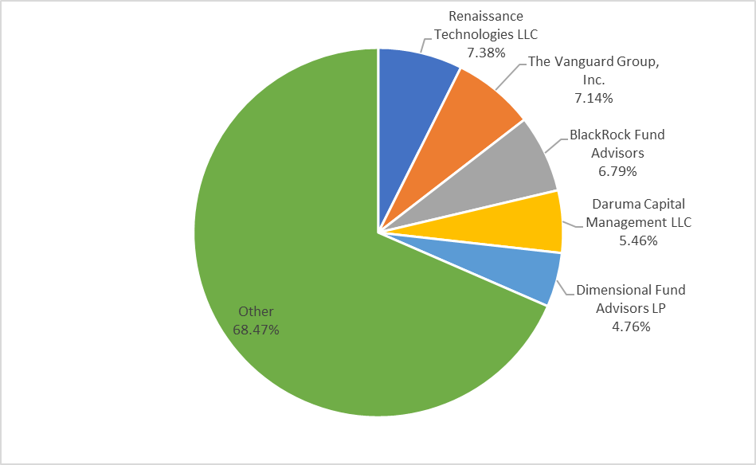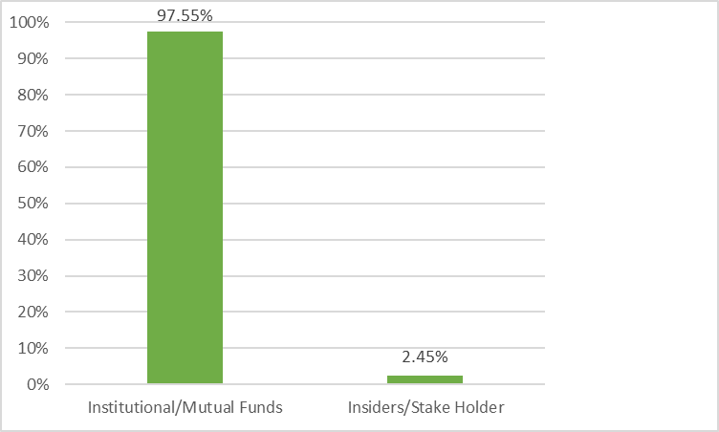 *Insider vs. Institutional/Mutual Funds Top 5 Shareholders*