RuoQian Hu & Yichen Huang

Senior Analyst: Megan Peterson

Ticker: SPGI

Current Stock Price: $341.57
Introduction:
S&P Global, Inc. engages in the provision of transparent and independent ratings, benchmarks, analytics and data to the capital and commodity markets worldwide. It operates through the following segments: Ratings, Market Intelligence, Platts and Indices. The Ratings segment offers credit ratings, research, and analytics to investors, issuers, and other market participants. The Market Intelligence provides multi-asset-class data, research and analytical capabilities, which integrate cross-asset analytics and desktop services. The Platts segment provides information and benchmark prices for the commodity and energy markets. The Indices segment provides variety of valuation and index benchmarks for investment advisors, wealth managers and institutional investors. The company was founded by James H. McGraw and John A. Hill in 1917 and is headquartered in New York, NY. Its primary areas of business are financial information and analytics. It is the parent company of S&P Global Ratings, S&P Global Market Intelligence, and S&P Global Platts, CRISIL, and is the majority owner of the S&P Dow Jones Indices joint venture. "S&P" is a shortening of "Standard and Poor's".
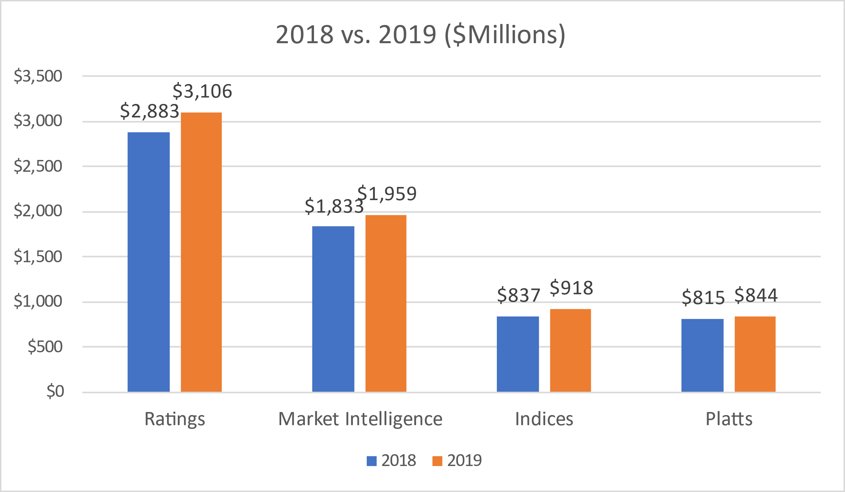
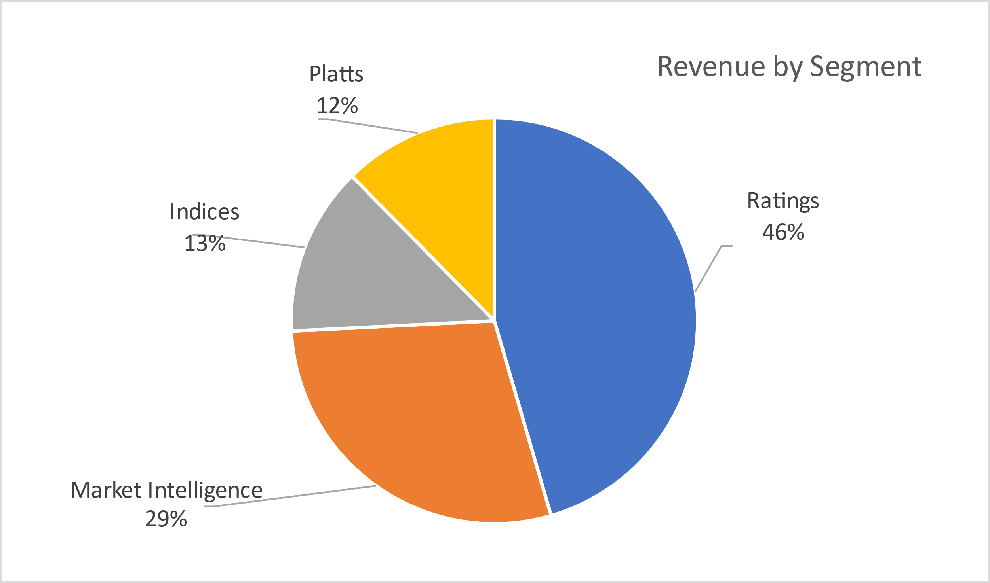
Revenue:

The first graph indicates that S&P Global, Inc. divides their business into four main segments. The most important part is ratings. In addition, S&P Global, Inc. plays 80% of rating market share, which provide an opinion about the solvency of an issuer and try to measure its possibilities t repay the debt. This segment grew from 2883 million to 3106 million by 7.7% from 2018 to 2019. The market intelligence covers 29% of S&P Global, Inc.’s business. Indices plays 13% of S&P Global, Inc. revenue. The platts plays 12% of the revenue which most come from digital subscriptions. Although financial sector of the market was affected this year, but the highlight of p S&P Global, Inc proves that they remain in a better position. Three quarters of 2020 has already made 5.8 billion net revenue in 2020. We could expect a better result in 2020 under the COVID-19 situation comparing 2019.From prediction, we may see a 12.6% increase of revenue in the whole year 2020.
Investment Thesis:

Benefits from COVID

I would like to put this investment thesis: reducing the effect in the first place. The COVID-19 crisis is a first-order effect that is driving great uncertainty about the timing of an economic restart. The market plunged during the COVID-19 pandemic because economic activity came to a screeching halt and investors worried that companies wouldn't have enough money to keep the lights on during the lockdown. But we are surprising to see that S&P Global performed better than other financial sectors’ companies. In 2020, companies have turned to the bond market to raise cash in group. This has been a huge boost to S&P Global, which is one of the largest credit rating company, covers almost 60-70% of the rating market. S&P Global's credit rating business is a high-moat asset. The barriers to entry are fairly low -- it's not hard to hire financial analysts to rate bonds -- but bond issuers hire S&P Global because it has a strong brand in the financial services industry and therefore investors and issuers trust the company's ratings more than a less well-known ratings company. Moody's enjoys a similar competitive advantage with its credit ratings brand, and it would be really tough to establish a brand new credit ratings firm and compete with either company.

Taking Tech Advance
In order to take the lead of data analysis, S&P Global made an acquisition of Kensho, which is an AI platform in order to develop and analyze business information and set up its database. “In just a short amount of time, Kensho’s intuitive platforms, sophisticated algorithms and machine learning capabilities have established a wide following throughout Wall Street and the technology world,” S&P global president and CEO Douglas Peterson said in a statement announcing the deal. We could see that the acquisition of Kensho will strengthen S&P Global's emerging technology capabilities, enhance its ability to deliver essential, actionable insights that will transform the user experience for its clients, and accelerate efforts to improve efficiency and effectiveness of its core internal operations. The successful plan of investing into Fintech company launched in 2017 has given S&P Global more database and space to maintain their lead position in ranking and market intelligence.

Expanding new market

S&P Global has the first wholly owned CRA subsidiary in mainland China. However, Moody’s, which is the mainly competitor of S&P Global in the market, has the 30% of China Chengxin internation Credit Rating Co. So, as S&P Global has been approved to open their rating service in China by People's Bank of China, which is the central bank of mainland China. As the global trend is going so fast, many American companies are seeking opportunities in a new market, and they would need rating in order to be legally on Chinese market. S&P Global could give a large trustworthy to American companies to has their expansion among Chinese market, which mean a huge opportunity for S&P Global.

Valuation:

Dividend Discount Model
In order to make a valuation of S&P Global, we would like to first determine its dividend growth trend in the future. From calculation, we could see that SPGI has an average yearly dividend growth of 16.9% since 2016. From 2019 to 2020, its dividend grew by 17.5%. Given that information, we could see that S&P Global is being healthy and growing at a good pace. It is a good way to determine the current stock value. In addition, we could see that S&P Global is not really impacted too much by COVID-19. We could expect a great increase after the vaccine come out.
After we analyzed the dividend growth and stock charts of SPGI, we could initially understand that SPGI is not really affected by COVID-19. It performs even better than S&P 500. We would like to assume a 10% growth of 2021 and 2022. And a 18% rate for 2023 and an 8% of a terminal rate. With the following:
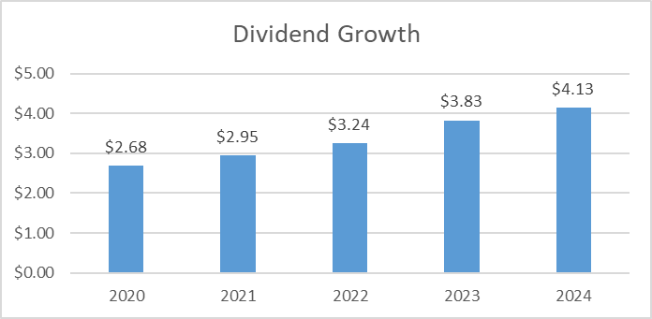
Based on these growth rate estimates, our model produced a price estimate of $526.7 which creates a 54% upside from the current share price of $341.57.
In addition, we would like to see a NOT VERY GOOD growth of SPGI stock if the Fed would like to keep the low interest rate or the government is changing some ways for finance market for COVID-19 recovery. We determined the rate of 2021 and 2022 to be 7% and 13% for 2023, 8% as a terminal rate for 2024. Here are the dividends below:

With these dividend estimates, our model produces a current stock price value of $477.25 creating an upside of 39.7% from the current stock price of $341.57.
Through these to valuations, we created a stock price value range of $477.25 - $526.7 for SPGI.

P/E Ratio and P/B Ratio Analysis
In our next valuation, we looked into P/E ratio in order to watch how SPGI perform with its competitors. We chose 3 main competitors to compare with SPGI: Morgan Stanley, Goldman Sachs and SPGI’s main market competitor Moody’s.Here is the chart that SPGI comparing with other companies:

As a leader of rating market, SPGI has a higher stock price, and a higher P/E ratio, which indicates that the market predict the profit of SPGI will be increasing, although the COVID-19 situation, SPGI’s stock performance is way more better than S&P 500. With target price of 396.56, we could expect an increase in following years. Then we look at the P/B Ratio, as we can see the P/B ratio has increased a lot, which indicates that market has expected S&P Global to earn in the future.
Basing on these two analyses, we could get a range of SPGI’s stock price is $420 – $501.98, which is increasing of 23.1% - 46.9%
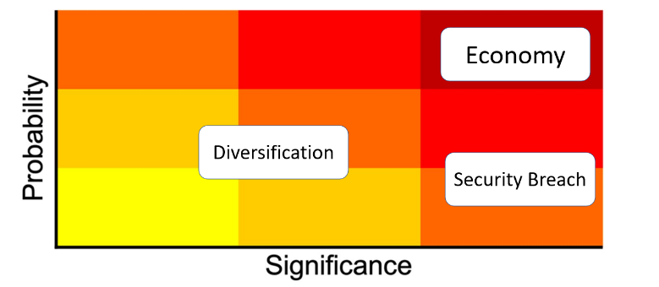
Risks:

Economy

As big recession hit the whole global market out of COVID-19, with many other political elements, stock market is at rising volatility statement. It may affect the companies S&P rated and which also make changes to S&P’s rating ability and their benchmarks.

However, S&P Global Inc is the most professional rating and full of experienced leadership group to address and analysis various problems since it established. This year’s condition would be their good analytical performance in recent years.

Diversification:

S&P GLOBAL INC prefers choosing to rate gigantic global companies and claims broad diversification of investment solutions, but S&P members they make few about entire industries or companies in the whole world or US’s.

Out of the specific choosing, the benchmark of each industry has been a part of the S&P index data, and these accumulated error or deviation will be parts of index too, then misleading people to invest to the right company. Another hand, those data cannot embody global industry market comprehensively, because they may be the relatively good part in the whole industry.

Thus, enlarging diversification of those choosing industries is the good solution.

Security Breach
S&P Global is famous with its rating and its market intelligence. It takes almost all the market of ranking. From annual report, technology budget of S&P Global took almost 57% of its net profit of the whole year in 2018. We could see that technology has taken a large place on S&P Global’s works. However, security breach is rarely happened so the probability is low.
Management:
Doug Peterson has served as President, Chief Executive Officer and a member of the Board of Directors of S&P Global since 2013. He joined the Company in 2011 as President of Standard & Poor’s Ratings Services. He was the member of the Boards of Directors of Business Roundtable, the Japan Society and member of series authority institutions’.
All over the world, in every corner of the globe, over 23,000 employees are focused on the real-time information that is vital to the world of business. Meet the faces behind our essential data and insights, which is ours goals.
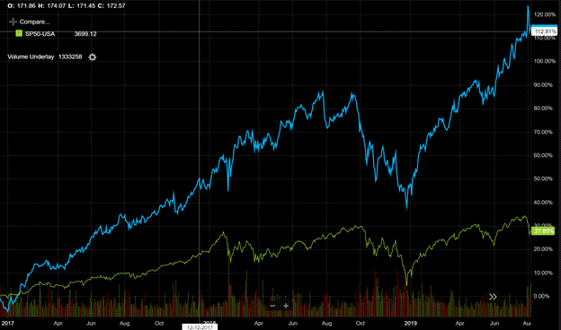
Stock Chart of Past Year Growth:
S&P 500: -27.89%

S&P Global Inc: 112.81%
09.10.2019 – 09.10.2020

As one of the most authorized institutions who rates the credit of companies, S&P Global has the most advanced information search engine and most updated information source from biggest companies. It maintains the high performance in the stock market and far beyond the S&P 500.
Peer Analysis:
 | Market Cap | P/E (NTM) | EPS | ROE % (5Year Average)
S&P Global | $ 87.00 | 27.6 | $ 11.2 | 616
FactSet | $ 13.34 | 31 | $ 6.3 | 47
Moody’s | $ 51.94 | 27.2 | $ 10.1 | 185.1
MSCI Inc A | $ 34.95 | 50.1 | $ 16.4 | -
Peer Average | $ 135.9 | 34 | $ 6 | 61

S&P had the astonishing ROE with excellent performance recent years. Compared with its rivals, S&P Global has standard performance in each area. It focuses more on the gigantic and global financial sectors and offer the instant information above the world.
Ownership:

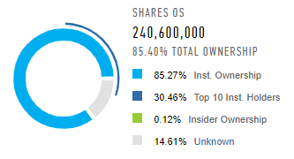
Insider VS Institutional/Mutual Funds

Top 5 Shareholders:

