Aptiv PLC
Consumer Discretionary A
Tanner Thompson & John Metzinger

Introduction
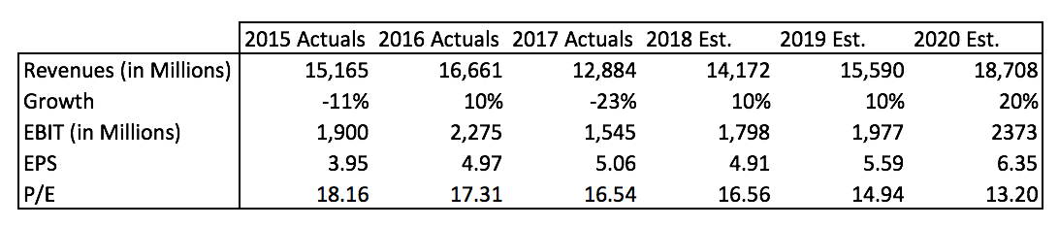
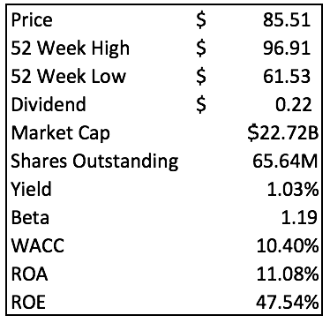
Aptiv PLC (NYSE: APTV) is a global technology company in the auto parts subsector that develops safer, greener and more connected solutions, which enable the future of mobility. It operates through two segments, Signal and Power Solutions; and Advanced Safety and User Experience. The Signal and Power Solution segment designs, manufactures, and assembles vehicle’s electrical architecture, including engineered component products, connectors, wiring assemblies and harnesses, cable management, electrical centers, and hybrid high voltage and safety distribution systems. The Advanced Safety and User Experience segment provides critical components, systems and advanced software development for passenger safety, security, comfort and vehicle operation, including body controls, infotainment and connectivity systems, passive and active safety electronics, autonomous driving software and technologies, displays and systems integration. Their products increase vehicle connectivity, reduce driver distraction and enhance vehicle safety.

Recommendation

In May 2017, Delphi Automotive PLC spun off its powertrain segment named Delphi Technologies and renamed itself Aptiv PLC to focus on innovation in autonomous driving. Over the past year, Aptiv is up 38.43%. With a market cap of $22.72 billion, they one of the largest companies focusing solely on high-tech auto parts and software. Approximately 74% of their revenue comes from the Electronic Architecture business segment and the remaining 27% comes from the Advanced Safety and User Experience segment. The revenues from each segment have increased 19% for Electronic Architecture and 22% in Safety and User Experience in the past 5 years. Aptiv’s largest customers are GM, Volkswagen Group, Fiat Chrysler, Ford Motor Company, and SAIC GM; together, those companies make up 41% of Aptiv’s revenue. Aptiv is a worldwide company, with 36% of revenues coming from the United States, 33% coming from Europe, and 28% coming from Asia Pacific. In 2017, Aptiv’s products were featured in every top 20 selling vehicles in the U.S., 19 of the 20 in Europe, and 13 of 20 in China. A market leader in the automated driving space, Aptiv is continuing to invest in the development of technology necessary to continue leading that industry. In October 2017, Aptiv (then known as Delphi) acquired nuTonomy, a leading autonomous driving software company that offers one of the most innovative autonomous driving systems in the world. With the nuTonomy acquisition, Aptiv will have 150 self-driving cars on roads across 3 continents by the end of 2018.

Investment Thesis
- Autonomous Driving. Currently, semi-autonomous driving and safety systems are becoming very popular, which bodes well for Aptiv, however, fully autonomous driving projected to grow exponentially in the near future, and Aptiv is well positioned to maintain their position as a market leader. On top of the short-term growth that this will result in, there is a major opportunity for long-term as there will be an increased need for additional computing power, enhanced connectivity, and on-going support services to continually upgrade the quickly advancing technology. Because technology is advancing so quickly in autonomous driving, the electrical architecture in vehicles will become more complex which will increase the demand for Aptiv’s market leading electrical architecture solutions.
- Data Gathering and City Integration. In 2019, Aptiv is planning to launch their Centralized Sensing Localization and Planning (CSLP) system which is their fully autonomous driving system. This system is completely integrated within a city and the vehicles within that city and will gather massive amounts of data. As our world is shifting to be more data driven, there is an opportunity for Aptiv to monetize the data they gather and make cities as whole more efficient.
- Mobility on Demand. As autonomous driving becomes the norm, taxis will fall by the wayside and autonomous ride hailing services will take over in urban areas. Aptiv is a leader in that field and will have over 150 self-driving cars on roads around the world by 2018. Aptiv’s purchase of nuTonomy, who is partnered with Lyft in Boston, shows their commitment to the commercialization of autonomous ride hailing services. There is opportunity for Aptiv to have their own mobility-on-demand service along with providing their technology to other autonomous mobility companies, which would drive revenues even further and increase Aptiv’s vertical integration.

Valuation
To determine an intrinsic value for Aptiv PLC, we used a discounted cash flow model with 5 years of future cash flows which we projected based on our estimates. Using a WACC of 10.4%, taken from Bloomberg, and a terminal growth rate of 2%, we found a value of $123.78. Additionally, a P/E multiple valuation was conducted using our projected 2018 earnings and peer comparable multiple of 16.4, resulting in a valuation of $109.76. We chose a 50/50 weighing of our two models.

Risks
- Heavily Influenced by the Automotive Sector. Since most of Aptiv’s revenue comes from car manufacturers, their earnings are tied closely with the success of the automotive sector. If vehicle manufacturers produce less vehicles because of lack of demand, Aptiv would be adversely affected.
- Dependent on Technological Advancements. Aptiv relies on being a leader in the introduction and implementation of new technology in automobiles. If they fail to keep innovating they could lose market share quickly.
- Cost Volatility of Copper and Other Materials. Copper and petroleum-based resins are the most significant raw materials used to produce Aptiv’s products. Rising prices of copper or other commodities would raise the price of operating.

Management
There are 11 members on Aptiv’s Board of Directors, all of which are independent except for the CEO, Ken Clark. Clark was named President and CEO in March 2015 after serving as CFO of Delphi for 5 years. Prior to joining Aptiv was a founding partner of a private equity investing firm focused on investing in middle market companies. Members of the Board of Directors collectively have years of experience leading public companies, extensive backgrounds at technologically innovative companies, and investment banking. In terms of executive compensation, 90% of the CEO’s compensation is performance based, while 78% of the other executive officers’ compensation is performance based.

Stock Chart of Past Year Performance

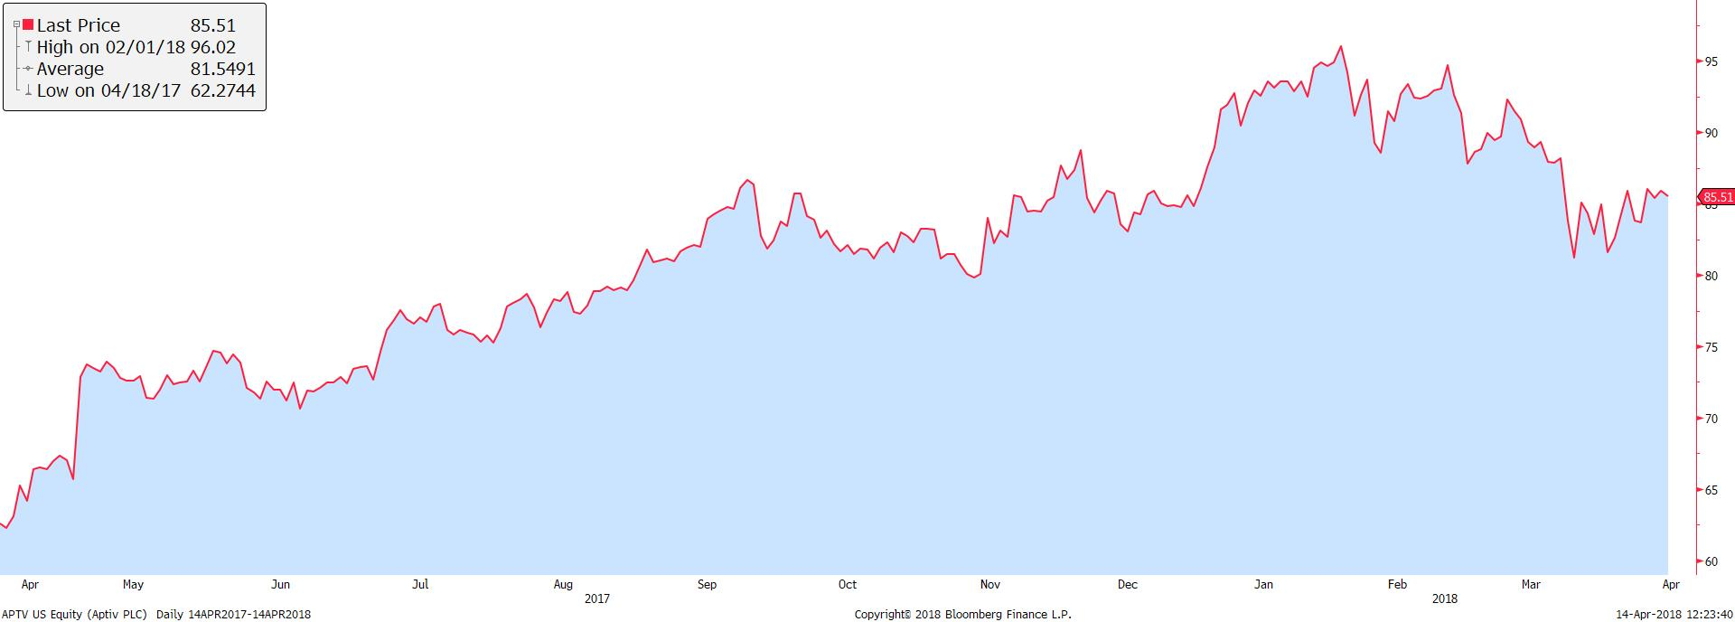

Peer Analysis

Compared to their peers, Aptiv has one of the largest market caps of companies specializing in electronic and autonomous safety features. On top of that, they have a relatively high EBITDA, indicating their efficiency. Comparing their ratios to peers, Aptiv does not stand out that much, however, we believe that their market leading innovation is a greater indicator of how they compare to their peers.

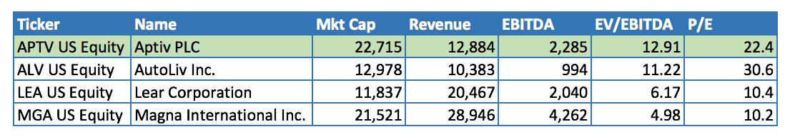

Ownership of Shares
% of Shares Held by All Insider Owners | 0.28%
% of Shares Held by Institutional and Mutual Fund Owners | 99.72%

Top 5 Shareholders
Holder | Number of Shares | % Out
Vanguard Group | 22,171,304 | 8.37%
Blackrock | 18,083,916 | 6.82%
Sun Life Financial | 12,749,928 | 4.81%
Janus Henderson Group | 6,988,866 | 2.64%
Norges Bank | 6,123,855 | 2.31%

