Sector: Information Technology B
Joel Yang, Allison Spegal
Senior Analyst: Ben Zielinski

Introduction
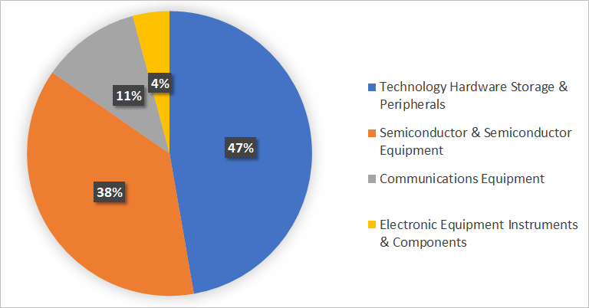
Information Technology has shown tremendous growth over the past ten years and is projected to continue modestly. With society being so technologically reliant, we see several opportunities for Information Technology to perform well and continue to make up the majority of the S&P 500. For our sector research, we focused on Information Technology B. Information Technology B consists of the following industries:

- Communications Equipment
- Electronic Equipment Instruments & Components
- Semiconductors & Semiconductor Equipment
- Technology Hardware Storage & Peripherals

Sector Overview
Currently, 20% of the S&P 500 consists of the Information Technology sector. Information Technology B can be divided by Technology Hardware Storage & Peripherals at 47%, Semiconductor & Semiconductor Equipment at 38%, Communications Equipment at 11%, and Electronic Equipment Instruments & Components at 4%. The Information Technology Sector has been performing above average especially since realizing a $400 price value in 2008 which has increased to $1322 in 2018. This trend has remained positive and has increased over the last ten years. According to Factset comparison, Information Technology Sector has increased about 140% when compared to the S&P 500 during this ten-year period.

Business Analysis
The key players of this sector include Cisco Systems, Motorola Solutions, AMD, HP, and Qualcomm. Overall, the 52-week stock price range has increased substantially with outstanding performers including AMD realizing a 155.8% return, Qualcomm gaining 39.11%, and Motorola Solution gaining 52.83%.
Information Technology has been performing well due to various key drivers in the industry:
- Low Cost of Sales
- Customer Acquisition
- Rising Demand for IT Products & Services
First of all, companies in this sector have low cost of sales when compared to other sectors. Their cost of sales can simply be technology upgrades every year, hardware refreshing every 3-5 years, documentation, duplicating software, and training. These costs sum up to only 15-20% of the sales revenue that make 85% of Selling, General and Administrative Expenses (SG&A), Marketing and Research & Development (R&D). This data shows us that these companies are able to invest more into Marketing and R&D. Especially for technology companies, R&D is the only way for them to succeed. This relates to the next key driver which is customer acquisition. Since this sector is willing to invest a lot in marketing, and R&D, it is not hard for this sector to promote their product and services. After a final product or service is manufactured, the only thing that tech companies have to do is find buyers as they can easily replicate the product. We can also see from economic patterns and trends that Information Technology products and services demand is still rising. However, tech companies have to be watchful of the business life cycle because the United States is currently at the end of the mid and start of late stages of the cycle. This means that the Information Technology sector will start to underperform as the U.S enters into the later stages of the cycle. There will be a lack of demand for this sector in the long run as inflation is rising. Information Technology goods are viewed as a luxury to consumers and therefore, demand decreases as inflation increases. As analysts, we believe that this will eventually occur but the Information Technology sector will continue to perform well through the 4th quarter of 2018.

Economic Indicators
In order to get a better understanding of the Information Technology B industry, we completed the following SWOT analysis, which will lead us to discuss some key economic indicators.

SWOT Analysis
Strengths Information Technology has evolved into a sector that society cannot live without. This allows the sector to have substantial control and emerging opportunity throughout the economy. Furthermore, Information Technology is associated and connected with many different companies, where it allows Information Technology companies to depend on others and hedge their risks through diversification. Due to advancement in Information Technology, companies have been able to use it to forecast future predictions with better accuracy and reliability.
Weaknesses There are signs of an increase in global competition, as Information Technology advancements open spaces for more competitors. This sector operates worldwide and across various countries, and there is no way for any company to disregard this fact. Moreover, as stored information data increases, and more confidential information is being stored online, government regulation continues to increase which will most likely negatively impact the bottom line of tech companies.
Opportunities
Technology is advancing faster than ever and some technologies that were used 10 years ago, are almost unrecognizable today. An example of constant evolvement of technology has been the evolution of the mobile industry starting with 3G systems with an upcoming 5G LTE system coming soon. Other key opportunities that we analyzed were changing Cloud Services, Virtual Reality, and Artificial Intelligence. Although these industries already exist, we see large expansionary potential here.
Threats
The threat of being hacked and having their intellectual property stolen are two major threats to the Information Technology B sector. Information Technology B participants also have the threat of being outperformed by other companies’ development due to the dominance of a few large competitors in the technology industry. Information Technology companies are forced to keep up with security to protect their information while staying up to date on current and future technology trends. Falling behind the curve could mean losing out on market niches, leading to the potential of being dissolved. When demand is high, you must provide what the consumer desires, when demand is low, continue to plan ahead which is key in this industry.

Unemployment Rate
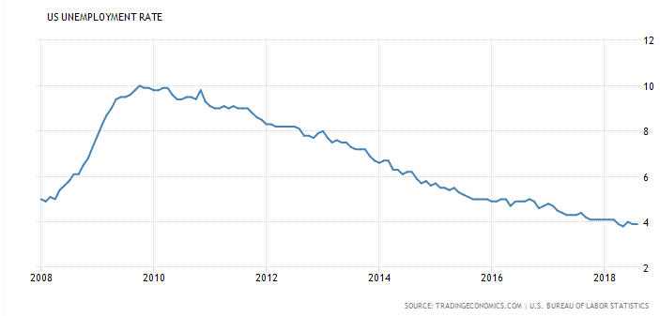
One key economic indicator that plays a strong role in the Information Technology B sector is the unemployment rate and consumer spending. While technology is a factor in several industries, it will only be purchased if the economy is strong. Although we depend a lot on technology, it is not a necessity should people not have the money for it. Currently, the unemployment rate is low and consumer spending is high; people have jobs and are spending money. When the economy slows down again, technology will see its business slow down. The graph above shows how much the unemployment rate has decreased since 2010. This is a strong indicator for Information Technology since human capital can be a crucial to a business’s operations.

Financial Analysis
For a financial analysis, we continued to focus on the industry’s five key players. Overall, these companies all have high short and long-term debt due to the need of staying competitive in the industry. Also, the majority of company revenues are spent on R&D, and marketing costs. In order to stay competitive in the industry, you must adapt to rapid growth. When preparing for rapid growth, companies must keep in mind that expenses will increase. Companies must be prepared to deal with increased expenses that come with growth or they may face financial trouble. A company must take on the high debt knowing that their level of cash will decrease to cover the debt.

Revenues & Consumer Demand
Revenues for the Information Technology sector depend on the consumer demand for technological advances. Recently, we have seen a rise in demand for these products. Every day, we depend on technology that interacts with various Information Technology systems through the Internet of Things. The Internet of Things is the concept of connecting any device to either the Internet or other devices including cell phones, appliances, headphones or wearable devices. Since consumer demand in the Information Technology sector is focused on innovative technology, it pushes companies like Cisco, HP, and Motorola, some of the sectors top contributors, to implement the best systems. With innovative systems being evolved, customers are constantly digging for updated technology in various forms. The Information Technology sector makes up 22% of the overall S&P 500. We suggest that this is because of the overwhelming interest in the expansion of the Internet of Things.

Ratios
Within the Information Technology B sector there is a great correlation between how much a company is spending on research and development and their gross margin. As we can see in the below table, Cisco and Qualcomm are leading in R&D expenditures and also have the greatest gross margins. In the Information Technology B sector, it’s important to spend a lot of time and money in the research of products. Since research and development contributes so much to the final product in the technology industry, we see why gross margins are high when a company is putting so much research and knowledge behind a product. Cisco and Qualcomm spend 10 times the amount of money on R&D as Motorola which contributes to a Gross Margin that is roughly 20% greater than that of Motorola. Consumers only want the best product and R&D allows the end products to be that much greater.

Company | R&D Expenditures | Enterprise Value/Sales | Gross Margin | Price/Sales | Current Ratio
Cisco | 1.626 B | 3.53 | 63.00% | 4.07 | 2.29
Motorola | .162 B | 3.46 | 45.18% | 2.93 | 1.21
AMD, Inc. | .504 B | 2.85 | 44.59% | 2.82 | 2.52
HP, Inc. | .347 B | .64 | 19.16% | .65 | 0.85
Qualcomm, Inc. | 1.416 B | 3.02 | 57.98% | 3.81 | 2.73

Company Analysis
We currently hold Ichor Holdings Ltd, Applied Materials Inc, and Square Inc Class A. They are small in proportion compared to our overall portfolio holding only 10%. They are $16,754.94 out of $176,268.78.
Square continues to perform well while Applied Materials and Ichor Holdings are showing a downward trend. Both Ichor Holdings and Applied Materials are cyclical companies which could be a positive indicator that trends will always be changing for these companies. Since semiconductors have several end products including personal computers, consumer products, communication infrastructure, and automotive products, it has a wide industry to keep its performance level up. Both Ichor Holdings and Applied Materials are affected by the growth of the Internet of Things and the expansion of technology but possibly in the long term prospect. This includes smartphones, smartwatches, home devices and systems, smart cars and more.

Applied Materials makes up 3.7% of our portfolio and Ichor 1.9%. Interestingly, Applied Materials is one of Ichor’s biggest customers. 40% of Ichor’s sales are created from Applied Materials purchases. Because of this connection, we see a trend in their overall performance. Both Applied Materials and Ichor’s stock prices have decreased since December of 2017. We believe that both Applied Materials and Ichor stocks should be sold due to the current downward trend of their stocks but also because of the cyclical characteristics of this industry, especially when transitioning into the late business cycle. Once we hit the late stages of the business cycle, we suspect that the price will decrease further due to the lack of demand for technologically advanced products.
On the other hand, Square Inc. has made tremendous leaps as a market player. It is expected that credit and debit card payment volumes will grow to over $55 trillion by 2025. This is a huge opportunity for Square since their only fear of competition is PayPal. While Square is far behind PayPal in their financials, with PayPal having 10 times the net cash of Square, the business model of Square is something to take a look at. Square plans to use cross-selling initiatives and international expansion to increase sales by almost 50%. We would recommend holding our shares of Square based on their business and growth model. It’s also safe to say that PayPal remains a competitor of Square but is no threat due to the completely different business models being used.

Outlook
The outlook for the Information Technology B sector is strong. Although we are approaching the late stages of the business cycle, the current demand for technology is still high. We believe that there would not be a decrease in demand at least for short term future. The Internet of Things, 5G Phones, and Artificial Intelligence will create a demand for these products in all forms. From having technology at our fingertips for years, we will become part of a world that knows nothing but technology. Smart cars, smart phones, and smart appliances are only the beginning of what’s to come.

