E*TRADE Financial Corp. (ETFC)
Financial Sector-Investment Banking & Brokerage Sub-Industry
April 16, 2018—Jacob Mussell & Ryan Frank
Introduction: E*TRADE Financial Corp. (NASDAQ: ETFC) is a financial services company that provides online brokerage and related products and services primarily to individual retail investors. Founded on the principle of innovation, E*TRADE aims to enhance the financial independence of traders and investors through a powerful digital experience that includes tools and educational material, supported by professional guidance, to help individual investors and traders meet their near- and long-term investing goals. E*TRADE provides these services to customers through digital platforms and a network of industry-licensed customer service representatives and financial consultants, over the phone, by email and online via two national financial centers and in-person at 30 regional financial centers across the United States. E*TRADE additionally operates federally chartered savings banks with the primary purpose of maximizing the value of deposits generated through our brokerage business. E*TRADE’s Corporate Services line also sells stock plan administration technology and equity compensation program administration to large corporation.
Price | $56.96 | Beta | 1.38
Price Target | $68.04 | WACC | 10.3%
52 wk. High/Low | $58.45/$ 32.25 | Net Income Margin | 32.5%
Market Cap | 15.1B | ROE | 9.7%
Avg Daily Volume | 2.48M | ROA | 1.1%
Dividend | $0.00 | Price/Earnings | 21.1
Yield | N/A | EV/EBITDA | 12.11
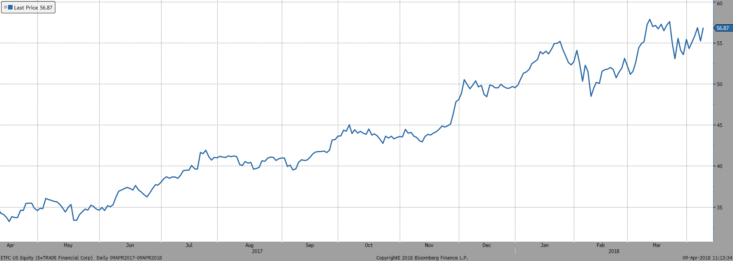

Peer Analysis: E*TRADE competes in a very crowded Investment Banking & Brokerage environment. Some of E*TRADE’s closest competitors include TD Ameritrade, Charles Schwab, and Raymond James. E*TRADE also competes with portions of large companies such as Goldman Sachs, and Morgan Stanley. E*TRADE must compete with these companies by offering low commissions, low transaction costs, ease of use, low account minimums, and cutting-edge research abilities.

Recommendation: We recommend a buy rating on E*TRADE due to the 19.4% upside potential at a price target of $68.04. Some of the key drivers for E*TRADE in the future will be the growth of their Corporate Services division through the attraction and retention of large corporate retirement and benefit plans. E*TRADE is also poised to grow based off their recent acquisition of OptionsHouse, a premium trading platform specializing in options and futures, and their deal to acquire over 1 million brokerage accounts from Capital One. E*TRADE also tailors to higher frequency traders with lower fees and better platforms and research. There benefits geared towards active traders differentiates them from their competition and will help to improve their Daily Average Revenue Trades (DARTs) into the future.

Investment Thesis:
- Increasing DARTs
Daily Average Revenue Trades (DARTs) are a key indicator of the trading segment of E*TRADE. This measure indicates the volume of trades that brokerage firms can expect to earn commission or fee revenue from. E*TRADE has seen a steady increase in DARTs and booming growth in total annual trades in the past year. Total trades grew 30% from 2016 to 2017, some of which can be attributed to decreases in average commission per trade. We believe E*TRADE’s pricing in addition to the acquisition of OptionsHouse and its accounts has distinguished it among its competitors in the trading realm. This is evidenced by the strong trading volume growth.
- Improving Operating Margin
E*TRADE has seen a strong improvement in its operating margin. This ratio takes the operating earnings and divides it by total revenue. Since 2013, E*TRADE has seen operating margin growth every year except 2015, the year in which they suffered a major loss on disposal of their wholesale funding business segment. We believe that this strong margin will maintain and grow as operating revenue continues to grow in the coming years.
- Improving Net Interest Margin
Net interest margin is the difference between interest earned on interest bearing assets and interest paid on interest bearing liabilities divided by average earning assets. This metric is important to E*TRADE and it has shown steady growth each quarter for the past few years. We anticipate these margins to continue growth as the Fed executes interest rate hikes throughout 2018 and 2019.
- Steady Net New Account Growth
E*TRADE has seen positive net new accounts, and a strong growth trend. Despite the decrease in the number of bank accounts E*TRADE manages due to scaling back of the banking segment, it has seen the number of accounts increase. This is mainly due to growth in the number of brokerage accounts, which had impressive growth in 2016 and continued to increase in 2017.

Valuation: To reach a valuation for E*TRADE, two valuation methods were used. The first being a five-year DCF model. Using a terminal growth of 3% and a WACC of 10.3%, an intrinsic value of $67.35 was established. A +/- .25% sensitivity analysis on the terminal growth rate and +/- .25% WACC resulted in an intrinsic value ranging from $62.85-$72.50. A multiple valuation was also completed using both Price/Earnings and EV/EBITDA. This evenly weighted multiple valuation resulted in a value of $68.72. Weighting the two valuation models evenly, a price target of $68.04 was reached, resulting in a 19.4% upside.

Risks:
- Unhedged Negative Interest Rate Changes
Changing interest rates have a negative impact on E*TRADE for a couple of reasons. The first is it could eat away at their largest form of income, net interest income. The other reason is rising rates can cause the Company’s borrowing costs to decrease, so without properly increasing the yields on interest earning assets there will be a negative effect on earnings.
- Decreased Trading Activity
Macroeconomic indicators have a major effect on the performance of the Company. GDP decreases will likely lead to a decrease in trading volume because average investors will have less disposable income to invest and will see the quality of investments deteriorate. This decrease in trading volume would lead to decreases in commission and fee revenue for E*TRADE.
- Pricing Competition
E*TRADE competes with many larger companies that are capable of large scale promotional campaigns and tend to have deeper pockets in a competitive environment. This allows these companies to offer a wider range of products and services that may be desirable to E*TRADE customers. It also means that these companies can offer competitive prices and promotions that put pressure on the Company’s margins. E*TRADE was forced to lower trading commissions in 2017, and this trend is not likely to blow over as investors seek cheaper, easier, and more hands-on ways to trade.
Ownership of Shares:
Most of E*TRADE is owned by institutional investors with about 63% of total shares. The second largest ownership type is mutual funds with about 36% of shares. The top five institutional investors are as follow:
- Vanguard Group Inc.
- Fidelity Management and Research Company
- BlackRock Inc.
- PRIMECAP Management Company
- State Street Corp.
Management: Chief Executive Officer Karl A. Roessner has been in his position since September 2016. He was the Senior Vice President prior to stepping into the role and has been with the Company since 2009. Roessner is the highest paid member of the management team. Michael J. Curcio, Chief Brokerage Officer, is pivotal to the operation of the business and has over 15 years of experience at TD Waterhouse-now TD Ameritrade. Since the ousting of previous CEO Paul Idzik in 2016, E*TRADE has seen improvements in net interest income, DARTs, and assets under management.

