Verizon Communications Inc. (NYSE: VZ)
Luis De La Peña and Jesse Tredinnick Telecommunications Sector

Introduction
Verizon Communications Inc. (NYSE: VZ), is an American multinational telecommunications company that provides communication services to consumers, businesses, and government agencies by two separate segments: Wireline and wireless. Its wireless segment, Verizon Wireless is the largest carrier of wireless service in the United States. It serves approximately 114 million connections across the U.S. on its wireline segment, Verizon is focusing on the next generation fiber optic wired internet “Verizon Fios.” Verizon’s revenues can be designated to come from three segments which are its services (Wireline and Wireless) at 63.12%, selling of equipment at 18.89% and Others at 5.5%. Through its services, it sells wireless access (including calls, text, and data) directly to consumers through post-paid customers to their smartphones, tablets, and wearables. Verizon communication also sells in-house internet connection through its wireline service. The most advanced part of this segment is the fiber optic connection that gives extremely high internet speeds to those lucky enough to have access to it. Verizon has been working very hard to bring this access to anyone who wants it but due to the extremely high infrastructure costs of introducing fiber optic cables to a new place it is a very slow process. As far as advancements in communications technology, Verizon is leading the charge in the 5th Generation wireless technology (5G). Over the last several years, they have worked with key partners and innovators to develop this breakthrough technology and have been one of the first telecommunication companies to test it out with actual markets. In 2018, they plan to bring the technology to 3-5 major U.S markets for further testing. Verizon Communications Inc. is based in New York City and was incorporated in Delaware. It was created in 2000 with the merger of Bell Atlantic Corp. and GTE Corp.
Price | $48.66 | Beta | .8
Price Target | $52.56 | Price/Sales | 1.55
52 WK High-Low | $42.8-54.77 | Gross Margin | 59.1 %
Market Cap (bil) | $200.97 Bil | EPS | $7.36
Avg. Daily Volume (mil) | 16.9 Mil | ROA | 12.01%
P/E | 6.29 | ROE | 91.74%
Yield (%) | 4.9% | Debt/Equity | 2.64

Recommendation
We recommend a buy strategy for Verizon Communications Inc. based on our relative and projected valuation of the company. Based on our calculations, the target price is $52.56 which gives us an 8.01% upside on this investment. We used a P/E multiple valuation and a Monte Carlo simulation and weighted them both equally to come up with our final price. We also see that Verizon is implementing 5g technology to multiple markets this year and expect this to positively affect their stock price but did not reflect it in our calculations.

Investment Thesis
- Demand for reliable wireless communication: With the demand for faster and better wireless for our smartphones and other devices, Verizon is positioned in a great spot to gain market share as this grows. Known as having the largest network coverage in the U.S, Verizon Communications has the most loyal group of subscribers as they know their connections will not drop even in rural areas. Being the most reliable network is what sets them apart from competitors like AT&T and T-Mobile, which is also why they have one of the highest retention ratios of their customer base. Their net additions of subscribers have remained positive over the last three years which means they are adding customers to their base every single year.
- Economic indicators favor Telecommunications sector: The telecommunications sector is known for performing above the market in the late stages and recessionary times of the business cycle. As we approach these stages, we know that people will continue to rely on their cellphones and other devices in their day to day lives and companies like Verizon do not see a huge drop in their subscriptions as most people will not cancel data plans during these times. Investing into this sector before we start seeing underperformance of other sectors is important if we want to capitalize as much of a gain as possible.
- New technology (5G): Like previously stated, Verizon Communications Inc. leads the way in the 5th generation wireless technology race. In 2017 they were able to test the technology in one public market where they saw average download speeds of 3.77 Gbps. In the U.S today, the average wireless download speed is around 17 Mbps, which makes 5g internet 217 times faster than the average wireless connection. This is huge for Verizon as they are the frontrunner in this amazing technology and they plan to start rolling it out to consumers in the second half of this year. Right now, is the perfect time to buy as we do not believe this is factored into their stock price.
Valuation
For the valuation, we decided to use a relative P/E multiple valuation with Verizon’s closest peers. We found the peer group P/E average to be 7.325x which is slightly above the 6.29 of Verizon Communications. Using this average P/E ratio, we multiplied it by Verizon’s current EPS of $7.36 to arrive at a target price of $53.91. We also decided to use a Monte Carlo simulation to predict the target price. Using 500,000 trials, an expected annual return of 3%, and annual volatility of 19.18% we concluded the one-year target price to be between $52.45 and $58.84 using a .25% sensitivity analysis in the growth rate. The mean one-year target price is therefore $55.64. Discounting it by 8.5% gives us a target price of $51.28. Since these prices are close together, we decided to weigh them 50/50 to come up with a final target price of $52.56 giving us an 8.01% upside on this investment.
Risks
- Significant Debt: Currently, Verizon has over $110 Billion dollars in outstanding debt and although they are a large corporation and can handle that debt, it will always be a risk for the company. This debt as of now is under control and Verizon can withstand it during the current economic conditions. But, if the economy were to take a hit and policies were to change, Verizon could easily see themselves in a problem financially with not being able to make payments on the debt and its interest. This risk essentially goes for any major corporation, but it has to be considered and brought up whenever there are major changes that could affect the industry.
- Cyber Attacks: Although Verizon Communications has not yet been successfully hacked, they do have to go through the process of paying for the protection and there is no reason they can’t get hacked in the future. Verizon pays millions of dollars per year for protection on their operation and have successfully fought off attackers, but this is always a risk when it comes to a company who operates in a technological field.
- Significant Competition: The telecommunications industry is a very competitive industry in the fact that it is very technology and innovational driven. With Verizon being one of the two major providers in North America, people are specifically targeting new ideas and ways of offering their business to “one step” over what Verizon already offers. Essentially if you’re not always developing new ideas and coming out with the latest and greatest products, it is tough to compete in this industry.

Management
Mr. Lowell C. McAdam has been the Chairman and CEO of Verizon Communications since 2007. Prior to his current title, he served as the President and COO of Verizon Wireless, which is the previous name of the company up until 2007. Mr. McAdam is considered one of the architects of today’s global wireless industry with building wireless companies on three continents.
Mr. Mathew D. Ellis has been with Verizon Communications for the past five years and has been serving as the Executive VP and CFO since 2016. Prior to his time spent with Verizon Communications, Mr. Ellis spent time with Tyson Foods Inc. as their VP and treasurer for over a 15-year time span.
Stock Chart of Past Year Performance
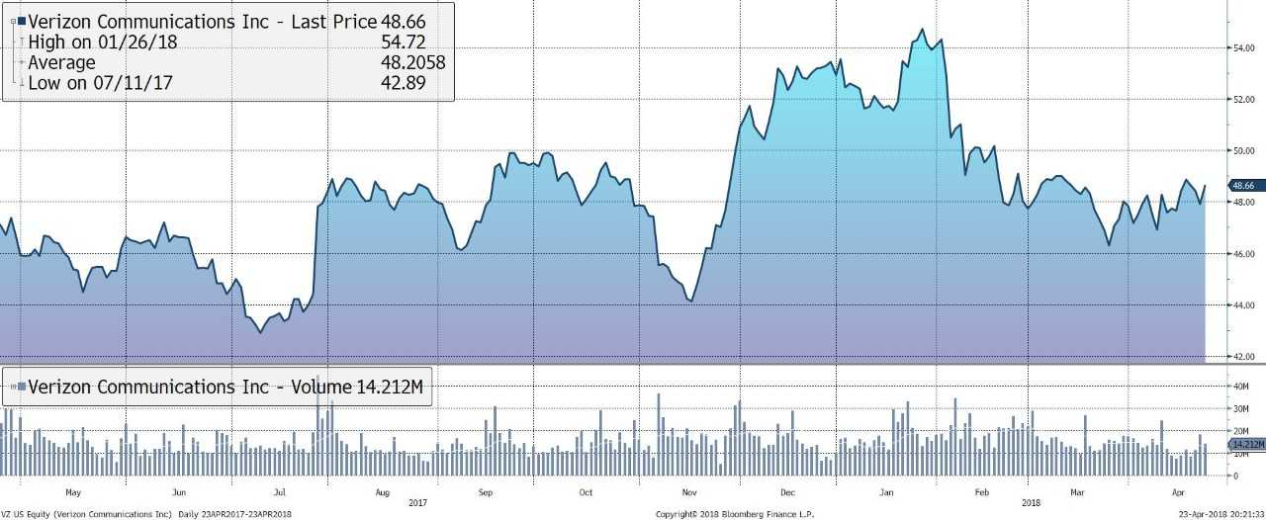

Peer Analysis
Name | Ticker | Market Cap (Bil) | Revenue (mil) | EBITDA | EV/EBITDA | Dividend Yield (%)
Verizon Communications | VZ | $200.97 | $126,034 | 42,281 | 6.53 | 4.9
AT&T Inc. | T | $231,490 | $160,546 | 45,826 | 6.21 | 5.6
China Mobile ltd | CHL | $190,411 | $726,941 | 290,352 | 7.64 | 1.7
T-Mobile US Inc. | TMUS | $53,615 | $40,604 | 10,816 | 6.53 | -
Sprint Corp | S | $23,417 | $33,247 | 9,874 | 5.35 | -
Industry Average |  | $15,385 |  |  |  | 3.9

Ownership Insider vs Institutional/ Mutual Funds
% of Shares Held by All Insider Owners | 3%
% of Shares Held by Institutional & Mutual Fund Owners | 70.26%

Top 5 Shareholders
Holder | Shares | % Out
Vanguard Group Inc. (The) | 290,162,326 | 7.11%
Blackrock Inc. | 265,904,768 | 6.52%
State Street Corporation | 162,763,040 | 3.99%
Capital Research Global | 158,406,980 | 3.88%
Wellington Management Co. | 101,613,115 | 2.49%

