Amazon.com, Inc.
(NASDAQ: AMZN)
Nicholas Brickner, Tumenkhuslen Batdelger & Luke Dorn
Senior analyst: Nate Zeller

Market Cap | Dividend | 52-week range | Current Price
1.5 trillion | $0.00 | $3,552-1,626 | $3,004.48

Introduction
Amazon is in the Consumer Discretionary sector, the ticker is AMZN, and trades at $3,004.48 The stock is up 81% over the past year and up 428% over the last five years. Amazon focuses on e-commerce, cloud computing, digital streaming, and artificial intelligence. The organization was founded in 1994 with a mission to be Earth's most customer-centric company by current president and CEO Jeffrey P. Bezos. Amazon launched its IPO in 1997 and is headquartered in Seattle, WA. In recent years Amazon has been active in mergers and acquisitions; a few include: Whole Foods, Zappos, and Twitch.
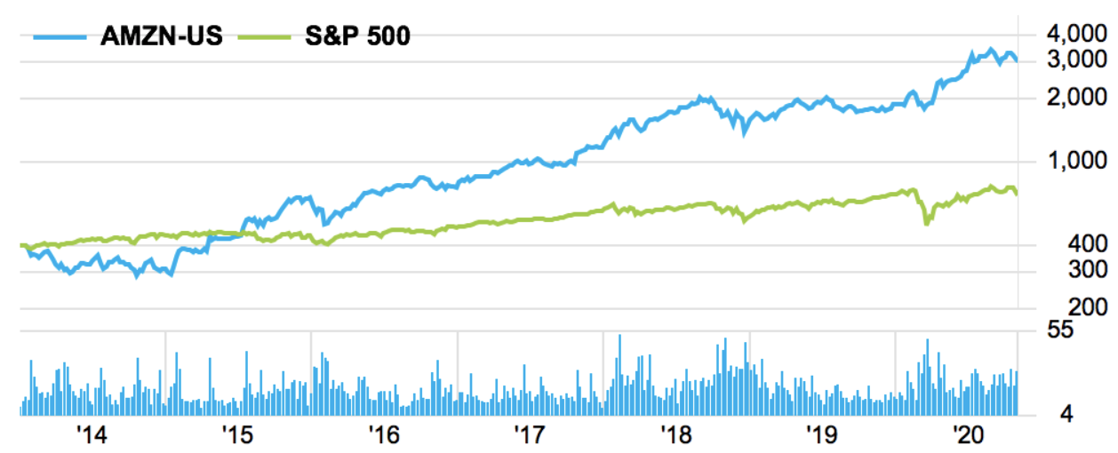

Recommendation

We recommend a BUY for Amazon.com. We came to a target price of $3,697.36 using a DCF model and a target execution price between $2,950 - $3000 by setting a support line near $2,950. This leaves a conservative ~15% upside on this investment. Aside from Amazons cash flow and current market movement, we believe in Amazon would be a good fit within our portfolio due to the ecommerce growth potential, diversity of the business, and the environmental/customer focus the company has. This investment would be something we would be proud to own, and we hope to see Amazon represented within our portfolio in the future.

Revenue Breakdown

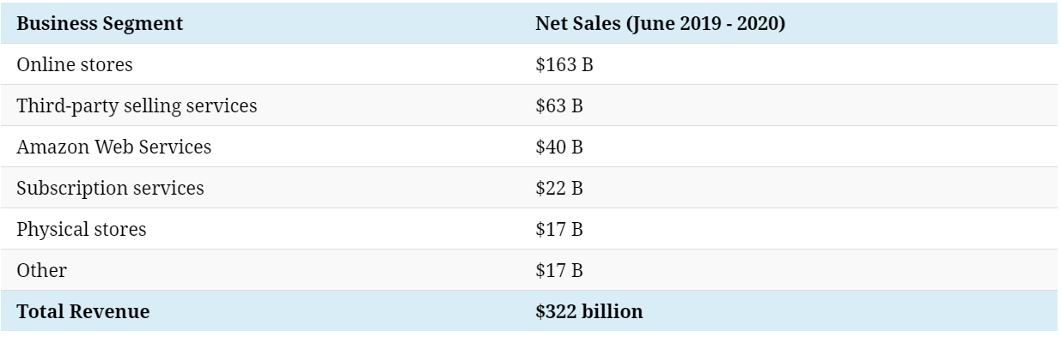

A Fully Formed, Multi-Pronged Investment Thesis

We believe Amazon is a no-brainer to buy. Amazon started out as a bookstore in 1994 and has transformed into an empire of business. Jeffrey Bezos has been a tremendous CEO and is one of the world’s greatest business minds. Throughout Amazon’s history we see their ability to change their business with time. These changes have allowed the organization to go from a bookstore to one of the most dynamic companies in the world.

The ecommerce industry is dominated by Amazon; with Covid-19, we expect online shopping to become more popular than it has ever been. Amazon has also become a leader in artificial intelligence, cloud computing, and streaming. These three industries are primed to grow in the future, along with Amazon.

Valuation

To find the intrinsic value of Amazon we used the discounted cash flow model. This model was used because it best represents the value of the company’s future cash flows. In this model we made 3 main assumptions. All of which were made in a conservative manner. Our first assumption was the average growth in free cash flow over the next 4 years. We found in Amazons top 4 revenue producing business segments had an average growth of 33% over the last 3 years. We put a conservative 12% growth on Free cash flow over the next 4 years. The next assumption was the perpetuity growth rate, we assumed an average growth of 5% after year 4. The last assumption was the discount rate. We put a value of 7% on the discount rate being the WACC found within FactSet was 5.1%. This gave us a target price of $3,697.36 and a conservative ~18% upside.
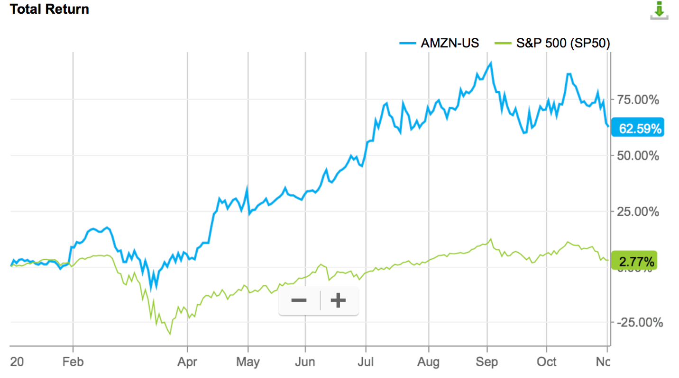
2020
Present

Risk Analysis

Limit in growth: Amazon has become so big that in the long run, it might be harder to impress investors with a rapid growth rate and bring value to shareholders. Despite its growth due to the COVID-19 pandemic, Amazon has shown a decrease in its sales growth in 2019 (20.5%) compared to its growth in 2018 (30.9%).

Competition: Amazon faces a great deal of competition in terms of, not limited to, e-commerce, web and infrastructure computing services, electronic devices, digital content, advertising, grocery, and transportation and logistics services. To overcome competition, Amazon would need to expand its business into a new market and offer new services. However, this can, in return, expose Amazon to new risks due to its limited or no experience in newer market segments and the possibility of not realizing consumers’ different demands.

Management: Amazon depends heavily on its senior management and other key personnel, particularly Jeffrey P. Bezos, President, CEO, and Chairman. Loss of senior management or other key employees can harm the business.

Regulation: As Amazon is subject to business regulations and law, evolving government regulation and unfavorable changes can have a negative impact on the business. It was mentioned that the European Commission announced that it has opened an investigation to assess whether aspects of its operations with marketplace sellers violate EU competition rules on Amazon’s recent quarterly report.

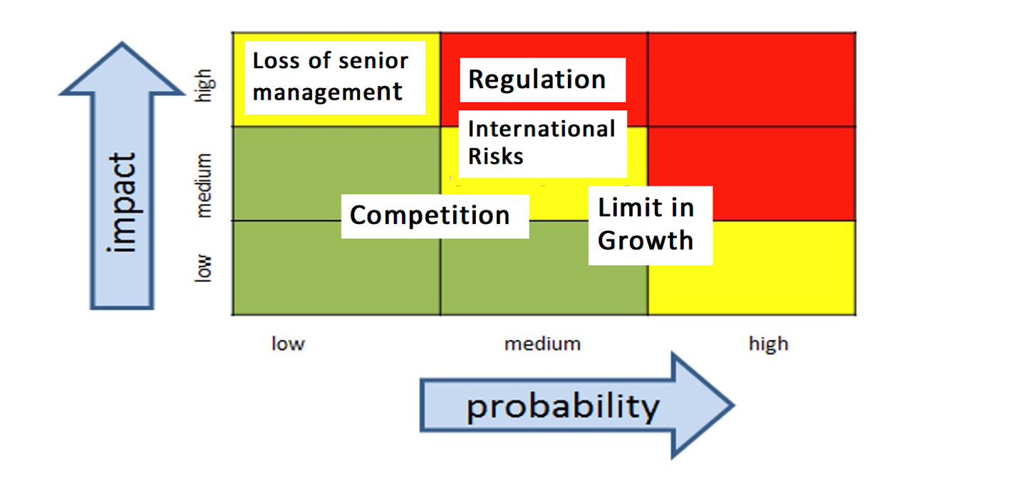
International risks: By expanding globally, Amazon is at risk of having little operating experience as opposed to local competing companies, and international market risks, such as local economic and political conditions. For example, due to the regulations in China and India, Amazon operates through a third party to provide services to the consumers. The possibility of violation or changes in the existing regulation could affect its operation or shut down the entire business in the worst case.

Management Team and Board of Directors

Amazon management team consists of five officers, President CEO Jeffrey P. Bezos, Senior VP CFO Brian T. Olsavsky, CEO Amazon Web Services Andrew R. Jassy, VP Worldwide Controller Shelley L. Reynolds, CEO Worldwide Consumer Jeffrey A. Wilke, Senior VP General Council Secretary David A. Zapolsky and ten other directors. The management members of Amazon are highly educated, have extensive experience in the business field, and have average of 24 years in working at Amazon.

President and CEO Jeffrey P. Bezos is also the founder of aerospace company Blue Origin, which is working to lower the cost and increase the safety of spaceflight, and he is owner of the Washington Post. In 2018, he founded the Bezos Day One Fund, which focuses on funding non-profits that help homeless families, and on creating a network of tier-one preschools in low-income communities.

Peer Analysis

Amazon has many competitors; the e-commerce industry has seen massive growth this year of 32.4%. Competitors in the industry include Alibaba, Walmart, and Target. Amazon is also a big player in streaming, competing with Netflix, Hulu, and Disney. In recent years Amazon has made inroads in cloud computing with their AWS product. Their major cloud computing competitors include Microsoft, IBM, and Oracle. With Amazon’s recent transaction buying Whole Foods they also have a stake in the grocery industry. Whole Foods competes with national grocers and local grocers. Amazon is incredibly unique compared to its competitors, because of their many different business segments. As you can see on page 6 that Amazon is dominating ecommerce. We also have a graphic of the projected growth of the ecommerce industry.

Key Ratios | Revenue Growth | Profit Margin | Price to Earnings
Amazon | 37.40% | 6.58% | 88.9
Walmart | 8.60% | 4.70% | 22.11
Alibaba | 34% | 30.92% | 32.22
Target | 1.80% | 7.36% | 21.97
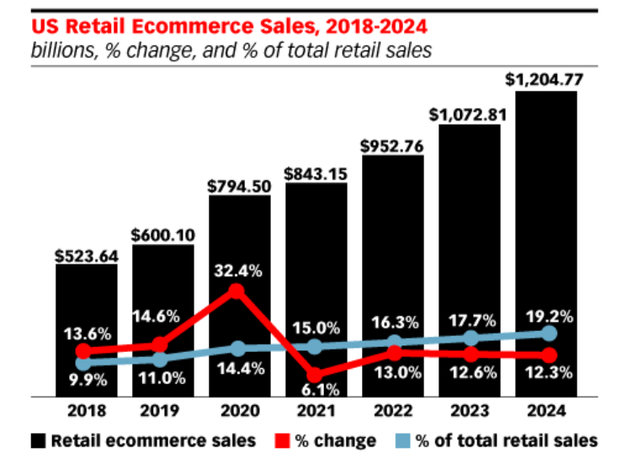
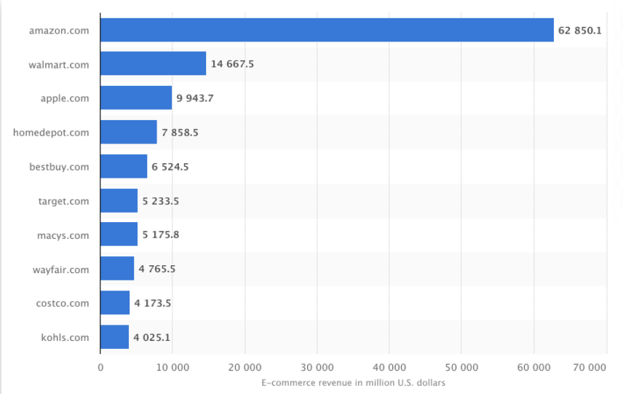
E-Commerce Revenue in million US Dollars

SWOT

Strengths | Weaknesses | Opportunity | Threats
- Brand Name  - Differentiation and innovation  - Acquisitions | - Tax policies  - Competition | - Positive Env impact  - Self-driving tech  - Expanding physical stores | - Government regulation  - Cyber crime
Strengths
- Brand Name
  - Amazon has become an icon and a way of life for millennials. According to CNBC the Amazon brand name has now grown stronger than both Google and Apple. The Amazon brand value is estimated to be worth 315 billion dollars.
Differentiation and Innovation
  - Amazon commercials can be seen everywhere. One huge initiative they are attacking is becoming more environmentally friendly as an organization. This innovative strategy has made them popular among consumers. The evolution of Amazon has also been incredible. Amazon started as a bookstore; they are now the world's largest ecommerce, they are a big player in artificial intelligence, and cloud computing.
Acquisitions
  - Throughout Amazon’s history the organization has shown the willingness to acquire companies to enter new business sectors. Amazon’s cash management and size allows them to make billion-dollar transactions with ease. Their recent transactions include: Whole Foods, Twitch, and Zappos.

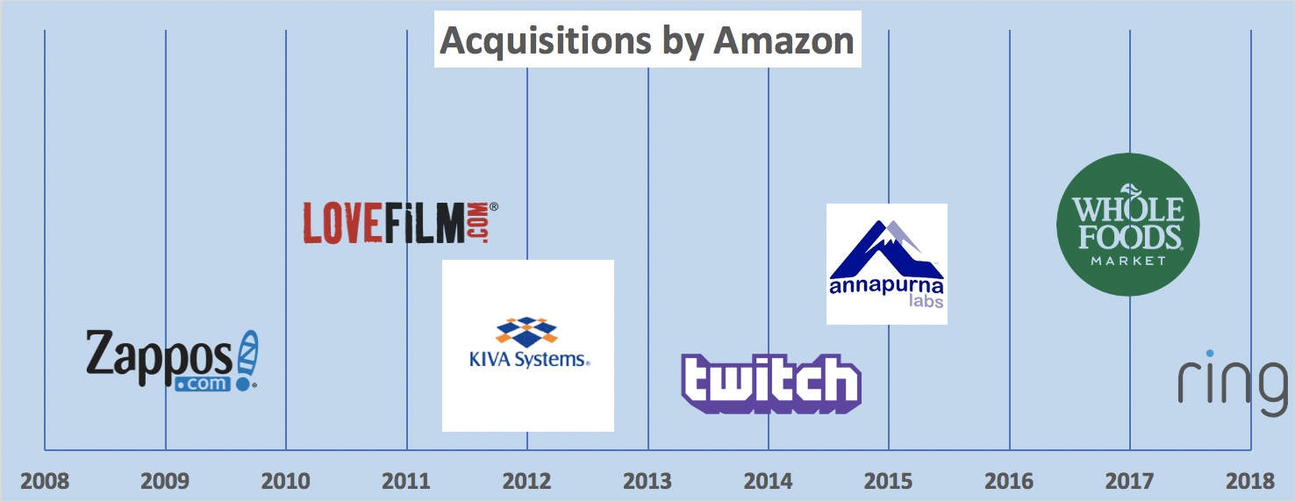

Weakness - Refer to risk analysis

Opportunity
- Positive Environmental impact
  - Amazon has pledged to make a positive impact on the environment. With recent plans to deploy 10,000 electronic rickshaws in India to help with delivery along with plans to power its operations with 100% renewable energy by 2025.
- Self-Driving Tech
  - In 2012 Amazon acquired Kiva systems, the purpose of the acquisition was to improve warehouse efficiency with robots. Amazon recently announced it will acquire Zoox which is a self-driving start up that was founded in 2014. This acquisition will not immediately affect the logistics of Amazon but is definitely something to keep an eye on as this could bring a new market to the company.
- Expanding Physical Stores
  - In 2017 Amazon acquired Whole Foods, this acquisition has improved their competitiveness against big box retailers and brand awareness. In the recent year they have moved away from physical stores due to COVID-19 but down the road it will be a place to watch for Amazon.
Threats – Refer to risk analysis

Ownership

A majority of the ownership is being help by “Professional Investors” showing a strong belief in the company.

 | Institutions | %OS | % Port
1 | The Vanguard Group, Inc. | 6.17 | 1.89
2 | BlackRock Fund Advisors | 3.69 | 2.14
3 | SSgA Funds Management, Inc. | 3.26 | 2.99
4 | T. Rowe Price Associates, Inc. (Investment Management) | 3.15 | 4.82
5 | Fidelity Management & Research Co. LLC | 3.06 | 3.11
Insider / Stakeholders | % OS
Bezos Jeffrey Preston | 10.88
Bezos Mackenzie T | 3.89
The top 5 owners of Amazon.com have increased their share over the past year. This is promising for Amazon.com, as this shows these established institutions value Amazon as an investment. With the top 5 institutional owners making up roughly 20% of the ownership it is unlikely the demand of a single owner will influence the price.

