Alec Gaffney & Tanner Thompson
Senior Analyst: Ben Zielinski
Marathon Petroleum Corporation (MPC)

Business Background
Marathon Petroleum Corporation (MPC) is a U.S. based company which operates through the following segments: Refining, Retail, and Midstream. The Refining segment refines crude oil and other feedstocks at its refineries in the Gulf Coast and Midwest regions of the United States. They also purchase ethanol and refined products for resale and distributes these refined products through various means, including barges, terminals and trucks that the company owns or operates. The Speedway segment sells transportation fuels and convenience products in the retail market throughout the Midwest. The Midstream segment gathers, transports, fractionates, stores and markets oil products. Marathon Petroleum was founded in 1887 and is headquartered in Findlay, OH.

Recommendation
For Marathon Petroleum Corporation (MPC) we are recommending a BUY due to the underlying factors:
- MPC’s substantial increase in scale and geographic diversity.
- MPC’s recent increase in refinery and midstream assets and cost synergies upon acquiring Andeavor Logistics(ANDV)
- MPC’s above average return and dividend yield when compared to the industry and S&P 500.

Investment Thesis
Acquisitions
- Due to their recent acquisition of Andeavor Logistics (ANDV), MPC will have the ability to expand into regions of the United States that were seemingly impossible in the past. This improves their existing operations, for both the refinery and retail segments of their business. Through this acquisition, MPC will be able to expand geographically west and is currently only serving the midwest and east coast. With the acquisition of ANDV, MPC has the resources and ability to profit from rich oil regions such as the Permian Shale Basin and the Bakken along with the potential to take their Speedway convenience stores from coast to coast. With their investment into regions like the Permian and the Bakken, we expect to see high returns in their refineries in those regions. Although many acquisitions in the oil sector fail, MPC’s acquisition of ANDV covers areas that were not otherwise possible for MPC and further diversifies their revenue sources and makes MPC the refinery leading of the US. Also, through the acquisition ANDV, MPC will be able to tap into the Mexico and Western region energy markets through their refineries and midstream operations in southern Texas and in California. The Mexican energy market is a great opportunity for MPC to expand into another market and the Western regions of the US will be great place to expand their Speedway retail brand. Below shows the MPC geographical operations (in blue) and the ANDV geographical operations (in red) showing the dramatic increase of presence that MPC has in states west of the Mississippi river.
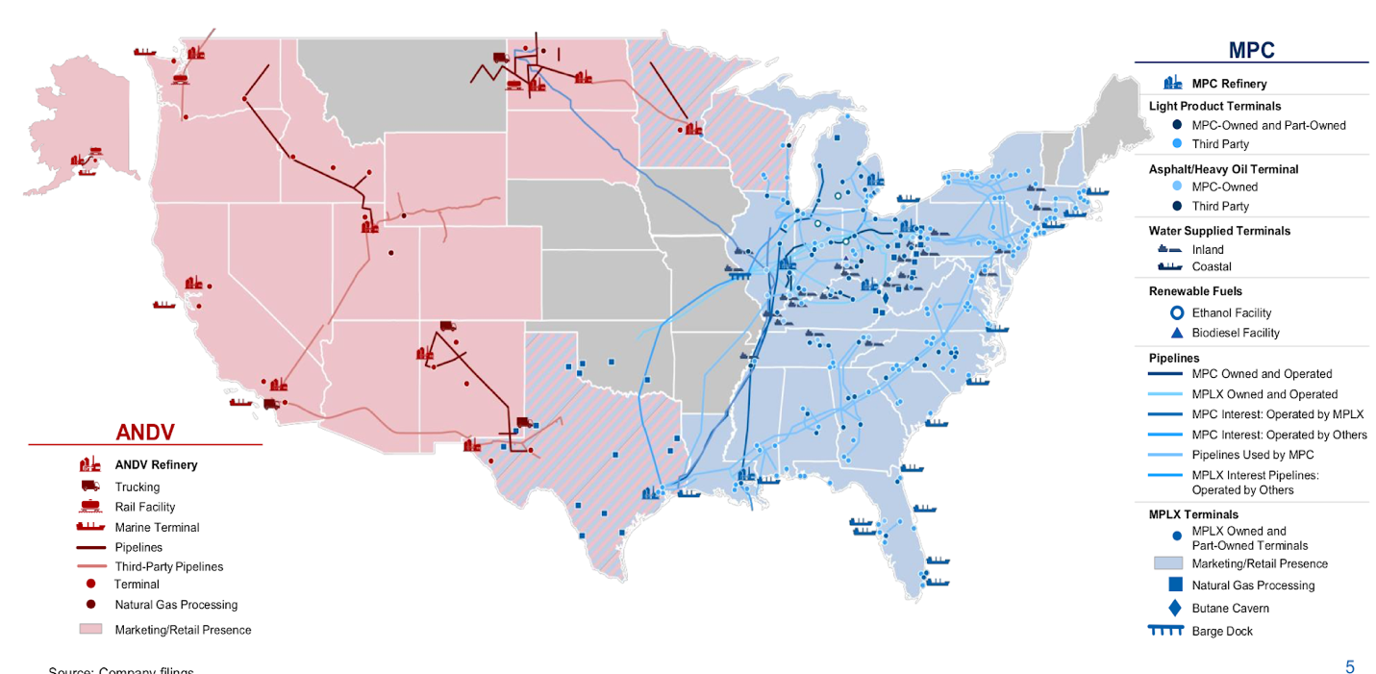
Integration
- MPC expects to save $1 billion in cost synergies over the first three years, with further gains from ANDV’s refining assets. The deal immediately increases Marathon’s refining footprint from east of Mississippi to California and the Pacific Northwest regions. When analyzing the Midstream segment, this integration increases its presence in the Permian basin and Bakken regions, and strengthens ANDV limited partnership to its own MLPX. MPC is also promising an enhanced integration model from wellhead to the customer and customer loyalty programs. For example, the Speedy Rewards program for their Speedway stores has been increasing in membership since its inception and increases customer retention and satisfaction. Both of which will be essential in the expansion into new regions. We believe their rewards program is going to drive the growth of their retail revenue.
Attractiveness to investors
- MPC has consistently outperformed the SPX Index over the past two years, has maintained a dividend yield above the industry and S&P 500 average, and has been increasing year over year. Their dividends are consistently paid out each quarter making the stock attractive to defensive investors. MPC has shown much more growth compared to their sector. MPC is now the leader in amount of US refineries and second in retail gas stations, with a large market share and room for growth. MPC is able to hedge their typical oil market risks through their gas stations as when the price of oil increases, their gas stations may take a hit but their downstream operations benefit. Similarly, when the price of oil goes down, their downstream operations will be disadvantaged, but their gas stations will benefit. In the likelihood that the price and demand for oil increases over time, MPC will be able to increase revenues in their refineries. Although their midstream operations account for a small portion of their revenue, the midstream operations are dependent on long term contracts that are not affected by the fluctuating price of oil. Overall, MPC has been an attractive stock for investors and can act as a defensive value stock in our portfolio with the U.S. moving to the later stages of the business cycle.

Management
Gary R. Heminger is the Chairman and Chief Executive Officer at Marathon Petroleum since 2011. He has been with Marathon since 1975 and has served in a variety of different roles. In 2001 he served as the executive vice president of downstream at marathon oil corporation till 2011 when the company separated from its parent, Marathon Oil Corporation. Gregory J. Goff is the executive vice chairman since 2018. He has an extensive background in the industry. Prior to the Andeavor acquisition, Gregory was the chairman, president and CEO for Andeaver since 2010. Before his time at Andeavor, he was at ConocoPhillips where he had several different roles including Senior vice president commercial. There is a pending management change regarding the board members. If the proposed idea is approved, the board will consist of eight members from MPC and four members from Andeavor. The members of the board have all had several years of experience and are highly qualified. See chart below for management compensation.

Name​ | Position​ | Tenure​ | Insider Holdings​ | Total Compensation​
Gary R. Heminger​ | Chairman & CEO​ | Since 2011​ | .124%​ | $19,670,807​
Gregory J. Goff​ | Executive Vice Chairman​ | Since 2018​ | .37%​ | TBD​
Donald C. Templin​ | President, Refining, Marketing and Supply​ | Since 2011​ | .019%​ | $5,864,386​
Anthony R. Kenney​ | President Speedway​ | Since 2011​ | .025%​ | $4,460,239​
C. Michael Palmer​ | Executive Vice President​ | Since 2011​ | .015%​ | $3,471,458​
Timothy T. Griffith​ | Senior Vice President and CFO​ | Since 2011​ | .010%​ | $4,442,869​

Stock Chart Comparing MPC to the SPX Index over the past year:
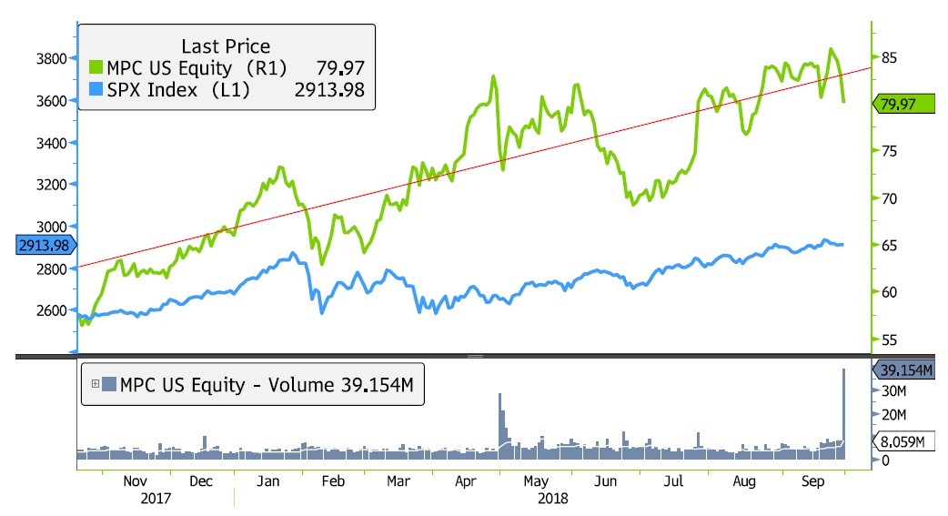

Risks
- There are inherent risks that comes with the acquisition of ANDV including:
  - The cost savings and any other synergies from the ANDV transaction may not be fully realized or may take longer to realize than expected
  - Disruption from the ANDV transaction making it more difficult to maintain relationships with customers.
  - Employees or suppliers risks relating to any unforeseen liabilities of ADNV.
This risk is initially present due considerable changes taking place initially during any merger and acquisition. There are also risks regarding the acquisition as far as the employees and management’s ability to adapt to MPC’s structure and operations. This could result in a loss of productivity and efficiency.
- Due to the governmental influences on energy production, there are ongoing risks associated with compliance of federal and state regulations surrounding the energy sector. This also includes governmental risks associated with current and future tariffs, international relations, and taxation changes. Steel is very important to this sector so the longevity of the recent tariffs could pose a risk to future projects and expenses.
- The price of oil heavily influences the operations of oil refineries and their gas stations. This also includes the risks associated with OPEC and the international oil market. Should OPEC choose to attempt to drive the price of oil down, this could impact MPC’s downstream operations. Our mentor, Aaron Reynolds explained, that the retail gas market could be disadvantaged if the international price of oil goes up, as consumers would be less likely to fill up their tanks, go on road trips, etc. This would also disadvantage the Speedway retail merchandise as less customers would enter the stores to purchase goods.
- The company also faces risks due to changes in the WTI-Brent Crude spread which shows the margin between the two oil price indicators. WTI is also known as Light Sweet Crude, the majority of which is located in the Permian oil Field. The Brent Crude Blend is a combination of crude oil from 15 different oil fields in the North Sea. It is less “light” and “sweet” than WTI, but still excellent for making gasoline. It is primarily refined in Northwest Europe, and is the major benchmark for other crude oils in Europe or Africa. Downstream companies are able to increase profit margins in their downstream operations when the spread/difference between the two increases, but face a disadvantage if the spread decreases.

Ownership
Vanguard Group | 34,419
State Street Corp | 23,725
Blackrock | 21,836
JPMorgan Investment | 11,832
Wellington management | 7,654

Ownership type
Investment Advisors | 77.18%
Hedge fund managers | 10.56%
Pension fund | 3.03%
Other | 9.23

Peer Analysis

​ | Product Sales Volume | Dividend Yield​ | P/E Ratio​ | EV/EBITDA ​ | Throughput (MBbls/d)​
Exxon Mobil​ | 5,530​ | 4%​ | 23.3​ | 21.2​ | 4,918​
Chevron​ | 2,690​ | 3.80%​ | 33.8​ | 9.5​ | 1,661​
BP​ | 5,948​ | 5.60%​ | 23.2​ | 7​ | 1,702​
Phillips 66​ | 2,195​ | 3.10%​ | 23.1​ | 14.1​ | 2,181​
Valero​ | 0​ | 3.40%​ | 18.5​ | 6.9​ | 2,940​
Marathon Petroleum Corp​ | 2,311​ | 2.50%​ | 17.5​ | 10​ | 1,944​

Valuation
When performing our valuation of Marathon Petroleum Corporation, we chose to apply the five-year discounted cash flow model for our intrinsic valuation combined with the relative P/E multiple model, weighting them 50% and 50%. Based on our investment thesis, we anticipate revenue to continue to grow significantly due to their expansion west, as well as considering the increasing price of oil. We chose the P/E multiple model as our second model to value MPC due to many companies in this sector typically having stable and low P/E ratios, which provided us with a confident multiple to use. We arrived at the prices of $88 and $95 respectively with a one year target price estimate of $91.62 representing a 23% upside. We evaluated the peers above and used their P/E multiples average to come to our relative valuation.

