Financial Sector Report
Marcus Kamrath and Yizhuo Liu Fall 2018

Sector Introduction
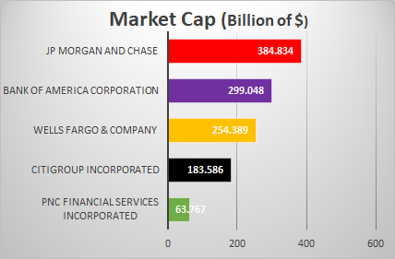
In the United States, the financial sector is one of the largest portions of the S&P 500, behind only information technology and health care. This sector can be broken down into three distinct sub sectors: banking, diversified finance, and insurance. Banking consists of diversified and regional banks, as well as many different types of lenders. Diversified finance consists of the consumer finance, credit, and capital markets. Asset managers and credit companies are the two largest groups within this sub sector. Insurance consists of many specific categories of insurance, but this sub sector can be loosely specified into the broader categories of property, casualty, life, health, and multi-line insurance. Each sub sector, as well as its relative components, are driven by differing economic occurrences and trends, however certain aspects are consistently influential throughout the entirety of the financial sector.
Key Industry “Players”
Banking
- JP Morgan and Chase
- Bank of America Corporation
- Wells Fargo & Company
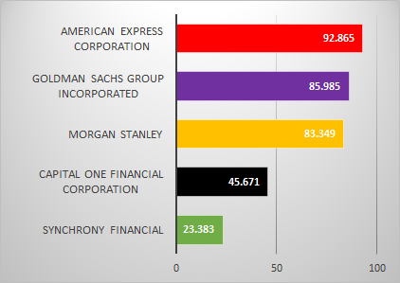
- Citigroup Incorporated
- PNC Financial Services Incorporated

Diversified Finance
- American Express Corporation
- Goldman Sachs Group Incorporated
- Morgan Stanley
- Capital One Financial Corporation
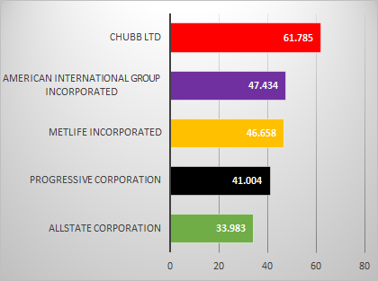
- Synchrony Financial

Insurance
- Chubb Ltd
- American International Group Incorporated
- MetLife Incorporated
- Progressive Corporation
- Allstate Corporation

Key Economic Indicators: Industry-wide
- Interest rates
  - Higher interest rates make lending much more profitable in the long term, as lenders will receive higher proportions of principal throughout the lifetime of their loans, effective fed funds rate is 1.91% and the target is 2%.
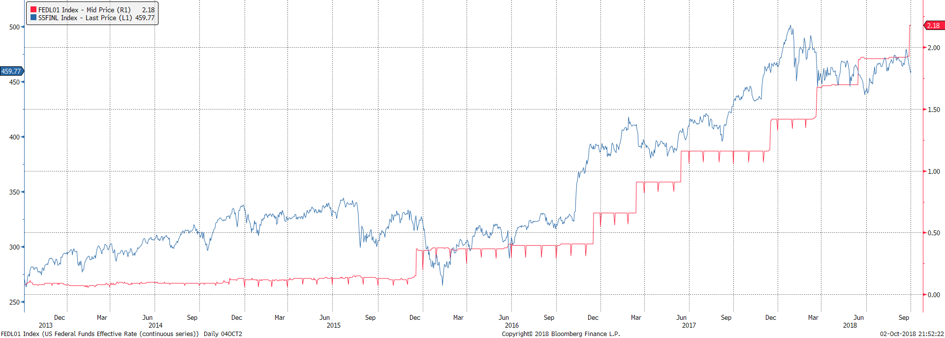
  - In the short term, increases in interest rates will stimulate the amount of consumer saving, subsequently decreasing net interest margins and increasing depository totals
Financials Sector (Blue)
Short Term Interest Rates (Red)
- Gross Domestic Product (GDP)
  - An increase in GDP, after accounting for changes in other components, shows us that consumers are receiving higher incomes, and thus spending more
  - This can lead to an overall decrease in amounts being saved, but an increase in lending and credit spending, stimulating growth for many institutions within the financial sector
  - Historically, United States GDP has been growing at a steady rate of about 4.1% each year
- Consumer Confidence Index
  - Provides insight into the consumer sentiment about the general economic situation in the future
  - If consumer confidence is high, consumers will be comfortable spending more, as they do not expect their own financial conditions, as well as the conditions of the overall economy to deteriorate
  - High consumer confidence correlates positively with depository growth, loan growth, investment growth, and policy growth
  - Reflects sturdy economic growth over the last nine years, with no end in sight. The index is at a 17-year high and we believe this trend will continue
- Unemployment
  - As more citizens develop consistent income, they tend to both save and spend more. This leads to an overall increase in the number of active loans as well as an increase in new depository accounts
  - We can also observe an increase in credit spending as unemployment decreases
  - United States unemployment rate fell to 3.9% in August of 2018. Nonfarm payrolls have also grown for a consecutive 91 months, the longest streak on record. If this trend continues, we can continue to expect to see growth across the entire financial sector.

Key Economic Indicators by Sub Sector
Banking
- Nonperforming loans
  - Important index when observing the overall quality of a bank’s assets
  - Nonperforming loans are much more likely to default, leading to lower interest income and revenues for banks
  - The percentage of nonperforming loans has been steadily decreasing, which correlates with steady income growth in the banking subsector
  - If we see a bank’s non-performing loan rate move against this trend, we can expect their income and stock price to decrease
- Allowance for loan losses
  - An increase in a bank’s allowance for loan losses means said bank is expecting an increase in nonperforming loans and loan defaults
  - Bank’s hold this reserve to prepare for accounts receivable that may end up uncollectible
  - This can be used to accurately forecast a bank’s confidence in its loans, and subsequently, its overall performance
- Non-interest income
  - Bank’s heavily rely on income from fees to derive profits, especially when interest rates are low
  - Downward trends in a bank’s non-interest income, when coupled with decreasing interest rates, demonstrates that a bank is not properly accounting for changes in its revenue stream, and forecasts potential decreases in a bank’s overall performance
Diversified Finance
- Disposable income trends
  - Assist in predicting the future of the diversified finance world
  - When households have more money available for spending and saving, they will be more inclined to spend said money
  - As overall disposable income decreases, consumers will feel less comfortable spending, especially when spending on credit
  - Disposable income positively correlates with the overall performance of the diversified finance sub sector, and it can be used effectively to forecast potential changes in overall performance
Insurance
- The bond markets
  - As of 2017, bonds account for almost 70% of all invested assets within the insurance sub sector
  - Changes in the yield curve could potentially have drastic impacts on the revenue stream of insurance agencies as a large portion of their investment revenue is directly tied to the performance of the bond market
- Average costs of incurred losses
  - Represents a major expense on any insurance agency’s income statement, thus directly affecting a company’s overall performance
  - When average costs of incurred losses increase, it can be assumed that the insurance agency is not properly managing its underwriting activities
- Rate of premium growth
  - Healthy premium growth is driven by an insurance agency’s abilities in expanding its customer base and developing new and relevant products
  - Thriving insurance agencies see steady growth in the quantity of premiums they receive
  - Healthy premium growth is directly correlated with net income, as premiums account for a large portion of any insurance company’s revenue stream. Decreases in premium revenue indicates a company is losing policyholders and could signify future distress for an insurance agency
Key Drivers: Industry-wide
Industry-wide
- Government regulation
  - New regulations consistently lead to a higher workload for employees within the financial sector, as it takes substantial time and effort to adapt business practices to follow new regulations correctly
  - Many regulations encourage more investment, which are meant to help stabilize the entirety of the financial sector
  - EPA regulations often require companies to upgrade equipment and to utilize more expensive processes to reduce environmental impact. Financial companies often prefer to shift their costs to benefit their consumers, however EPA regulations cause them to shift costs elsewhere, potentially disrupting revenue streams
  - Too much regulation can stifle innovation and drive up costs, while too little regulation can lead to mismanagement and collapse. This makes it difficult to identify potential future impacts of government regulation, but the impact is usually far-reaching and long-lasting
  - With newly elected officials, we have already seen suggested regulations that would loosen restrictions in the financial sector. These new regulations could allow for more trading and lower tax rates, leading to higher profitability and more freedom for entities within the sector. We believe this will have a positive impact when it comes to the overall health of the industry
- Environmental, Social and Governance (ESG) Criteria
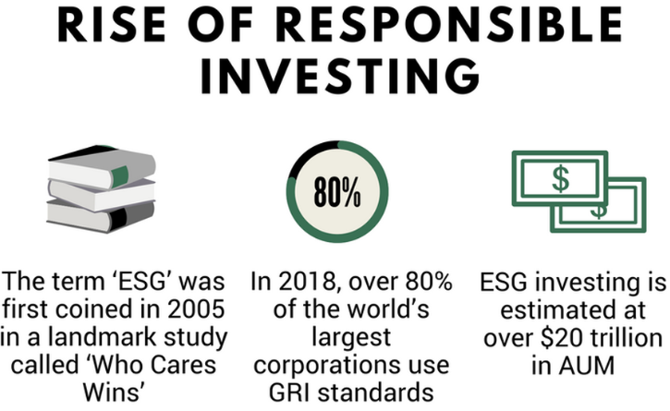
  - Globally, a strong majority (83%) of financials indicate that an ESG investment policy is important to their firm
  - Data suggests that ESG compliance provides companies with lower volatility in their stock performance
  - Many major companies within the financial sector publish reports that extensively review their ESG Criteria. Many of these efforts include prohibition of certain transactions, portfolio reviews, risk exposure, and legal requirements
  - The financial sector is exceptionally prone to internal misconduct. Data suggests that if a financial company is unable or unwilling to comply with ESG criteria, they will receive much less attention from investment analysts and their overall performance may potentially deteriorate
  - Many large companies within the sector have proven their devotion to ESG Criteria. If any company moves away from this trend, we believe their overall performance and the quality of their investor relations may be at a very high risk
Key Drivers by Sub Sector
Banking
- Financial technology (Fintech)
  - Fintech has vast horizons that include any technological innovations that affect how business is done in the banking world. This includes online banking, online lending, mobile credit analysis, etc.
  - The introduction of fintech has been astoundingly disruptive, as banking products and services that were once performed by salespeople in branches have moved to web-based platforms and mobile applications
  - Trends toward mobile banking, increased availability to information, more accurate data analytics, and expansion of access will create unprecedented growth in the banking sub sector
  - According to EY’s Fintech Adoption Index, one-third of banking consumers utilize at least two fintech services, and at least half of consumers are aware of how fintech affects their daily lives
  - If a banking institution is unable to adapt to the “fintech revolution”, they will be unable to survive in the consumer-driven world of banking.
Diversified Finance
- Mergers and acquisitions
  - The diversified finance sub sector is largely dominated by four main corporations (Discover, Capital One, American Express, Synchrony) that often merge with or acquire prominent new entrants into the market
  - This process allows established customers to expand their capital markets through new processes and services
  - Potential new regulations offer trade concerns that could adversely affect the way these mergers and acquisitions are performed. We foresee higher costs incurred in the future
Insurance
- Financial technology (Blockchain)
  - Blockchain is described as a globally distributed database system that collects and analyzes data in real time
  - These technologies are allowing insurance companies to cut underwriting costs while still providing more accurate predictions based on increased availability to data
  - Blockchain technology is roughly as mature today as the World Wide Web was in 1996, most likely impacts include: Improved trust, Fraud detection and prevention and enhanced efficiencies.
  - We predict future developments in blockchain technology to spark unprecedented growth in the insurance industry, the most important benefit is blockchain can bring trust, eliminate the crisis of trust in the financial services industry because it is self-managed and does not require coordination from an intermediary. Other benefits include but not limited to enhance efficiencies, fraud detection and prevention.
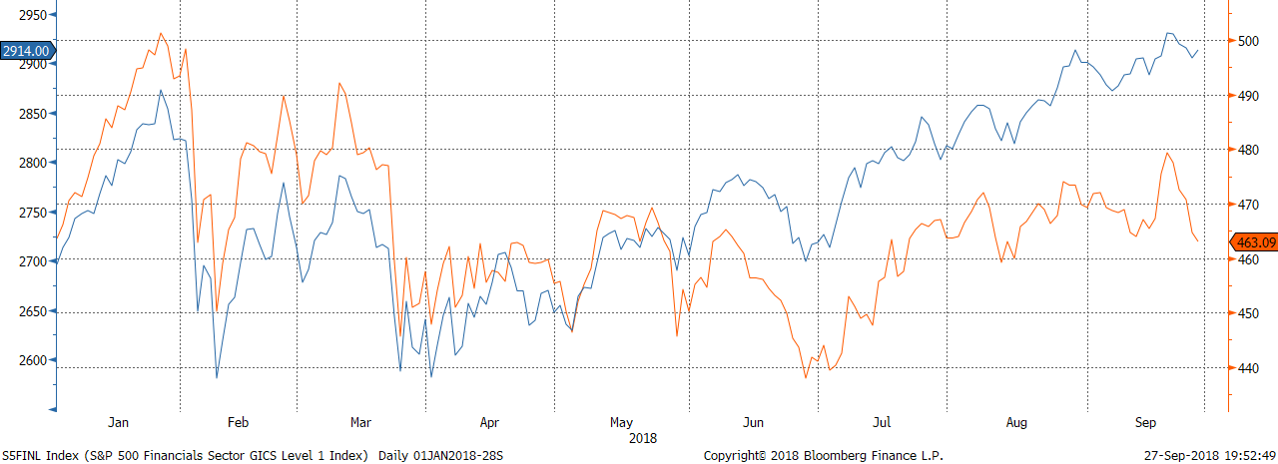
Key Ratios and Statistics
Financial Sector (Orange)
S&P 500 (Blue)
Industry-wide | Banking | Diversified Finance | Insurance
-P/E 15.48  -P/Book Value 1.53  -Dividend Yield 1.82  -Return on Assets 1.11  -Return on Equity 9.60  -Return on Capital 3.40  -Operating Margin 20.83  -Profit Margin 14.02 | -P/E 16.34  -P/Book Value 1.40  -Dividend Yield 2.17  -Return on Assets .80  -Return on Equity 8.15  -Return on Capital 2.40  -Operating Margin 32.68  -Profit Margin 19.92 | -P/E 17.58  -P/Book Value 1.84  -Dividend Yield 1.25  -Return on Assets 2.09  -Return on Equity 13.14  -Return on Capital 5.04  -Operating Margin 20.87  -Profit Margin 13.14 | -P/E 16.55  -P/Book Value 1.35  -Dividend Yield 2.18  -Return on Assets .83  -Return on Equity 7.41  -Return on Capital 6.76  -Operating Margin 10.45  -Profit Margin 6.52

Stocks within our portfolio
BofI Holding Company (BOFI) - HOLD
BofI (Bank of t is a completely online banking platform that attracts web-based customers from every US state. Because the bank is branchless, they utilize a completely digital marketing platform to gather intuitive user data. This helps them cross-sell products and generate ideas for new products and services. BofI generates a large portion of revenue from its loans, 85% of which are adjustable rate. Their easy to use platform and wide variety of depository and lending products have helped them expand to all demographics of consumers. We recommend a hold for BofI, as their EPS has been increasing every year over the past 6 years, despite downward trends in their stock price. They have demonstrated rapid success over the last 8 years. Interest income has jumped from $63M to $380M, non-interest income from $1.4M to $68M, and net income from $3.9M to $135M. BofI has achieved this success by growing its loan portfolio through new products, leveraged data mining, and occasional acquisitions. BofI is expected to continue its development over the next 3 years, and we believe their stock will be of a much higher volume over that time.

Progressive Corporation (PGR) - HOLD

Progressive is a multi-line insurance company that primarily focuses on vehicle insurance types. Progressive uses successful advertising and a long-standing brand recognition to obtain new policyholders. They offer a competitive bundling package to retain multiple insurance policies per individual. Revenue, net premiums earned, and investment income have all been steadily growing since 2008. Most importantly, revenue has been substantially improving over the last few years, growing 14% in 2017 to $26.8B. Unlike most insurers, Progressive earns over 90% of its revenue from policy premiums, while most insurers earn revenue from investments. This provides Progressive with a much lower investment risk. We recommend a hold for Progressive. Their stock price has been steadily growing over the past 5 years, including a 31% increase over the course of 2018. Their EPS and free cash flow have also been steadily growing over the past 5 years. Their indexed total return has increased by over 20% since June, suggesting they are receiving substantial income relative to their stock price. We expect their value to increase, based on steady economic growth and new initiatives to expand its geographic markets and online distribution.

E-Trade Financial Corporation - HOLD

E-Trade Financial Corporation is a financial services company that provides online brokerage and related products and services primarily to individual retail investors. They have a vast array of services, offering common stock and debt info, financial filling, analysis, portfolio management, deposits, mutual funds and EFT. In 2017, their net income rose by 105% to $552m, due to jump in gains on securities and higher interest income, offset by an increase in income tax expense. Additionally, EPS has held a steady growth over the course of 2018. We recommend a hold for E-Trade, as they have had steady financial growth and they also recently acquired Trust Company of America, which had $18.3B in assets. E-Trade has long been at the forefront of the digital revolution and keeps innovating their mobile and technical services. We believe their price will increase according to stable growth, technological innovation, and the acquisition of Trust Company of America.

