Introduction – Becton, Dickinson & Co

Becton, Dickinson & Co (BDX) is a global medical technology company with a market capitalization of $68 billion. The company currently has roughly 42,000 employees worldwide throughout 50 countries. They operate in North America, South America, Europe, Middle East/Africa, and Asia. Some of the most notable of the 50 countries they operate in include India, China, and the United States. BDX is broken down into two primary segments which is BD Medical and BD life sciences. The BD Medical segment produces medical devices for healthcare institutions, clinical laboratories, pharmaceuticals, and the public. The BD Life Sciences consists of products that are developed for the safe transporting and collection of specimens and the instruments to detect potential contamination. Currently their revenue is composed of 67% in the medical equipment sector and 33% in life sciences. Becton & Dickinson Co. Is overall a very strong company. However, during this year the stock price has greatly fluctuated, as you can see below. This fluctuation and current low-point provides a great opportunity for investors, which we will break down why below.

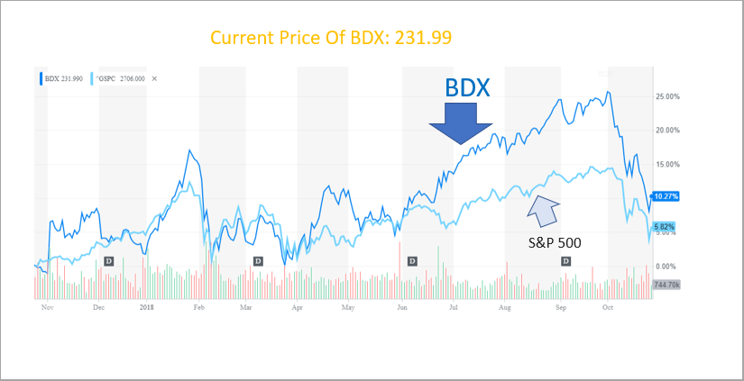

Recommendation

We recommend a BUY on Becton, Dickinson and Company. Currently the stock is priced at $231.99, however we believe the price will increase to around $272.72 based from our valuations shown below. This offers an upside of approximately 17.55%. Due to key drivers within healthcare, our investment thesis below, and our valuation we believe that BDX has significant room to grow.

Investment Thesis

- High Differentiation of Technology and Breath
A key survival tactic on the medical equipment sector is to have as many product differentiations as possible due to the increasing difficulty of medical technology companies to survive with a limited range of products. Technology has taken center stage in all areas of medical treatment; meaning more accuracy, faster treatment times and fewer occurrences of error. BDX currently has several products in the market that are high in demand such as BD FlowSmartTM which reduces unplanned insulin flow in diabetes patients and BD SurePathTM which is the most advanced and accurate cervical cancer detection test available. Further, BDX has recently announced molecular test for tuberculosis in Europe for the model BD MaxTM MDR-TB which identifies treatment-resistant mutations of TB that can help doctors combat the mutated bacteria.

- Growing International Presence
BDX have direct presence in 50 countries in the world. Some of them are nations with huge populations of middle-income families with growing disposable income to spend such as India and China. In 2016, BDX’s revenue from Asia was 13.6% while in 2017 it was 14.4%. That number will gradually increase as we determined that the population growth in China and India as well as other growing middle-income nations begins to age over the next few decades. Further, the worldwide population will see an increase of aging people from nearly 1 billion in 2017 to 1.4 billion by 2030. To summarize, as these nations spend more on healthcare, the quality of life will increase. This in turn will lead to the higher demand for medical treatments as they live longer. Since BDX has already established a strong presence in these nations, it can only lead to an increase in revenue for the company.

- Strong Financial Standing
BDX have seen growing revenues for the past 20 years. This is in part to their innovative product pipeline that is introduced to the market and effective market penetration. They have minimal debt that is covered by their cash. In recent years the debt has increased due to mergers and acquisitions but we believe that the debt is still in healthy range. The reason we believe this is a healthy range is because they plan to reduce their leverage to below three times by 2020 and they also have a healthy coverage ratio of 2.87 showing that they can handle the debt they own. Furthermore, as seen below, their ratios are performing well against their peers, such as; Abbott Laboratories and Hologic.
Name | ROA | ROE | Current Ratio
Becton, Dickinson | 1.7% | 4.6% | 1.23
Hologic Inc | -1% | -3% | 1.29
Abbott Labs | 1.2% | 2.6% | 1.58
As seen above, BDX is performing well based on ROA and ROE. Their current ratio is worse than the others due to participating in mergers and acquisitions and taking on debt from those transactions.

- Active in M&A
Since the stock’s IPO in 1972, BDX have engaged in 91 M&A transactions, of which they have bought 57 companies and sold 34. The companies that they acquire are diverse in the healthcare sector, thus BDX can enter new markets without having to spend on R&D and capture new target customers. With the acquisitions the customers of the acquired companies are absorbed into BDX’s outreach. Overall, BDX has shown a willingness to take risks in M&A to provide future growth for many years to come.

Becton, Dickinson & Co. Valuation
For our valuation we combined multiple models to end up with a share price of $272.72. We used two multiples, price-to-earnings and EV/EBITDA, we took a weighted average comprised of 40% of the price-to-earnings and 60% EV/EBITDA. This gave us a price of $267.7 From there we then created a discounted cash flow model while using a perpetuity growth rate of 2% which resulted in a price of $280.2. We then weighted our two results with 60% of the share price from the multiples model and 40% from the discounted cash flow which resulted in a final price of $272.72 as mentioned above. The current price is $231.99 which offers us an upside of approximately 17.55%.

Becton, Dickinson & Co. Risks

Merger Risk:
As with every company, mergers can drive success but also provide potential chances of not being profitable. There are multiple reasons such as financial shortfalls from miscalculations or unexpected costs, poor strategizing while merging, and culture fit. Recently, BDX has acquired Bard, which will significantly expand their business while offering about $300 million in cost synergies. If this merger works out, it should propel BDX to new heights.

Currency Risk:
The currency risk with BDX is currently quite significant, and we expect the risk to grow even more. Currently, they operate in 50 countries and nearly every continent which will lead to dealing with multiple different currencies. They will have to attempt to hedge this risk ask the international markets continue to grow.

Medical Landscape Changes:
As discussed in our sector presentation, hospitals are going to significantly look to cut costs in the future which could influence the financial landscape of healthcare companies. This change would potentially push down profits for medical devices. However, if they continue to have strong relationships with customers and suppliers, we believe they will be able to still be extremely profitable in the long run.

Government Risk:
Health is the most important piece of anyone’s life. As a result, the government is directly involved in the field with many regulations that could significantly change as administration changes. Products are always monitored and must pass all three phases to hit the market. Currently, the administration intends to cut down on the necessity to have insurance. This could lead to less coverage, and less demand for devices. However, there will always be a need for medical practices, so it should not result in significant differences.

Legal Risk:
Being in the healthcare sector poses a lot of risk legally. If a medical device leads to malpractice or improper care, the company can potentially be sued for millions of dollars. However, this company has a good track record of proper devices and we do not believe the legal risk to be too high.

Becton, Dickinson & Co. Management

Vincent A Florenza, MBA:
Mr. Florenza is a long-time member of Becton, Dickinson and company. He has been with the company since 1980 and was influential in getting two of their most successful products to the market earlier in his tenure. His long tenure provides a steady hand to keep pushing the company forward. He has worked his way up to the position as a Chairman and CEO. His current salary is roughly $13 million.
Thomas E Polen, MBA:
Currently, Mr. Polen is President & COO. His salary is roughly $4.2 million. Mr. Polen joined the company in 1999 and worked his way through multiple positions including General Management, sales, marketing, and strategic planning. Overall, he has a deep understanding of the company.
Christopher Reidy, CPA:
Currently the CFO, CAO & EVP with a salary of $4.6 million. Mr Reidy has a more diversified work history then most of the current members. He currently holds the CPA certification and has been CAO and controller of AT&T previously. He got his masters at Harvard and overall has an impressive career track that can add a lot of value to BDX.

Board of Directors Brief:
Overall, BDX has an overall diversified and professional board from various industries. They have medical professionals such as Rebecca Rimel, a former member of Bard who they recently acquired, other medical device professionals, and professionals from various backgrounds such as international marketing. In addition, 31% of the board comprises of women which is larger than most of their peers.

Peer Analysis
In the medical technology subsector, BDX has 4 main competitors: Abbott Laboratories, Baxter Intl, Johnson & Johnson and Hologic. Based from company product lines and similarities within the industry, we decided this was our strongest peer group. Below we have created a matrix to represent key metrics within these competitors. As you can see, BDX is one of the most attractive companies of the group from a valuation and profitability standpoint.
Company Name | Net Debt | Net Income | EPS | PE
Abbott Lab | 18,314 | 344 | 0.3 | 24
Baxter Intl | 118 | 724 | 1.3 | 27
Johnson & Johnson | 16,285 | 1,300 | 0.5 | 17
Hologic | 2,839 | 755 | 2.6 | 18
Becton, Dickinson | 4,670 | 1,100 | 4.6 | 21

Ownership of Shares for Becton, Dickinson & Co
Becton, Dickinson and Company is primarily composed of institutional investors, sitting at 93.47%. The top 10 institutional investors own 48.65%. The top 10 consist of notable and respectable names in the industry including T. Rowe Price, Fidelity, Vanguard, BlackRock, and JPMorgan. With these top 10 investors, there has been a lot purchase activity of BDX with minimal sell-offs. Current management for BDX has also consistently repurchased the companies' stocks. All this positive movement makes us believe that the market, and the management of the company, have strong faith that this stock will continue to grow into the future.

