Megan Peterson & Abdurrahman Mamou

Senior Analyst: Rachel Dax

Ticker: V

Current Stock Price: 185.09
Introduction:
In 1958, Bank of America launched BankAmericard, the first card with a “revolving card” feature and the first consumer credit card program for the middle-class. In 1976, BankAmericard was renamed to Visa. In 1974, the company expanded internationally. In 2008, Visa went public and became the largest initial public offering in US history. Today the company operates in more than 200 countries and territories. They have more than 348M cardholders and is accepted by over 40M merchants. Visa engages in the provision of digital payment services. They offer debit cards, credit cards, prepaid products, commercial payment solutions, and global ATMs.

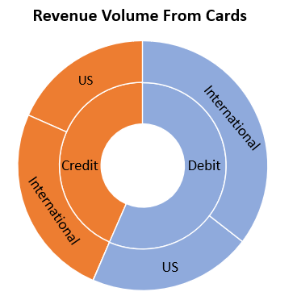
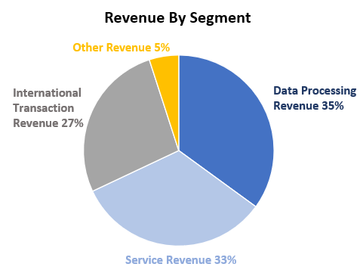
Revenue:

The revenue by segment graph shows how Visa divides their revenue into four different segments. Data processing revenue includes all revenue generated because of the company’s authorization and settlement of services. This segment has grown 11% in 2019. Service revenue is revenue from services provided to support client usage of payment services. This segment has grown 9% in 2019. International transaction revenue is revenue from cross-border transaction processing and currency conversion. Other revenues consist of license fees, value added services, account holder services, and more. The revenue volume from cards graph shows how majority of their revenue volume is from debit cards specifically international programs. One of Visa’s top competitors Mastercard generated $16.9 billion in total revenue in 2019 while Visa generated $23 billion. In payment volume Mastercard only generated $6.5 trillion while Visa generated $8.8 trillion.

Investment Thesis:

Partnerships
One of Visa’s core business models is partnerships. There current long-standing partnerships are with J.P. Morgan Chase, Bank of America, BBVA, and others. They are building new relationships with emerging players such as digital banks, wallets, and a range of fintech’s. Fintech has been a growing industry. In 2019 the company launched Visa Fintech Fast Track Program globally to provide emerging partners with the tools they need to more easily scale and leverage Visa’s reach, capabilities, and security. They also launched Visa Partner Portal which provides comprehensive services and resources to help fintech’s and other partners bring new ways to pay. A couple of Visa’s fintech partnerships are with Airwallex, PayPal, Chime, and Rappi.
In 2019 Visa partnered with Revolut, a fintech company, to expand the company’s business to five regions. Revolut provides consumers a range of digital financial services via a mobile application, including currency exchange, budgeting, and person-to-person payments. Also, in 2019 Visa in Asia partnered with and invested in Gojek, a mobile app, featuring more than 20 different verticals, spanning payments, food delivery, ride-hailing, laundry, courier services, tickets, and more. Visa is constantly looking for new partnerships to build and grow their company.

Innovation
Visa is providing innovations for a cashless world. In a recent study by Visa, 70% of consumers consistently feel their devices improve their quality of life. 60% of consumers said they would like to pay for products more efficiently and quickly. 40% of consumers preferred to automatically pay without having to manually check out online or physically stop by the counter. Payment technology companies are providing more secure and faster transactions.
Visa introduced the next-generation wearables with Visa’s Token Service. Using the Internet of Things and tokenization, they can offer integrated payments for wearables that blend function and style. This wearable will allow people to enhance their on-the-go lives with easy and more secure contactless Visa payments. Using tokens replaces sensitive account information, such as the 16-digit primary account number, with a unique digital identifier. This token allows payments to be processed without exposing actual account details. Visa is constantly innovating to keep a competitive edge and to draw in more consumers.

Reduction in the Use of Cash
Society has slowly been moving away from using cash to using plastic card payments, as well as new payment methods such as mobile payment. Cash has long been known to be dirty and carry bacteria and viruses, and this is even more relevant currently with the COVID-19 pandemic. Many businesses have began rejecting cash, and only accepting card payments. We believe this is will be a growing trend both within the U.S. and abroad. Society will begin moving away from using cash due to its transmission of viruses and bacteria, and begin using card payments, as well as emerging payments such as touchless and wearables. Many cards, including Visa cards allow for tap and pay meaning the customer no longer has to touch any buttons. We suspect this to become a growing trend, therefore, because Visa is already offering these payment methods, and is continuing to innovate this technology, there future sales growth will be amplified due to the current pandemic. In addition, Visa by far holds the largest portion of the market share of debit and credit cards at 60% followed by MasterCard at 30%. Therefore, Visa will benefit greatly from the increased use of debit and credit cards in the future. In addition, while many people in the U.S. already hold cards, and the increase will not be that significant in the U.S., many countries globally still use cash as the main form of payment, and due to the current global pandemic, many of these countries will begin transition to cards. With Visa operating in over 200 countries, they will benefit greatly due to this societal change.
Valuation:

Dividend Discount Model
In creating a valuation for Visa, we first used the Dividend Discount Model to generate a stock price. Using the DDM, we created a range by using a conservative dividend growth rate, and a higher growth rate more in line with historic growth rates. Visa has had on average a 17.59% yearly dividend growth rate since 2015. Based on this, the DDM is a good valuation method to determine the current stock price value.
The first valuation using the DDM uses conservative dividend growth rates as we are currently in a pandemic and an economic recession. In this model, we estimated a dividend growth rate of 3% for 2021 and 2022, and a 10% growth rate for 2023 and 2024 with a terminal growth rate of 6%. With this, our model produced the following dividends per share:

Based on these growth rate estimates, our model produced a price estimate of $222.08 which creates a 19.9% upside from the current share price of $185.09.
In our next DDM, we used higher growth rates which are more in line with historic rates, however they are still considerably lower than the 5-year average of 17.59%. We estimated a growth rate of 6% for years 2021 and 2022, with a growth rate of 10% for years 2023 and 2024 along with a terminal growth rate of 6%. Based on these growth rates, our model produced the following dividend per share:

With these dividend estimates, our model produces a current stock price value of $235.10 creating an upside of 27% from the current stock price of $185.09.
Through these to valuations, we created a stock price value range of $222.08 - $235.10 for Visa.

Market Based Valuation
For our next valuation, we used a multiples model to value Visa against its main competitors. Visa’s two main competitors are Mastercard and PayPal. There are very few firms that truly offer the same services that Visa does, or that are of similar size as Visa. To compare Visa to its two main competitors, we used the P/E ratio, and used the peer average to generate a target price for Visa.
Comparing Visa against Master Card and PayPal using their P/E Ratios:

Visa’s price compared to its earnings is cheaper than both its peers, offering a better price for its earnings. Using the peer average P/E ratio of 39.5, we get a target price for Visa of $214.06. Therefore, based on this valuation Visa is currently trading at a 16.34% upside.

Both valuation methods give us an upside with Visa’s current price of $184. Using a weighted valuation with the following weights:
- DDM: 70%
- P/E Analysis 30%
We get a range of $219.67 - $228.78 for Visas target price. Therefore, Visa is currently trading with an upside of 19.4% - 24.3%

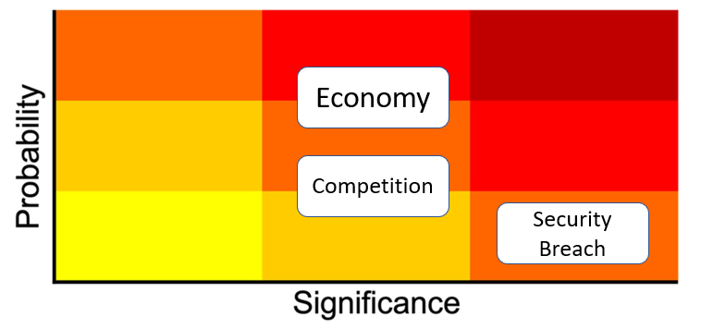
Risks:

Economy
If the economy is going through a decline consumer are less likely to travel. Of the company’s total revenue 27% is international transactions. Also, over half of Visa’s credit card and debit card revenue is from international programs. The company also provides travel protection and support to their customers. If there is less travel, there revenue decreases. With the high probably of this risk Visa is still a good investment because the company decreases this risk with other revenue sources, for example, service revenue and other revenues.

Competition
The digital payment services industry is highly competitive. Consumers have the power to choose between company’s; Visa, American Express, Discover, Mastercard, and many more. There is constantly new providers, new platforms, and new payment tools being launched. Visa decreases this risk with a high market cap. One of the company’s top competitors Mastercard only has a market cap of 270 while Visa’s market cap is 376.

Security Breach
Visa contains sensitive personal information of their customers. If that information gets out it could destroy the company’s image. Visa decreases this risk with evolutionary security. The company devalue sensitive data so that stored information cannot be used to commit fraud, reducing the incentive for criminals. They also invest in predictive analytics to identify potentially fraudulent activity and stop it before it happens.
Management:
In December of 2016 Alfred F. Kelly, Jr was appointed CEO of Visa. Alfred has been in leadership roles for majority of his career. Before he joined the company, he worked for American Express, one of Visa’s competitors, for 13 years. He also worked in the white house as manager of information systems for 2 years. Under Alfred there is 11 other executives, from chief financial officer to regional president Asia Pacific. The executives are compensated through annual salaries and majority stock awards. The CEO’s annual salary is $1.4M with a $22.8M stock award. Visa is proud of the equality and diversity they have at their company. There are constantly trying to challenge themselves towards further change. In 2018, Visa was recognized for best place to work for women, multicultural women, and millennials by Women’s Choice Award. In 2019, they were awarded diversity best practices by Inclusion Index Company.

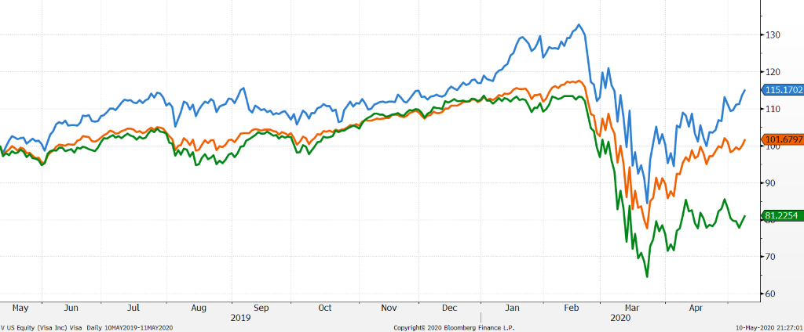
Stock Chart of Past Year Performance:
05.10.2019 – 05.10.2020

Visa
S&P 500
S&P 500 Financial Sector
$115
$101

$81

Visa outperformed the S&P 500 Index as well as the S&P 500 Financial sector Index over the past year. While the current pandemic affected Visa’s price, it was able to recover better than the S&P 500, and far better than the S&P 500 Financial Sector Index.
Peer Analysis:
Company | Market Capitalization (B$) | P/E (LTM) | Net Income 2019 (M$) | ROA % (5 Year Average)
Visa | $ 394.00 | 34.2 | $ 12,034.00 | 13.60%
Master Card | $ 283.60 | 36.1 | $ 8,118.00 | 24.50%
American Express | $ 72.05 | 13.6 | $ 6,712.00 | 3.10%
PayPal | $ 170.20 | 91.7 | $ 2,459.00 | 4.90%
Peer Average | $ 175.28 | 47.13 | $ 5,763.00 | 10.83%

Comparing Visa to its peers, it has the largest capitalization. In addition, its P/E ratio is well under its peer’s average. Visa also has a higher 5-year average ROA than its peers average. Based on these comparisons, Visa operates well above its peer’s average.

Ownership:
Insider VS Institutional/Mutual Funds Top 5 Shareholders
