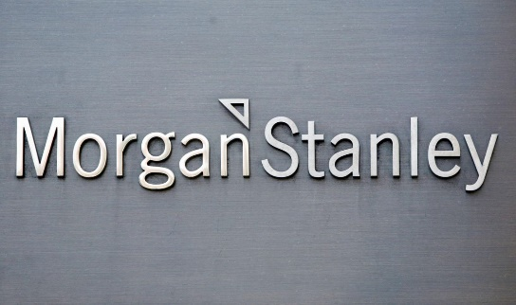
RuoQian Hu & Yichen Huang

Senior Analyst: Megan Peterson

Ticker: MS

Current Stock Price: 51.87
Introduction:
Morgan Stanley operates as a global financial services company. The firm provides investment banking products and services to its clients and customers including corporations, governments, financial institutions, and individuals. It operates through the following business segments: Institutional Securities, Wealth Management, and Investment Management. The Institutional Services segment provides financial advisory, capital-raising services, and related financing services on behalf of institutional investors. The Wealth Management segment offers brokerage and investment advisory services covering various types of investments, including equities, options, futures, foreign currencies, precious metals, fixed-income securities, mutual funds, structured products, alternative investments, unit investment trusts, managed futures, separately managed accounts, and mutual fund asset allocation programs. The Investment Management segment provides equity, fixed income, alternative investments, real estate, and merchant banking strategies. The company was founded by Harold Stanley and Henry S. Morgan on September 16, 1935 and is headquartered in New York, NY.

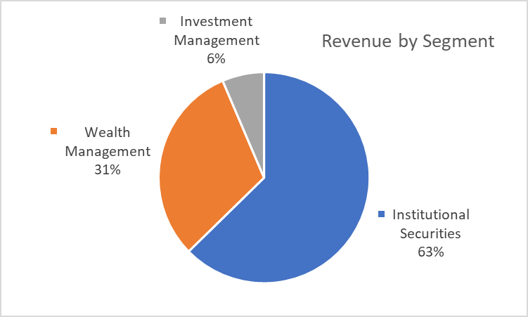
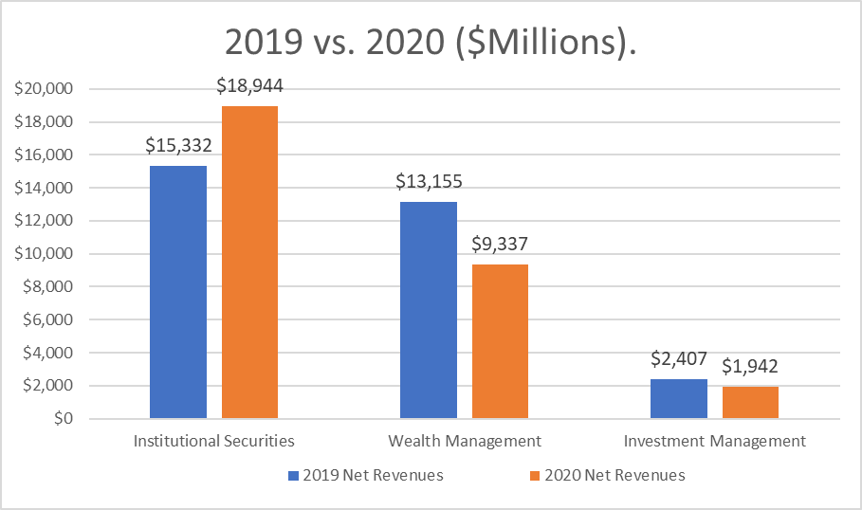
Revenue:

From segment graph, it shows that Morgan Stanley separate their revenue into three main parts. Institutional securities segment plays a large part of Morgan Stanley’s services, which provides most banks functions. This segment grew from 15,332 million to 18,944 million by 23.6%. However, other two segments have been affected by the coronavirus. The wealth management segment has decreased by 29% and the investment management has dropped about 19% from 2019. Also, total revenues include capital market earning and common stock repurchases, which both have increased about 1%. Although financial sector of the market was affected this year, but the highlight of Morgan Stanley proves that they remain in a better position. Firm net revenues up 16% and net income up 25%, reflecting strength across all business segments. Institutional Securities net revenues reflect strong performance across all businesses with higher results in sales, trading and strength in equity underwriting.

Investment Thesis:

Reducing COVID effect

I would like to put this investment thesis: reducing the effect in the first place. The COVID-19 crisis is a first-order effect that is driving great uncertainty about the timing of an economic restart. To prevent the market from seizing, the Federal Reserve (the Fed) cut short-term rates, opened swap lines to help U.S. dollar-funding demands, and initiated several facilities to stabilize money market, commercial paper, and primary and secondary corporate credit markets. The underestimate of COVID-19 has influenced all the financial institutions like JPMorgan, Goldman Sachs and Bank of America. However, Morgan Stanley performed really well in the third quarter after COVID-19. The bank's renewed focus on the investment management segment and the securities trading business has been key to its outperformance this year. For the three months, ended on Sept. 30, Morgan Stanley reported a 20% year-over-year increase in sales and trading revenue. The investment banking division reported sales growth of 11% in comparison to the corresponding period last year. This positive performance helped the bank grow its net income by over 53% in the third quarter. The acquisition of E*Trade played an important role in helping the bank generate record revenue from the sales and trading segment.

Looking into future
The merger between Morgan Stanley and E-Trade should be a big news beside the impact of the COVID-19. That means Morgan Stanley is looking forward into growth of young adult’s wealth manager and their investment choice. Morgan Stanley knows, as the society is moving more faster than ever into digital. Morgan Stanley also knows that young people "only want to interact with the bank digitally," said Brian Chappatta at ­Bloomberg​. E-Trade gives Morgan access to digital natives and their "emerging wealth." Get them into the fold early and they'll be more likely to eventually "move over to the bank's existing wealth-management offerings once they accumulate more money and need a robust financial plan." In addition, Visa, Mastercard and Paypal is going more popular than ever, along with other mobile payment with the situation of COVID-19.
Using the Internet gives Morgan Stanley more advantages to offer their service. Therefore the market has more digital engagement, it's discount brokerages like E-Trade that killed brokerages' traditional source of revenue. But it's worth it for Morgan Stanley to steal the opportunity from Goldman Sachs.

Expanding new market
The cooperation with Fintech IPO will give Morgan Stanley a chance to embrace a new market. As the situation of COVID-19 in China is being controlled, the financial services are growing healthy in China. With the deal of Ant Group, they will offer Morgan Stanley and other financial big firms a new way to have contact with costumers from a different market. “It is clear that almost all of the American bulge-bracket firms have ambitions to be leading Asian and Chinese investment banking businesses, using an industry term for top investment banks.” said Alexander Owen, senior research manager at consulting firm Coalition. In addition, with Chinese Fintech Alipay, Morgan Stanley can grow a better place in new Chinese young people’s wealth management market.

Valuation:

Dividend Discount Model
In order to make a valuation of Morgan Stanley, we would like to first determine Morgan Stanley’s dividend growth trend in the future. From calculation, we could see that Morgan Stanley has an average yearly dividend growth of 19.2% since 2016. Given that information, we could see that Morgan Stanley is being healthy and growing at a good pace. It is a good way to determine the current stock value.
We would like to see where Morgan Stanley goes in the future. We assumed that for the impact of COVID-19, the growth of 2021 and 2022 could be 5% for the finance recovering, a 15% growth rate for 2023 and 8% of a terminal rate. We can see the following dividends:

Based on these growth rate estimates, our model produced a price estimate of $71.06 which creates a 37% upside from the current share price of $51.87.
In addition, we would like to see a better growth of Morgan Stanley stock if the Fed would like to rise some interest rate or the government is giving some stimulus for finance market for COVID-19 recovery. We determined the rate of 2021 and 2022 to be 9% and 15% for 2023, 8% as a terminal rate for 2024. Here are the dividends below:

With these dividend estimates, our model produces a current stock price value of $76.54 creating an upside of 47.5% from the current stock price of $51.87.
Through these to valuations, we created a stock price value range of $71.06 - $76.54 for Morgan Stanley.

P/E Ratio Analysis
In our next valuation, we looked into P/E ratio in order to watch how Morgan Stanley perform with its competitors. There are many financial institutions in Wall street. However, we chose two main institutions in order to make sure that the data is most typical when comparing with Morgan Stanley.
Comparing with Morgan Stanley against JP. Morgan and Goldman Sachs with P/E ratios:

Morgan Stanley’s has a lower stock price than its peer, but offering a better earning and return than its peer. Using P/E ratio, we could come out with Morgan Stanley’s target price is $61.67. We could see basing on the current price is $51.87, which has a 15.89% increase.

Basing on these two analyses, we could get a range of Morgan Stanley’s stock price is $63.7 – $76.15, which is increasing of 22.8% - 46.8%

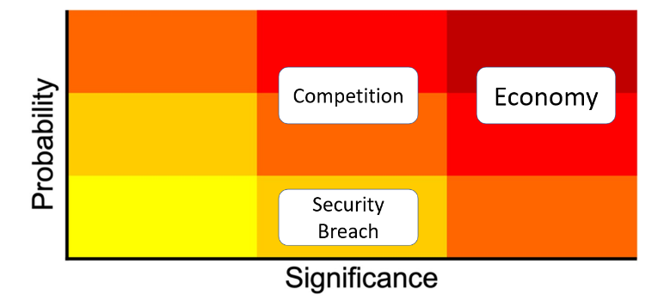
Risks:

Economy
Out of pandemic and many other political events, stock market is at high volatility statement, but weak homes sales may weigh on the bank’s fourth-quarter results. Morgan Stanley also faces external headwinds in 2020, which concludes the uncertainty after elections and investors worried about an overly aggressive Federal Reserve and the weak economic growth may trigger a recession.

Competition

CEO James Gorman once said in an interview, the real rivals of Morgan Stanley are not those traditional financial institutions or some companies, but one like Amazon. As the biggest Financial management in the world, Morgan Stanley is bounded to invest more in digital bank, internet security and some other field, these sequences actions may make less profit and risk of paying back. What is also vital is small companies take advantage of lowering cost in technology and diversity of communication, which may in ways of cooperating with other companies.

Security Breach
Morgan Stanley is always holding with its innovative business model, which is also a point that it can transcend other banks. It invests bunch of money in their information department. Last year, technology budget of Morgan Stanley took 44% of its net profit of the whole year in 2018. We could see that technology has taken a large place on Morgan Stanley’s works. However, security breach is rarely happened so the probability is low.
Management:
Morgan Stanley’s chairman and CEO is James P. Gorman. In September 2009, it was announced he would become CEO of Morgan Stanley in January 2010. He also assumed the title of Chairman in January 2012 following the retirement of John J. Mack. Press reports indicate his compensation as Chairman and CEO was $9.75 million for 2012, with the New York Times reporting an increase to $18 million in 2013. He earned about $19 million in Morgan Stanley shares and another roughly $8 million in cash, including salary and bonus. Except James Gorman, there are about 14 directors to cooperate with Gorman to run Morgan Stanley. Morgan Stanley is proud of their equality and diversity. The committee is consisted of several international groups and Morgan Stanley is very willing to embrace any talent people no matter who he/she is. Morgan Stanley always has their ambitions to explore future market. In addition, Morgan Stanley on the first place of “North America's best bank for financing 2020” and “North America's best bank for sustainable finance 2020”. We can see the potential of Morgan Stanley in future several years.

Stock Chart of Past Year Growth:
09.10.2019 – 09.10.2020
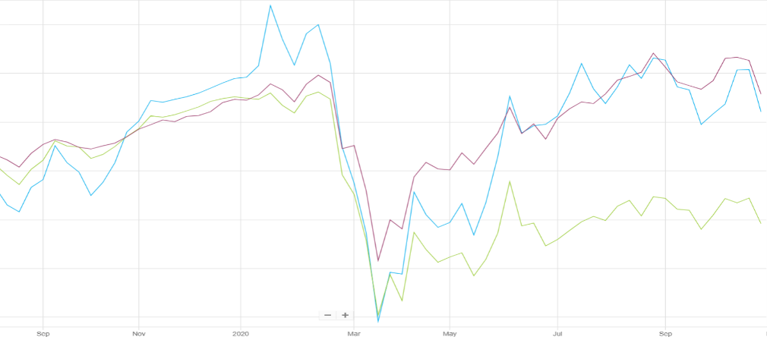
S&P 500: 15.71%
Morgan Stanley: 12.08%

S&P 500 Financial: -10.87%

We can see although COVID-19 affect a lot on Financial market, Morgan Stanley’s growth is still performing around the index of S&P 500. From this case, we can oversee that as the vaccine and another stimulus from government or the Fed. There will be a better improvement for Morgan Stanley.
Peer Analysis:
Company | Market Capitalization (B$) | P/E (LTM) | Net Income 2019 (B$) | ROA % (5 Year Average)
Morgan Stanley | $ 87.00 | 9.14 | $ 9.31 | 0.86
JP. Morgan | $ 298.85 | 12.78 | $ 23.80 | 1.00
UBS Group | $ 44.8 | 7.1 | $ 5.6 | 0.4
Goldman Sachs | $ 65.04 | 10.48 | $ 6.53 | 0.812
Peer Average | $ 135.9 | 10.12 | $ 11.97 | 0.73

We could see that Morgan Stanley has a low market capitalization from other peer companies. And Morgan Stanley has a lower P/E ratio than other companies. When we can expect a better return than others. and it’s 5 years average ROA are higher than peer average, which indicates a Morgan Stanley perform a healthy growth in its expansion.

Ownership:
Insider VS Institutional/Mutual Funds Top 5 Shareholders 