**McCormick & Company, Inc.**

April 11, 2018

Caiti Setterman | Griffin Egan Consumer Staples Sector

# Introduction

McCormick & Company, Inc. (NYSE: MKC | price: $106.59) is a global corporation that manufactures and sells spices and flavorings in two operational segments: consumer and industrial. MKC was founded in 1889 in Baltimore, Maryland, and is now headquartered in Sparks, Maryland. With approximately 20% share of the $11 billion global market, McCormick’s portfolio includes brands in 150 different countries and territories. Of the 20% market share, 67% results from the Americas, 20% from Europe, Middle East, and Africa, and 13% from the Asia-Pacific Zone. With a market cap of $13.72 billion, MKC is a global leader in the Food Products Industry.

# Recommendation

We issue a buy recommendation for McCormick & Company, Inc. based on a 1-year target price of $114.50. This intrinsic value represents a 7.43% upside potential from the April 11, 2018 closing price of $106.59. Over the last five years, MKC has displayed steady growth of 2-3%, resulting from continuous product innovation, cost-saving efforts of the company, and merger and acquisition activity. The most recent acquisition of Reckitt Benckiser Group’s food division (RB Foods) resulted in a 9.56% YOY growth in revenue from 2016 to 2017. An estimated 6.5% of this growth was attributable to the acquisition, while 3% resulted from organic growth of the company. After seven acquisitions in two years, MKC has added a substantial amount of debt to their balance sheet. Therefore, we anticipate a standstill in M&A activity through 2020 to allow the company to repay some of the accrued debt. We do not see this as a threat to their short-term financial performance, however. MKC will continue to strategically focus expansion in both developed and emerging markets in which there is growing consumer demand in bold, flavorful products.

# Investment Thesis

***Product Innovation:***The recent health movement has consumers increasingly interested in fresh, healthy, and flavorful food options which has posed a threat to many companies within the food industry. MKC, however, is well positioned as these trends continue to emerge. Research and development has allowed MKC to develop products that appeal to a wide variety of consumer tastes, since consumers respond well to continuously new product offerings.

***Cost Restructuring Initiative:*** Recent inflationary pressure, as well as volatility of raw materials, has led to a significant increase in material and production costs industry wide. In response to this issue, MKC has implemented a Comprehensive Continuous Improvement (CCI) program aimed to improve productivity and reduce operating costs. In 2016, MKC set a four-year cost savings plan goal of $400 million in hopes of allocating additional funds into brand marketing and product innovation. In just two years, MKC has delivered $226 million in cost savings, signaling that the company is on track to meet the four-year savings goal.

***Mergers and Acquisitions:*** Since 2015, MKC has completed seven acquisitions with the intent to drive sales and profit in both of its business segments. MKC’s most recent acquisition of Reckitt Benckiser Group’s food division aimed to also expand the opportunity for international growth and diversification. This acquisition, including products such as Franks RedHot and French’s, has also allowed MKC to expand its flavor options in the condiments category. Unlike prior acquisitions, which were financed through the use of cash and short term borrowings, the RB Foods acquisition was financed through the issuance of 6.35 million shares of common stock as well as senior unsecured notes and pre-payable term loans. The projected increase in sales for 2017 and 2018 would allow MKC to pay back the pre-payable term loans in the short run, ultimately influencing this financial decision.

# Valuation

To reach an intrinsic value for MKC, two valuation methods were used. The first method used for valuing the company was a five-year DCF model. Using a terminal growth rate of 2% and a WACC of 6.09% a price of $90.88 was derived. A sensitivity analysis of ±.25 on the terminal growth rate and WACC resulted in an intrinsic value range from $89.58 - $92.76. The second valuation method used was an EV/EBITDA multiples valuation. Peers were selected through the analysis of annual revenues, market cap, P/E ratios, and inventory turnover ratios. A chart of the peers used in this relative valuation can be found in *Table 1*. Using MKC 2018 EBITDA of $853.07 and an average peer multiple of 27.62x, a relative valuation of $138.13 was derived. Weights for the models were split 50/50 and resulted in a 1-year target price of $114.50, representing a 7.43% upside potential.

# Risks

We see three key risks for McCormick, but believe the company has taken the necessary steps to mitigate any downside potential resulting from the following factors.

***Global Business Risk and Commodity Pricing*:** As a geographically diversified company with 40% of revenues resulting from transactions outside the US, MKC faces risk from its exposure to global currency fluctuations. In addition, a significant portion of cost of goods sold result from the purchase of raw materials, especially vanilla, pepper, capsicums, and garlic. The majority of these goods are purchased outside of the US, where pricing can be volatile due to unpredictable weather, domestic costs, and government subsidies. While MKC does not use derivatives to hedge this type of risk, they do use customer price adjustments and future delivery purchases to mitigate any resulting exposure.

***Highly Competitive Industry:*** The spices and seasoning sector is very competitive. With extremely low-cost products, companies must compete on other values such as unique flavors, visual appeal, and shelving placement. In addition to peers used in the EV/EBITDA valuation model, MKC competes against national players such as Hormel, Kraft, and Heinz, and is able to mitigate resulting risk through leveraging its competitive advantages and responding quickly to changing consumer tastes.

***Concentrated Buying Power:***MKC receives about 20% of its revenue from two customers: WalMart and PepsiCo (FY 2016). This gives a large amount of pricing power to a small number of companies. If these companies decided to switch producers, that would have an unfavorable impact on MKC. However, MKC has excellent relationships with its customers, so we see low probability of this occurring.

# Management

Lawrence E Kurzius (59) currently serves as the Chairman, President, and Chief Executive Officer for MKC. Mr. Kurzius was first elected on the board in 2015 as Chief Operating Officer and President. In February 2016, he was named Chief Executive Officer and one year later named Chairman of the Board. His combined compensation in 2017 was $9 million, with a majority from stock options. Michael R Smith (53) currently serves as the Executive Vice President and Chief Financial Officer for MKC. Mr. Smith was elected to his current positions September 1, 2016 after holding various roles within the company.

# Stock Chart of Past Year Performance

**Figure 1: MKC Stock Prices**

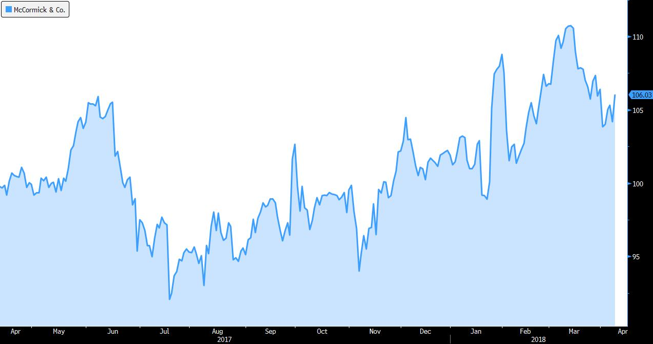

Source: Bloomberg

# Peer Analysis

**Table 1: Valuation Peer Analysis**



# Ownership

**Table 2: MKC Ownership**



# Top 5 Shareholders

**Table 3: MKC Top 5 Shareholders**

