MGM Resorts International (MGM)
Tanner Thompson & John Metzinger
April 16, 2018

Introduction
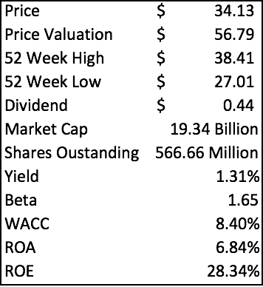
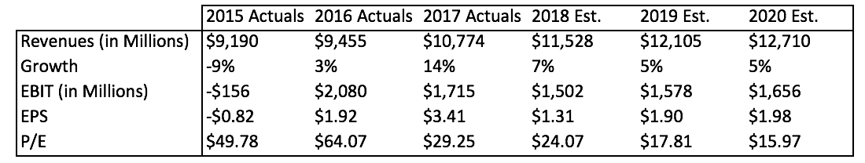
MGM Resorts International (NYSE: MGM) is a global entertainment company with domestic and international locations featuring best-in-class hotels and casinos, state-of-the-art meetings and conference spaces, live and theatrical entertainment experiences, and an extensive array of restaurant, nightlife and retail offerings. The MGM Resorts portfolio encompasses 28 unique hotel offerings including some of the most recognizable resort brands in the industry such as Bellagio, Luxor, MGM Grand, and The Mirage. A majority (66%) of MGM’s revenues come from lodging, food and beverage, while the remaining 34% comes from casinos and gaming. MGM Resorts controls and holds a 73% interest in the operating partnership of MGM Growth Properties LLC (NYSE: MGP), which is the real estate holding company for their resorts. The Company also owns 56% of MGM China Holdings Limited, which owns MGM MACAU and MGM COTAI, and 50% of CityCenter in Las Vegas, which features ARIA Resort & Casino.

Recommendation

As one of the largest casino and gaming in the world, MGM has been a market leader for decades. MGM has a market cap of $19.34 billion, one of the largest among it’s peers. Over the past year MGM is up 23%, and with a strong economy, looks to continue growing through 2018. Most MGM’s revenues come from their resorts and casinos in Las Vegas, meaning their operating results are highly dependent on the volume of customers in Las Vegas and other domestic resorts. The visitor volume in Las Vegas has been steadily increasing annually for the past decade, with an 8% increase in visitors over that time. Combining that with a 29% increase in average daily room rate, and 30% increase in revenue per available room indicates that the lodging side of MGM’s business is continuing to grow. MGM also has the largest meeting and convention footprint in Las Vegas, controlling over 30% of that market which has grown 47% since 2010. MGM is the largest resort and casino operator in Las Vegas, which positions them well to take advantage of the increases in visitors, especially as more professional sports teams are moving into the area. MGM differentiates itself from its peers by having a much greater emphasis on slot revenues than on table games, with slots making up 61% of its gaming winnings and 35% from table games. This focus on slot machine business allows for MGM to have less volatility and more control over casino revenues than its peers because they can control their slot hold more than table game win. The ownership of MGM Growth Properties allows for more financial flexibility since MGM Resorts pays all its rent to MGM Growth Properties. In addition, MGM’s 56% ownership of MGM China gives them exposure to the world’s largest gaming market in Macau.
Investment Thesis
- Growth of Las Vegas Tourism: The City of Las Vegas has a residential population of 633,000 people and has consistently brought in over 42 million tourists annually for the past three years. We expect this number to rise because we believe that the new professional sports teams will increase the annual tourism rates which therefore will help MGM grow. The Vegas Golden Knights, a professional hockey team, is currently underway in their first NHL season and play at the T-Mobile Arena which is 50% owned by MGM. T-Mobile Area is third amongst NHL stadiums according to capacity, and ticket prices are expected to increase based on demand in the first season. The Oakland Raiders of the NFL are also coming to Las Vegas in 2019. The National Football league notoriously has the largest annual revenue of every professional sports league in the world. With a new NFL team coming to the city in 2020, we expect fans from all over the country to be coming to Las Vegas and checking out the new stadium. We expect a large increase in tourists from the Oakland area as well as from around the country, meaning an increased demand for hotel rooms in Las Vegas. MGM is in control of 35% of the hotel rooms on the Las Vegas Strip, so they will be positioned well to take advantage of this increased tourism.
- Expanding into New Markets: MGM Resorts International owns 56% of MGM China which is in the autonomous territory of China called Macau. Macau has produced the world’s largest stream of gambling revenues for over a decade and is one of the world’s richest regions. The casino and gaming market in Macau is 72% greater than the five-major gaming markets combined. The Casinos located on the Macau strip are known for having high rollers and offer many frequent customer plans to these very wealthy customers. MGM China owns and operates MGM Macau and recently opened MGM Cotai on the Cotai Strip just this year. We expect this to increase revenues because of the larger gambling presence in Macau. Back in the United States, MGM Resorts is opening a brand-new resort and casino in Springfield, Massachusetts in quarter three of 2018.
- Consumer Spending Trends: Today, consumers are purchasing less of physical items for leisure fun and have decided to spend their money on experience based activities. For example, some popular items would be vacations, concerts, and food just to name a few. This switch over to purchasing these experiences rather than material goods will be a large contributor to the success of MGM Resorts, as they are a global leader in the entertainment business. We believe and can see the younger generations using social media to show off their leisure activities and can attest to this trend.
Valuation
To determine an intrinsic value for MGM Resorts International, we used a discounted cash flow model with 5 years of future cash flows which we projected based on our estimates. Using a WACC of 8.4%, taken from Bloomberg, and a terminal growth rate of 2%, we found a value of $42.00. The reason why we chose the discounted cash flow model is that we believe that future cash flows are the most important driver for the price of MGM. Additionally, a P/E multiple valuation was conducted using our projected 2018 earnings and peer comparable multiple of 24.47, resulting in a valuation of $41.00. We chose a 60/40 weighing of our two models, with the majority weight going to the discounted cash flow model, we arrived at a target price of $41.60, an upside of 21.88%.
Risks
- High Level of Debt. Since MGM is such a capital-intensive business, they have a significant amount of debt. If interest rates were to rise quickly, they may have trouble repaying those debts, which in turn would decrease the value of the business.
- Changing Markets. MGM falls into the consumer discretionary sector, which historically follows the market. A downturn in the economy will affect MGM and their expected earnings for investors.
- Concentrated Location. Most of MGM’s major resorts are concentrated on the Las Vegas Strip, so their business may be significantly affected by events that disrupt the tourism industry in Las Vegas.

Management

Jim Murren was named Chairman and CEO of MGM Resorts International in December 2008. Mr. Murren joined MGM in 1998 after spending more than a decade on Wall Street, where he was regarded as a leading analyst in the hotel and gaming industries. The entire management team for MGM is comprised of members with years of experience in the resort and casino industry. It is important to note that the executive compensation committee is made up solely of independent board members. Nearly 76% of the target direct compensation for executive officers and 83.3% of the CEO’s target direct compensation is based on the achievement of performance goals. Jim Murren is also the largest insider stockholder.

Stock Chart of Past Year Performance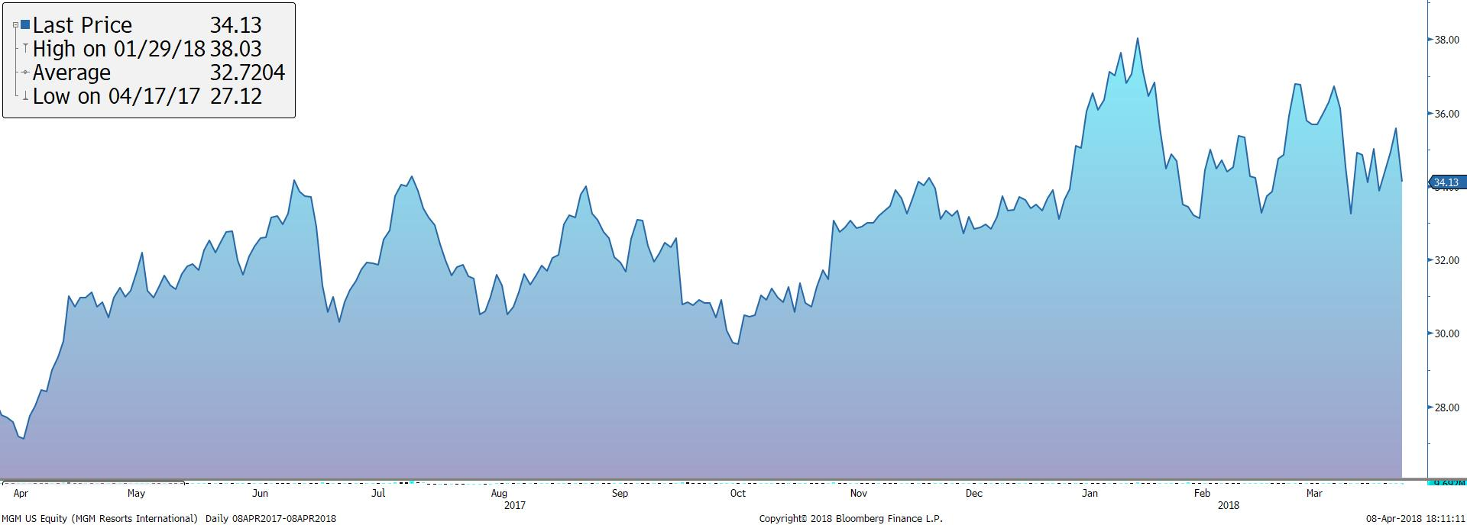
Peer Analysis
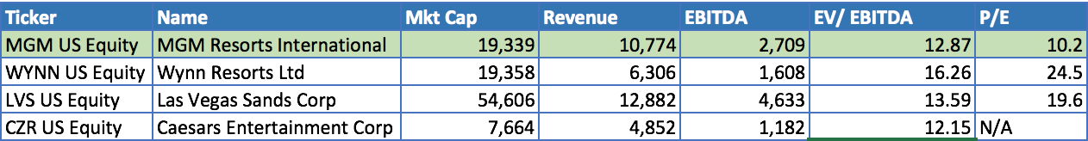
Ownership of Shares
% of Shares Held by All Insider Owners | 0.15%
% of Shares Held by Institutional & Mutual Fund Owners | 99.85%
Source: Bloomberg
Top 5 Shareholders
Holder | Shares | % Out
Vanguard Group | 50,534,889 | 8.92%
Capital Group Companies Inc. | 40,221,269 | 7.10%
Blackrock | 35,609,163 | 6.28%
Soroban Capital Partners | 35,304,047 | 6.23%
Tracinda Corporation | 27,173,744 | 5.65%

