Nasdaq: (ADBE) Adobe Information Technology
Ben Zielinski, Alyssa Haglind (Software)

Introduction:
Adobe Systems Incorporated is a multinational computer software company with multiple expanding business segments. Its fastest growing segment, Digital Media, which is used mainly for Adobe’s creative cloud, allows companies to develop creative products and operate with cloud platforms across desktop, web, and mobile devices. An additional operating segment, Digital Experience, is used for businesses and their different channels to connect their company to their customers. Adobe’s final major business segment, publishing, contains products and services that work with eLearning solutions, technical document publishing, web application development and high-end printing. Users are able to create and use the information across all print and electronic media. Adobe is headquartered in San Jose, California and is one of the largest software companies in the world. In 2017 their revenue reached roughly $7.3 billion while operating with over 18,000 employees worldwide.

Price | 225.30 | Beta | 1.22
Target Price | 239.31 | WACC | 7.91%
52 wk. High/Low | 129.48-231.34 | Gross Margin | 85.04%
Market Cap | 113.49 Billion | ROE | 21.76%
Shares Outstanding | 492.47 Million | ROA | 12.18%
Forward P/E | 34.97 | Price/Earnings | 53.13
Dividend Yield | N/A | Price/Sales | 12.14

Recommendation
Adobe products can be found throughout most universities, businesses, and households across the globe. It is this global outreach and dedication to innovation that allows Adobe to be highly successful within the dynamic technology industry. Through its several business segments, Adobe offers products that incorporate creativity and design capabilities, marketing and analytics, PDF and e-signatures, and creative business solutions. There newest and most innovative product incorporates cloud technology which has been their most successful business line as of recent, along with incurring steady growth within the subscriptions of their base products. Because the demand for cloud computing technology is steadily increasing as businesses are moving from older data sharing systems to the more cost effective and compatible cloud systems, we believe that this will have a positive impact on the future earnings and stock price of Adobe. We also believe that this company will continue to grow and innovate and is doing this by acquiring new companies to incorporate new technology within its base products and new products. We also believe that this is a safe and stable investment for our portfolio because of the global footprint it operates under as well as their dedication to expansion within the industry. We view this company differently than some analysts may view it. Although it is a high P/E stock and has the characteristics of a growth stock, we believe that as the earnings continue to grow the P/E ratio will lower and may evolve to a value company. We believe that Adobe will be a company that will continue to evolve and be around for years to come.

Investment Thesis:
Rapid growth and development: Adobe has seen rapid growth in earnings over the past few years, growing from 22% in 2016 to 25% in 2017. This growth can be contributed to the development and introduction of new cloud technology. Many companies are switching from the traditional operating systems to cloud systems to reduce costs, increase efficiency, and allow for more flexibility in the workplace. Competitors have not been able to produce a product that can compete with Adobe and until they do so, we would expect this growth to continue over the next several periods. We also believe this trend will continue due to the high demand for cloud computing products.
Partnerships and Acquisitions: Adobe has recently acquired Sayspring, a small startup company that specializes in voice recognition software. Although not well known, Sayspring built the voice interfaces for the Amazon Alexa product as well as the Google Assistant App. The two companies will begin to work together to incorporate the voice recognition software into Adobe products. The plans for new products have not been released, but this acquisition is another step towards Adobe further innovating its products. Adobe has also recently partnered with Nvidia to further develop Sensei Artificial Intelligence. We believe that this announcement is already factored into the stock price, but the future earnings that it could generate is not. We would expect these acquisitions and partnerships to only benefit the revenue growth moving later into the 2018 period.
Low competition: Adobe controls a substantial portion of the software market mostly because the wide variety of products that they offer and the reputable brand name that they have developed over several years of business. Their extremely large market cap also proves that they are the premier leader in the software industry. Many of the direct competitors that operate within the software industry can only compete by offering one or two unique products giving Adobe the competitive edge while offering a wide variety of personal and corporate products. We would expect Adobe to continue to control this market, especially with the barriers of entry in the industry being so high. We believe this will be a key advantage moving into the future years of their business.

Risks:
Development of technology: If Adobe does not continue to adapt and evolve within the technology sector, a risk arises from other smaller companies gaining market share with the introduction of new products and technologies. The process of developing and acquiring new technology products is complex and costly, and if Adobe does not continue to evolve, we could see a decline in their revenue stream throughout future periods.
Increase regulation of privacy laws: As of recent, legislators and regulators have put increasing pressure on software producers to help keep personal data safe. We have seen record numbers of hacking cases over the past several years and this number continues to grow. This has potential to increase costs to Adobe by forcing them to further develop product security on future and current products.
Fluctuation in global markets: Being a global company, Adobe faces the risk of economic uncertainty in the global market. Roughly 42% of Adobe’s revenue is generated from countries outside the domestic market, and if unexpected economic events occur in areas in which they receive large portions of revenue from, Adobe, as well as others, could potentially be hurt.
Reliance on subscriptions: Adobe receives large portions of their income from subscription service products such as Adobe Acrobat. The risk that arises from subscription revenue is that they must continue to acquire new subscribers. Another risk from subscription revenue is that it can alter the financial data in periods in which they receive new subscriptions and alter the reporting of their financial statements.

Valuation:
To reach an intrinsic value of Adobe, we chose to use the 5 year discounted cash flow model and the EV/EBITDA multiple model weighting them 60/40 which brought us to a 1 year target price of 239.31. This represents a 6.22% upside potential from its current price of 225.30 and a $14 overall price increase. We found it difficult to find peers that were direct competitors of Adobe due to the large number of products they offer and the sheer size and growth capabilities that they have. When selecting our peers, we used companies such as Amazon, Netflix, Microsoft, Google, and Facebook who have realized tremendous growth over the past several years and who also operate as leaders in their respective industries. It is not uncommon to find inflated ratios for companies that are growing near 30% per year which made it difficult to find a multiple to select. When averaging out the EV/EBITDA multiple across its peers, we determined that this was the most realistic and accurate multiple to use for a relative valuation of Adobe.

Management:
Adobe was founded by Charles Geschke and John Warnock in 1982. They both served in different executive management positions until 2000, when both executives retired. Shantanu Narayen is Adobe’s current CEO and president. He was named one of the world’s top CEO’s by Barron’s magazine in 2016 and 2017. Mark Garrett is the current CFO and executive vice president and Mike Dillon is their current executive vice president and general counsel. Garrett and Dillon recently announced their intended retirements in 2018. They intend to remain in their current roles until the training and transition of new executives is complete. This process is intended to create a smooth transition without disrupting organization. Their newly announced CFO is John Murphy and was hired after working as the Chief Accounting Officer at Qualcomm for 4 years.

Stock Chart Past Year Performance:

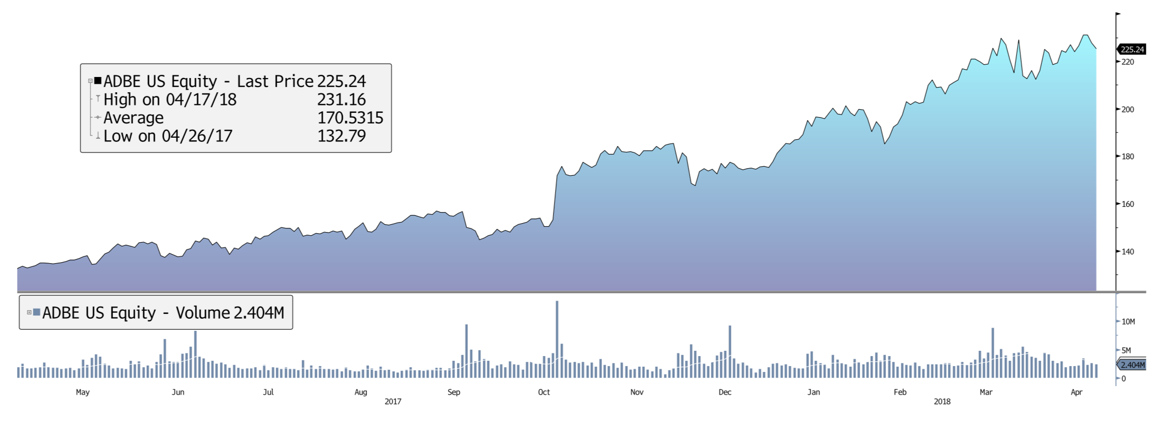

Peer Evaluation:

Name | Ticker | MKT Cap | Revenue | P/S | EV Mult. | P/E
Adobe | ADBE | 113.49B | 7.70B | 12.14 | 33.78 | 53.13
Microsoft | MSFT | 513.31B | 102.27B | 5.53 | 12.82 | 21.01
Alphabet | GOOG | 731.88B | 110.85B | 6.58 | 19.18 | 31.24
Amazon | AMZN | 566.02B | 177.86B | 7.77 | 81.28 | 256.60
Facebook | FB | 512.79B | 40.63B | 12.61 | 20.28 | 28.65
Netflix | NFLX | 83.19B | 11.70B | 7.09 | 95.40 | 143.80
Average |  | 420.13 | 75.16B | 7.85 | 36.44 | 89.07

Top 5 Shareholders:
FMR LLC | 36,390,225 | 7.3%
Vanguard Group Inc | 35,213,142 | 7.15%
Blackrock Inc | 32,675,677 | 6.64%
Primecap Mgmt. | 23,468,731 | 4.77%
State Street Corp | 18,941,507 | 3.85%

Ownership:
Adobe is owned by predominantly by domestic investment advisors. Currently, 85% of its shares are traded within the U.S. with the next closest geographical ownership being 5% in the United Kingdom. Finally, the ownership type is dominated by investment advisors, owning roughly 84% of shares with the next closest type being hedge fund managers at 6%.

